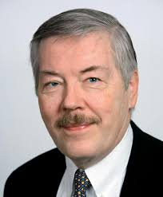
M. B. B. Biskupski

Dr. M. B. B. Biskupski is the Stanislaus A. Blejwas Endowed Chair in Polish & Polish American Studies at Central Connecticut State University. He received his B.A. in history, summa cum laude, from the University of California, Los Angeles. He received his M.A. in history from UCLA in 1972, and his M. Phil., also in history, from Yale University in 1975. He completed his Ph.D. there in 1981. At Yale he held dissertation fellowships from the Fulbright-Hays Foundation and the International Studies Association/Ford Foundation. Prior to his arrival at CCSU, he taught at Yale, Millersville University, and the University of Rochester. In 1995, he held a Fulbright Research Professorship in the Institute of History at the University of Warsaw.

Dr. Biskupski is the recipient of several academic and national awards, such as the Honor Roll of Polish Science by the Polish Ministry of Education (2001), and the Officer’s Cross of the Order of Merit of the Republic of Poland (2000) and also the Commander’s Cross of the same order. In 2004 he received the Mieczyslaw Haiman Award from the Polish American Historical Association. He is the former President of the Polish Institute of Arts and Sciences of America and served as the member of the Board of Directors of the Józef Piłsudski Institute of America and the president of the Polish American Historical Association. He is the author of more than a dozen books, and many articles. In 2017, the President of Poland granted him Polish citizenship.

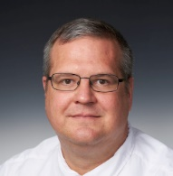
Michael Guzik, S.J.
Before entering the Society of Jesus in 1992, Prof. Michael Guzik, S.J. received my B.A. in history from St. John Fisher College in Rochester NY, and an M.A. in history from the State University of New York at Buffalo. In both places, he focused on the history of East Central and Eastern Europe.
Although he had a passion for history, God had a greater passion for me him and he became a Jesuit. He earned an M.A. in philosophy at Fordham University, and wrote as much as I could on the philosophy of history. During my theological studies, he earned the requisite M.Div for ministry and was able to earn an S.T.L. in church history under the direction of John O’Malley.
After his ordination, he worked for a year at a parish on Long Island, and then lived in Poland for about a year and a half and then returned to the United States, and worked for a time at Canisius High School in Buffalo, NY. He finished his Ph.D. in May 2017.
His appointment as the Wade Scholar at Marquette University for the 2016-2017 academic year helped greatly, as it allowed him to conduct additional research for his dissertation and began expanding his research in his core academic interest, which is the dynamics of identity formation.

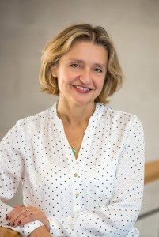
Anna Jaroszynska-Kirchmann
Dr. Anna Jaroszynska-Kirchmann was born in Lublin, Poland. She attended Maria Curie-Skłodowska University (UMCS) in Lublin and in 1984 received an MA with Honors in history, with a minor in archival studies. She worked as an Assistant Professor in the Department of History at UMCS till 1988, when she immigrated to the U.S. While in the doctoral program at the University of Minnesota, Jaroszyńska-Kirchmann worked as a research assistant at the Immigration History Research Center at the University of Minnesota, and published several archival inventories to the IHRC manuscript collections. In 1997, she earned her Ph.D. from the University of Minnesota, after studying American immigration and ethnic history. That same year she began working in the Department of History at Eastern Connecticut State University in Willimantic, CT, where she is now a Professor of History and Chair of the Department of History.
In 2004, Jaroszyńska-Kirchmann published The Exile Mission: The Polish Political Diaspora and Polish Americans, 1939-1956, which was awarded the Polish American Historical Association’s (PAHA) Oskar Halecki Prize for the best book on Polish American topics. She also published on different aspects of the Polish postwar political Diaspora in the U.S.; two of her articles received PAHA’s Swastek awards in 2002 and 2003.
Jaroszyńska-Kirchmann’s research in progress focuses on the history of Polish American community in Connecticut, issues of interethnic relations, memory and commemoration, and intersection of urban and ethnic history in the post-war decades.
Since January 2015, Jaroszyńska-Kirchmann serves as Editor-in-Chief of Polish American Studies and she is a member of many professional organizations.

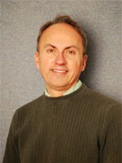
Neal Pease
Dr. Neal Pease is a professor of History at the University of Wisconsin-Milwaukee with a specialty in modern Polish and central European history. He is editor in chief of The Polish Review and past president of the Polish American Historical Association.

Over the course of his career, Professor Pease has devoted most of his research and publication to the role of the Catholic Church in recent Polish history. Current areas of research interest include: the “Jewish revival” in contemporary Poland; soccer in Polish politics and society; and historical symbolism and memorialization of public spaces in Poland. His previous position was as a lecturer at the Department of History, Yale University.

He graduated from Yale University with a Ph.D. in History, 1982, and M.A. in History, 1976. Also,
University of Kansas, M.A., History, 1975. B.A., History, 1973. His foreign studies consist of Uniwersytet Warszawski, Warsaw, Poland, 1978-79 and Uniwersytet im. Adama Mickiewicza, Poznań, Poland, 1972-73.

He has many publications and is a recipient of many awards including Mieczyslaus Haiman Medal, for sustained contributions to Polish American studies, Polish American Historical Association and 2015 Officer’s Cross, Order of Merit, Republic of Poland, 2014.

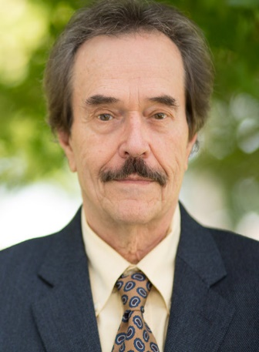
Robert Szymczak
Dr. Robert Szymczak is an associate professor of history at Penn State Beaver. Mr. Szymczak received the Polish Gold Cross of Merit, one of Poland’s highest honors and is recognized internationally for his body of work and research on Polish history, the Holocaust, World War II, the Soviet Era, the Cold War, modern Eastern Europe, and United States ethnic and diplomatic history.
He has presented more than 50 papers at academic conferences, including “The Vindication of Memory: The Katyn Case in the West, Poland, and Russia, 1952-2008,” which was published in The Polish Review by The Polish Institute of Arts and Sciences of America and is the recipient of the Swastek Award for Best Article of the Year, “Cold War Crusader: Arthur Bliss Lane and the Private Committee to Investigate the Katyn Massacre, 1949-1952,” which appeared in Polish American Studies: A Journal of Polish American History and Culture.
Dr. Szymczak is also the recipient of numerous Penn State honors, including the university’s prestigious George W. Atherton Award for Excellence in Teaching, the Penn State Beaver Advisory Board Excellence in Research Award and the Penn State Commonwealth College Excellence in Teaching Award. In addition, he is a three-time recipient of the Penn State Beaver Advisory Board Excellence in Teaching Award.

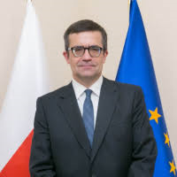
Piotr Wilczek
Piotr Wilczek is a Polish intellectual historian, a specialist in comparative literature and a literary translator, who currently serves as the Ambassador of Poland to the United States.
He graduated from the University of Silesia in Katowice, Poland where he received his Ph.D. and Habilitation degrees. In 2006 he was nominated professor of the humanities by the President of the Republic of Poland. Since 2008 he has been a tenured full professor at the Faculty of „Artes Liberales", University of Warsaw and has served there as Head of the Collegium Artes Liberales (College of Liberal Arts and Sciences) and Head of the Centre for the Study of the Reformation and Intellectual Culture in Early Modern Europe.
In 1998-2001 he was a visiting professor at Rice University, the University of Illinois at Chicago and the University of Chicago and gave invited public lectures at Harvard and the University of Texas at Austin. He was also a visiting scholar at Boston College and Cleveland State University.
He has been a board member of numerous international scholarly journals, book series and academic initiatives Since 2014, he has been a Representative in Poland of the Kosciuszko Foundation, Inc. (New York) and President of the Management Board of the Kosciuszko Foundation Poland as well as a member of the Polish-American Study Group at the Polish Institute of International Affairs.

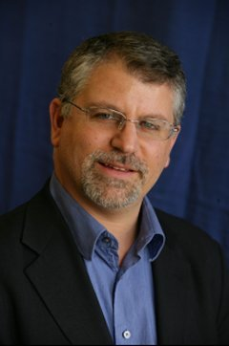
Joshua D. Zimmerman
Joshua D. Zimmerman is Professor of History at Yeshiva University, where he holds the Eli and Diana Zborowski Professorial Chair in Interdisciplinary Holocaust Studies.
He is the author of The Polish Underground and the Jews, 1939-1945 and of Contested Memories, Poles and Jews during the Holocaust and Its Aftermath as well as Poles, Jews and the Politics of Nationality: The Jewish Labor Bund and the Polish Socialist Party in Late Czarist Russia, 1892–1914.
Dr. Zimmerman graduated from the University of California at Santa Cruz in 1989 with a BA in History, and with the M.A. in History from UCLA in 1993. In February 1998 he completed his PhD thesis in Comparative History at Brandeis University. In the summer of 2004, he was appointed to the position of Associate Professor of History at Yeshiva University in New York City. Dr. Zimmerman is an American author proficient in Yiddish, Polish, Hebrew, Russian, and French.

