Responding to Student Writing:
Ideas for Creating “Instructive and Portable” Conversations

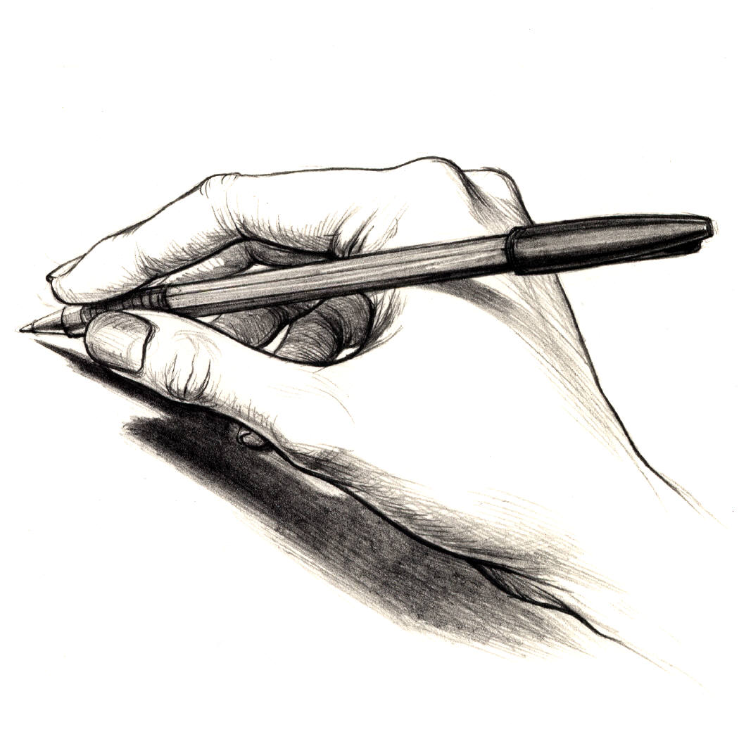

The comments students identify as the most helpful are responses that straddle the present world of the paper at hand with a glance to the next paper, articulating one lesson for the future.
- Nancy Sommers, “Across the Drafts”
The Goals of Response

Comments are a way of modeling the kind of dialogue students can begin to have with themselves when revising their papers. Students need to know why some things work and others don’t. Thorough, articulate instructor comments assist students in becoming more articulate and developed in their own writing. Hopefully, these comments become what Nancy Sommers calls “instructive and portable words to take with them to the next assignment, across the drafts.” As instructors respond to student writing, it may be helpful to consider how one’s response builds upon the language of the assignment and in what ways it sets the stage for future student writings.
The craftsman isn’t ever following a single line of instruction. He’s making decisions as he goes along…The material and his thoughts are changing together in a progression of changes until his mind’s at rest at the same time the material’s right.
-Robert M. Pirsig, Zen and the Art of Motorcycle Maintenance

Laying the Groundwork

Establishing the terms and goals of writing in the course early on, elaborating and revising them as the semester progresses, provides a supporting framework for commenting and grading.
Comments on student writing are distinct from (but of course related to) grading. When serious, thoughtful comments come before grading, students are more likely to separate commentary from judgment. In most instances, dialogue is better than pronouncement for effecting lasting change.

- Scott Campbell, “Responding to Student Writing”

The following advice is adapted from the UConn Writing Center webpage, www.writingcenter.uconn.edu:

Give assignments in ways calculated to elicit the kind of student writing you want.
- Write out the assignment (in take-home form)
- Identify its primary traits, and be sure to emphasize these in discussing the assignment with the students. Explain what you mean by each primary trait. [specific aspect(s) of content, organization, emphasis, definition of particular terms, review of the literature, whatever...]
- Give process oriented assignments--tell students how to write what you're asking them to do.
- Spend considerable time in class going over the assignment, explaining how to write it and what you're going to look for. Entertain student questions on this.

Be explicit about your grading criteria in advance.

Make exemplary models of professional and student writing available for students to refer to during their own writing.

Help make students aware of time management in planning, researching, writing assignments.

Set aside a few minutes of class time at each meeting to discuss ways of handling the writing assignment and to entertain questions.

Successful Response Practices

Perhaps the most successful response practices are those that in some way resemble a conversation between the student (or at least the student text) and the reader/instructor. Some instructors even prefer on occasion to replace written commentary with face-to-face responses in conferencing. However instructors choose to communicate their responses, it’s crucial that instructors not feel burdened by the time it takes to respond, and that students receive communications that they can translate into action in future papers.

So that you don’t spend all your time commenting…and the students still benefit:

- Represent to students what you understand their ideas to be. This can be the foundation for the prioritizing of other comments as it assists students in understanding how their work appears to an outside audience. Questions reacting to these ideas further help students to more clearly recognize the possibilities of their texts.

- Try reading papers through twice, the first time without commenting. Though this may sound like more work, it actually assists you in recognizing general ideas and patterns and prioritizing your comments in the second read-through. The result: fewer, more focused comments.

Additional suggestions for response practices…

The following advice is adapted from the UConn Writing Center webpage, www.writingcenter.uconn.edu.

- Don't become an editor of your students' writings, either of their drafts or their final papers.
- Employ peer editing, peer responding
- Use a check sheet or some other response format that suits your taste and the assignment. Supplement that with computer-written comments, if possible.
- Consider portfolio grading, especially of assignments with multiple drafts. You don't have to put a number or letter grade on every assignment, or on every stage of every assignment.
- Decide when not to comment--at all, or minimally. Particularly true of experimental or exploratory stages of writing.
- Decide what to focus on in responding to a particular piece of writing--perhaps one or two of the primary traits you identified in the assignment.
- Avoid response overkill--too many comments make it impossible for the student to sort out what's important. And they're self-defeating; how can a student correct so many blunders all at once?
- Better to pick a primary trait or two for each assignment; build on those in successive assignments as you escalate the complexity of the demands, and also your expectations of higher quality.

University of Connecticut
Greater Hartford Writing Center
http://hartfordwriting.uconn.edu
hartfordwriting@gmail.com

