Types of Online Classes
HyFlex - HyFlex courses are delivered in person and broadcast online at the same time by the same faculty member. The class will be recorded and available to students who miss class or need a refresher.
On Ground Section: You can sign up for the in-person section of the HyFlex class by selecting the section with a room location with the “Hybrid: HyFlex” attribute.
You will need:
- Personal laptop/desktop/tablet
- Face Mask
Online Section: You can sign up for the online section of the HyFlex class by selecting the section with ONLINE SYNCH as the location with the “Online: HyFlex” attribute.
You will need:
- Personal laptop/desktop/tablet
- Reliable network/internet connection

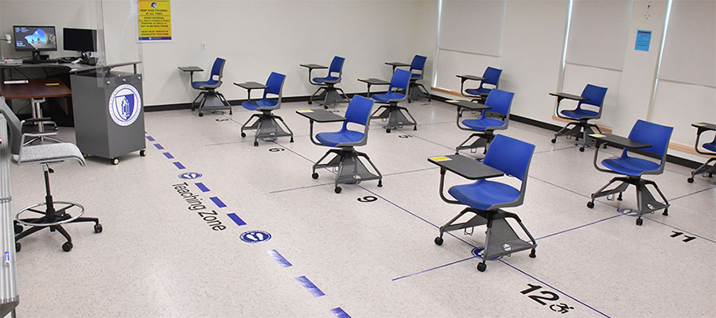

Online Synchronous – These classes are fully online with a scheduled meeting time. Your professor will let you know which platform they are using for the class meetings (i.e. Teams, Webex, Blackboard Collaborate, etc.) Classwork will be done asynchronously throughout the week.
You will need:
- Personal laptop/desktop/tablet
- Reliable network/internet connection
- Webcam and microphone to participate in meetings
Online Asynchronous – These classes are fully online but do not have set meeting times. You will learn on your own schedule. Classwork is done asynchronously online but has specified due dates.
You will need:
- Personal laptop/desktop/tablet
- Reliable network/internet connection
- Access to specified software and browsers for the class. * Your professor will notify you of what you need. *

*NOTE: Students should not connect to an online class with their phone. This is an unreliable method that does not allow for full participation.
How to Request a Computer
If you do not have a personal laptop or device to access online meetings or classwork, you can request one from CCSU using the CARES Act. You will sign into the form request system with your BlueNet ID (ex. ab1234) and password then search for the “Student Loaner Laptop” form.
More information on Loaner Laptops: https://www.ccsu.edu/it/itservices/student_laptop_info.html
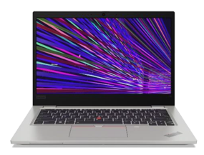

Check out the Student section of our Technology Training and Resources webpage for more helpful resources: https://www.ccsu.edu/ttr/

