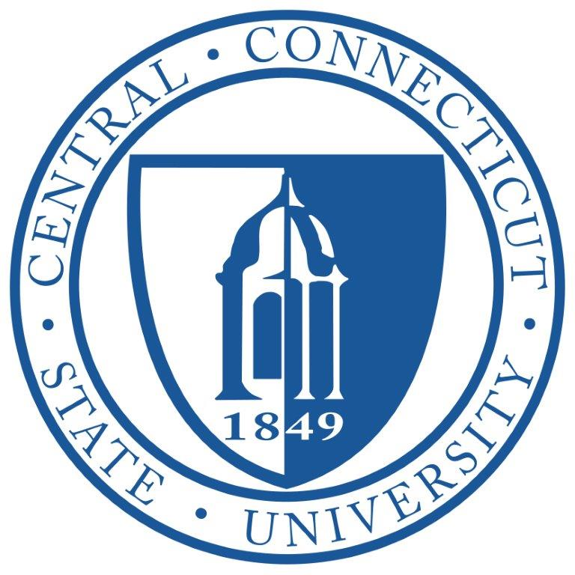 Facilities Planning Committee

November 17, 2021

Via Teams

Attendees: Lisa Bucher, Interim Chief Budget and Compliance Officer
Sal Cintorino, Chief Operations Officer
Dr. Marianne Fallon, Associate Vice President for Academic Affairs - Planning and Resources
Dr. Kimberly Kostelis, Interim Provost
Carolyn Magnan, University Counsel
James Grupp, Director of Engineering
Dr. Frederic Latour, Faculty Senate President
Dr. Stacey Miller, Chief Diversity Officer
Dr. John Tully, Interim Vice President for Student Affairs
Kathy Poirier, UPBC Representative

Davidson Hall
- Conference room created and nearing completion.
- Alumni Affairs in room 206 construction

Marcus White
- Student Technology Center/Copy Center slated to reopen in Spring 22.
- Copy Center charges pilot being reviewed, and budgets will be made whole

Barnard Hall
- Advising has moved in
- Ongoing work on existing building (Literacy, Dean’s Office, Special Education)

Carroll Hall
- Director in place, review legal issues with C. Magnan
- Continuing Education moving in late November from 185 Main St

Vance Academic Center
- Social Work to relocate to Barnard
- Review of building space to get existing offices together and improve building functionality
- Question on Design Department (3rd floor), potential merger with Art, for future discussion
- Develop different building space scenarios

library/Library Annex
- Project over budget
- In Open Forum with CSCU President, indicated Library is not well maintained

Applied Innovation Hub
- Labs will be moving over Thanksgiving break

Copernicus Backfill
- Determine what vacated space will be used for/issue of relocated departments retaining their existing space needs resolution

Willard DiLoreto Parking Garage
- Goal to open for spring semester, issues with obtaining Certificate of Occupancy as elevator shaft is not complete

185 Main St
- CCSU presence downtown in unknown/College office construction in progress

Misc
- Assessment of campus lactation rooms and changing tables
- Prayer spaces-currently former LGBT space in Student Center is available. Various organizations have asked for private prayer and office space. C. Magnan noted that there cannot be space for only 1 religion.
- S Miller indicated the restroom near OEI is not accessible. Accessible restroom on the other side of Davidson.
- K. Poirier indicated lock issues in the Student Center (Summer 2022 project?)

Respectfully Submitted,
Rene Karas

