LONDON: THE CITY STAGED!
(Shakespeare Survey, ENG 220)
Spring Term, 2022

This coming spring, Shakespeare Survey (ENG 220) is going to London! Students who take the course will begin the course in the classroom but conclude in England over 9 days of spring break (that’s right: students who go to London finish the course in mid March). And ENG 220 gives students Gen Ed credit for Study Area 1 and fulfills both the Literature and International course requirements. Two course times to choose from!

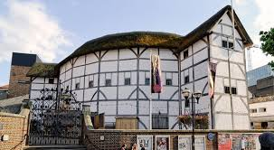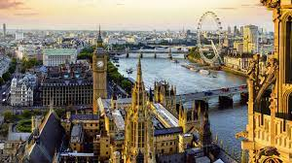

Some scheduled highlights:
- A guided visit to Shakespeare’s Globe
- Attend performances of Merchant of Venice, Henry V and Hamlet, plus some non-Shakespearean theatre and music
- Visit the British Museum, National Portrait Gallery, Westminster Abbey, the National Gallery, Museum of the City of London, and the Tower of London
- Guided Tours of “Legal London” (including the Inns of Court) and “Working London” (Cheapside and the Guildhall)
- Visit sites of other early modern “performances”: Blackfriars, playhouse sites in The Liberties, St. Paul's, bearbaiting rings, execution sites
- Great food at Borough Market and traditional English pubs
- Francis Drake’s tall ship “The Golden Hind”
- Plus, plenty of free time for students to use their transit and museum pass to explore all parts of the city

For more information, please contact Eric Leonidas in the English Department; to register, visit the Center for International Education courses page.

