Integrated Planning Council

February 23, 2022

Meeting Notes

Present: L. Bucher, S. Cintorino, G. Claffey, C. Robinson, N. Elsinger, A. Bray, L. Frank, S. Hazan, Y. Kirby, F. Latour, S. Miller, Z. Toro, J. Tully, E. Moore, K. Kostelis

Vote: New Academic Program Process Documents
K. Kostelis noted that the UPBC did not have any feedback on the New Academic Program Process Documents, and that they are still aligned with the BOR new program process. As such, the IPC should be ready to vote on these documents.
Vote: IPC members voted to approve the New Academic Program Process Documents.
Members then engaged in discussion regarding the new academic program process. There are a number of steps in the process that can be done concurrently. K. Kostelis, F. Latour, and E. Moore will look at the new academic program process to determine what steps can be performed in parallel and inform the IPC of these changes.

FY22 & FY23 Budget Update
The following summary was provided:
- The mid-year spending plan was recently submitted with a balanced budget
- The three-week freeze numbers came in approximately $2.1 million more than we had projected
- There will be some savings from retirements for FY22
- Since our last meeting we received approximately $2.4 million in infrastructure funding
- We just received our tuition and fee package for FY23, which include significant changes:
  - We will offer the New England tuition rate for New York and New Jersey
  - Our sister institutions will offer the New England tuition rate for New York and New Jersey
  - It is possible the tuition rate discount may be extended to all out of state students, which will have a significant financial impact on CCSU and SCSU
  - Tuition and fee increases for next year may be as high as 4-6% (4% = $3.6 million)
  - A tentative agreement has been reached with AAUP and SUOAF that includes a retroactive payment and a salary increase for this year and next year (a $143 million cost)
    - The Governor is proposing to contribute $45 million, and the universities will need to come up with the balance.
  - The decline in enrollment and additional expenses will result in an approximate deficit of $15 million for this year and next year
- There are 83 retirements as of yesterday

New Academic Programs Update
K. Kostelis provided summaries of the Bachelor of Science in Business and the Bachelor of Science in Business Analytics (see Appendix I), which have both been review by the UPBC. The following is a summary of the conversation that ensued.
- Concept Paper Bachelor of Science in Business:
  - This would provide a student with a business degree that is not targeted in a specific discipline
  - There is a market for this program
  - The program will be hybrid, with some courses online and some on-ground
  - As of now, this program can be offered without additional resources
  - There are some similarities to BGS; there may be a chance the Board will give us the same response for this program (i.e.: work with Charter Oak)
  - Vote: unanimously approved
- Concept Paper Bachelor of Science in Business Analytics
  - The Deans and UPBC have approved the concept paper, and the Deans would like to further refine the tracks
    - Proposed tracks include:
      - Marketing
      - Accounting
      - Financial
      - Sports
      - Healthcare Data
      - Data Science
      - Business Informatics and Intelligence
  - There are no resources needed in SOB at this point; however, some tracks in other schools may or may not need resources in the future
  - Vote: unanimously approved

Actions:
- K. Kostelis, F. Latour, and E. Moore will look at the new academic program process to determine what steps can be performed in parallel and inform the IPC of these changes

Appendix I
CENTRAL CONNECTICUT STATE UNIVERSITY
NEW PROGRAM PROPOSAL ROUTING SHEET (form created November 15, 2021)
GENERAL INFORMATION
Name of New Program and Credential |  |  |  |  |  | Bachelor of Science in Business
FACULTY CONTACT(S) (Name, Dept, College/School) |  |  |  |  |  | This Degree is hosted by the School not Department
CHAIR CONTACT(S) (Name, Dept, College/School) |  |  |  |  |  | Dr. Chris Lee, School of Business
DEAN’S OFFICE CONTACT(S) (Name, Dept, College/School) |  |  |  |  |  | Dr. Joseph Farhat, School of Business
REASON FOR NEW PROGRAM
New offering |  | □ Concentration becoming  standalone program |  | □ Program coming off suspension  (requires #6 for Concept Paper) |  |  |  | □ Program reinstated after discontinuation  (requires #6 for Concept Paper)
CONCEPT PAPER
Required Signatures |  |  |  |  | Signature |  |  |  | Date
1. Faculty Contact(s) |  |  |  |  | This Degree is hosted by the School not Department
2. Department Chair(s) |  |  |  |  | This Degree is hosted by the School not Department
3a. Dean(s) |  |  |  |  | Dr. Joseph Farhat |  |  |  | 12/22/2021
3b. AVP-GSRFD, if graduate level |  |  |  |  | N/A
4. Provost submittal to IPC Portal |  |  |  |  | Dr. Kimberly Kostelis |  |  |  | 1/28/2022
5. Chair, Integrated Planning Council
6. Provost submittal to System Office (if applicable)
NEW PROGRAM PROPOSAL
Required Signatures |  |  | Attestation |  |  |  | Signature |  | Date
1. Faculty Contact(s) |  |  | I verify that the information in this proposal is  accurate to the best of my knowledge.
2. Department Chair(s) |  |  | I verify that this proposal was prepared and  reviewed in accordance with Department bylaws.
3. Dean(s) / AVP-GSRFD |  |  | I support this proposal.
4. Chair, Curriculum Committee |  |  | The Curriculum section is consistent with the proposal approved by the Curriculum Committee  and by Faculty Senate.
5a. Chair, Academic  Standards or Graduate Studies Committee |  |  | The admission standards of the program have been approved by the Committee and by Faculty Senate.
5b. Chair, Information  Technology Committee |  |  | The ITC has been informed of or has reviewed and  approved the proposal.
5c. Chair, Facilities Planning  Committee |  |  | The FPC has been informed of or has reviewed and  approved the proposal.
5d. VP of Equity and  Inclusion |  |  | I have reviewed the portion of the proposal related  to equity.
5e. AVP of Planning and Institutional Effectiveness |  |  | I have reviewed the learning outcomes, plan for external accreditation (if applicable), and labor  market analysis/demand.
5f. Director of Library  Services |  |  | I have reviewed portions of the proposal that have  implications for the Library.
5g. AVP of Enrollment Management |  |  | I have reviewed portions of the proposal related to recruitment, admission practices, enrollment  projections, and marketing.
5h. Chief Budget and  Compliance Officer |  |  | I have reviewed the pro forma budget.
6. Chair, University Planning  & Budget Committee |  |  | The committee has reviewed the proposal and the  proposal has been uploaded to the IPC portal.
7. Chair, Integrated Planning  Committee |  |  | The committee has reviewed and approved the  proposal.
8. Provost |  |  | The proposal has been submitted to the System  Office.

CONCEPT PAPER
Bachelor of Science in Business – On ground and Hybrid
December 2021
Program Contact: Dean Joseph Farhat

General Information

- Program Name: Bachelor of Science in Business – On ground and Hybrid

Credential: BS
- Target Semester for Implementation: Fall 2023
- Home Department: The School of Business interdisciplinary programs: Business Studies Program

Briefly describe the potential program, including proposed concentrations or areas of specialization.

The Bachelor of Science degree in Business provides students with the same high quality business education as the five specialized business degrees (AC, FIN, MIS, MGT, MKT) while allowing students a broader education in business and preparing them for positions in business organizations. The courses that comprise the program will be offered in flexible formats, including on-ground, Hybrid, and online, to support the scheduling flexibility demanded by our student population. Students can select from courses within the other disciplines, creating an interdisciplinary program that is independent, flexible, and career focused. The demand for this skill set comes from a wide range of areas from office executive assistant to managing one’s own business. We expect this program to attract students who know they want to major in business, but do not want to limit themselves to one specific field, as well as students who already have a job or have one lined up (upskilling and reskilling) and need a business degree that is more general and less focused on one discipline. The interdisciplinary nature of the program allows adult students to pursue careers in areas that intersect with the primary disciplines (career-focused pathway), such as manufacturing, construction, computer science, communication, science, economics, Engineering, media studies, tourism, networking technology, journalism, science, healthcare, sports, community engagement, real estate, advisory, business development, production, sustainability, and more.

Would the program pursue external, discipline-specific accreditation? If so, identify the accrediting body and timeline for accreditation.

The program will pursue external accreditation by AACSB. AACSB currently accredits all School of Business programs (B.S. in AC, FIN, MKT, MGT, and MIS; MBA; MSA). While AACSB accreditation specifies that the B.S. in Business is accredited as soon as we offer it, we will be required to include it in the ensuing accreditation continuous improvement review, and at that time address all aspects of accreditation requirements including faculty qualifications, faculty sufficiency, assurance of learning, and the three pillars of AACSB accreditation: Innovation, Impact, and Engagement. As our upcoming Continuous Improvement Review is scheduled for Fall 2023, we expect to include B.S. in Business in the accreditation review process for Fall 2028. AACSB views our undergraduate disciplines as one program based on the common curriculum, therefore during the 2028 review we expect this program to also be included under the same undergraduate program umbrella for accreditation purposes. Furthermore, the nature of the Fall 2023 review allows us the opportunity to utilize the expertise of the peer-review team as we plan for including this program in the 2028 review.

Would the potential program qualify students for professional licensure or industry certification? If so, describe.
No, NA

How does the potential program align with CCSU’s mission and strategic plan?

Overall, this program will help CCSU increase access to Higher Education (Goal 2) and ensure sustainability for the Future (Goal 5). This program will increase adult learners’ access to higher education to help them with workforce upskilling and reskilling to meet job market needs and will increase the supply of the entry level workforce to Connecticut and neighboring states.

What potential jobs would students who earn the proposed credential be qualified to hold?

The Bachelor of Science degree in Business prepares students for a wide range of entry-level positions in any industry, for example Services, Manufacturing, Construction, Wholesale Trade, Retail Trade, Transportation, Communications, Finance, Insurance and Real Estate. More information about the prospective positions is listed in the following link: https://www.bls.gov/ooh/field-of- degree/business/business-field-of-degree.htm#emp. This program is also intended to bring an opportunity to currently employed individuals seeking their next promotion.
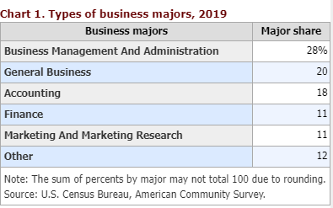
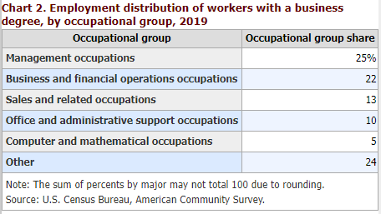

What is the labor market demand for the proposed program nationally and within the State of Connecticut? (Attach completed Hanover Market Analysis.)

Hanover Research conducted a market study for this program and according to that report estimated employment in 2018 is 45,045 and 2,774,300 jobs in the state and nation, respectively, and the projected employment for 2028 is 48,642 jobs in the state and 2,889,300 jobs in the nation. Hence, the labor market demand for this program is promising.
 | State | Regional | National
Estimated Employment (2018) | 45,025 | 194,266 | 2,774,300
Projected Employment (2028) | 48,642 | 203,664 | 2,889,300
Employment Growth, Observed occupations | 8.0% | 4.8% | 4.1%
Total Annual Openings, ObservedOccupations | 4,057 | 17,587 | 218,300
Employment Growth, All Occupations | 5.1% | 3.4% | 3.7%

How does the potential program overlap with and/or complement existing CCSU programs, as well as other programs from CSCU institutions? Are there transfer agreements with other CSCU institutes that will be instituted as a result of this approval?

This program is designed to use a set of current courses from the existing course offerings within the programs in the School of Business and from other colleges, schools, and departments on campus. The program does not overlap with existing offerings, and it will be a complement to CCSU and CSCU programs. The current TAP agreement will be utilized for this BS, thus there is no need for new transfer agreements. Currently, only Eastern Connecticut State University has Baccalaureate Degrees with CIP Code 52.0101.

Is there a natural pipeline for enrollments to this proposed program? If so, please describe.

CSCU community colleges (CC) are expected to be the major natural pipeline for enrollments to the Bachelor of Science in Business. Unlike our current Bachelor of Science program, this program will also attract students with associate degrees in areas other than business studies. In addition to the CC, adult learners in the workforce seeking upskilling and reskilling through flexible programs will provide a second major pipeline.

Describe the potential to generate new enrollments for CCSU (not internal transfers from other programs).

The new degree will attract adult learners holding associate degrees who seek to supplement their existing skillset (upskilling) to advance their current career pathway, and adult learners looking to learn new skills (reskilling) to explore new jobs and career pathways.

How much enrollment do you expect to be drawn from existing CCSU programs (i.e., internal transfers)? Which existing programs would students be most likely to transfer from? Why?

We do not expect that the new program will draw from existing CCSU programs.

Provide enrollments for similar programs at competitor institutions, if available. Include Fall enrollments for the past 5 years.

We were not able to find enrollment data for similar programs at competitor institutions, but we do have the data for conferrals (please see the next question).

Provide conferrals for similar programs at competitor institutions. Include the most recent conferrals for the past 5 years.

Institution - 4-Year or Above | State | Bachelor's Degrees Awarded for 52.0101
 |  | 2015-16 | 2016-17 | 2017-18 | 2018-19 | 2019-20 | 2020-21  (preliminary)
Total |  | 1792 | 1757 | 1763 | 1869 | 1792 | 1628
University of Bridgeport | CT | 33 | 33 | 24 | 31 | 23 | 22
Eastern Connecticut State University | CT | 119 | 104 | 111 | 123 | 81 | 0
University of Connecticut | CT | 61 | 62 | 51 | 51 | 35 | 44
Brandeis University | MA | 56 | 42 | 34 | 37 | 48 | 40
Eastern Nazarene College | MA | 4 | 0 | 0 | 0 | 0
Emerson College | MA |  |  |  | 1 | 33 | 39
Massachusetts Institute of Technology | MA |  | 6 | 7 | 8
Nichols College | MA | 72 | 71 | 70 | 68 | 66 | 83
Northeastern University | MA | 884 | 819 | 871 | 898 | 938 | 874
Regis College | MA | 22 | 20 | 20 | 13 | 16 | 11
Springfield College | MA | 2 | 4 | 11 | 10 | 1 | 1
Suffolk University | MA | 1 | 2 | 0 | 0 | 3 | 2
Western New England University | MA | 12 | 10 | 11 | 13 | 13 | 17
Worcester Polytechnic Institute | MA | 2 | 5 | 5 | 4 | 3 | 2
Framingham State University | MA | 105 | 99 | 84 | 80 | 73 | 72
University of Massachusetts-Dartmouth | MA | 16 | 26 | 26 | 35 | 23 | 18
Westfield State University | MA | 191 | 172 | 205 | 233 | 214 | 148
Worcester State University | MA | 1 | 0 | 1 | 2 | 0 | 0
Husson University | ME |  |  | 0 | 5 | 1 | 9
University of Maine at Fort Kent | ME | 19 | 26 | 13 | 20
University of Maine at Presque Isle | ME | 15 | 18 | 30 | 45 | 52 | 65
Saint Anselm College | NH | 34 | 51 | 66 | 42 | 48 | 47
Plymouth State University | NH | 73 | 67 | 72 | 92 | 84 | 87
University of New Hampshire at Manchester | NH | 28 | 29 | 28 | 31 | 17 | 34
University of Rhode Island | RI | 10 | 4 | 6 | 7 | 3 | 3
Castleton University | VT |  | 73 | 12 | 12 | 16 | 10
Northern Vermont University | VT | 32 | 14 | 5 | 8 | 1 | 0

- What is the estimated total number of credits for the potential program?

Students must earn a minimum of 120 credits for this degree program.

Describe the credit hour allocation between core classes, program electives, program requirements (outside of the program), general education, and unrestricted free electives.

Students earning the Bachelor of Science in Business must satisfy:
- 60 credits in general education and School of Business pre-major courses (A minimum GPA
2.5 required)
- 30 credits Common School of Business Core
- CCSU’s residency requirements (30 credit overall)
- 15 credits General Business Core
- 15 credits in a career-focused pathway (cannot be in one business discipline of the following: ACCT, FIN, MGT, MIS, or MKT)
- 120 total credits required with a minimum of 2.5 over all GPA.

19. List the proposed learning outcomes for the program. Please identify whether outcomes are prescribed by an accrediting body.

The learning outcomes follow those we report to AACSB. On a regular basis we assess the following learning outcomes:
- Communication Skills
CS1: Students will prepare and deliver an effective business document.
CS2: Students will demonstrate comprehension of the business communication process.
- Team Players
TP1: Students provide meaningful contributions to team outcomes.
TP2: Students will describe, identify and explain characteristics of effective teams.
- Ethics and Social Responsibility
ES1: Students can recommend actions consistent with high ethical standards in response to an ethical dilemma.
ES2: Students will identify the impact of business actions and decisions on multiple stakeholders.
- Thinking Skills
TS1: Students will identify appropriate issues for action when faced with a business situation. TS2: Students will gather, interpret and integrate data from across disciplines to solve business problems.

What is the estimated number of new courses which are not currently offered at CCSU?

We expect to have two new courses that focus on business technology and skills.

Would students from other existing programs have the opportunity or interest to take new courses within the potential program? If so, explain.

Yes. The courses offered by this program are open to all students from other colleges/schools within CCSU and CSCU, provided they meet the prerequisite requirements.

Would class size for new courses be limited by factors other than "sound educational principles" (e.g., size of specialized classroom, accreditation requirements, safety issues)? If so, explain.
No, the class size will be at par with the other business courses. Currently, 200-level classes have a size of 35-40 students, 300-level classes have a size of 30-35 students, and 400-level classes have a size of 30 students.

Do we have the expertise to develop and maintain the program? If additional faculty are needed, explain the need, and provide a potential timeline for hire.

The program leverages current courses from existing programs in the School of Business and other departments across campus. Thus, we do not anticipate any issues in developing or running this program, from inception to continued maintenance. However, as the program grows, we may request additional resources (one faculty line) in the third year of the program to keep up with increased demand for this program.

Are there any other aspects of the program that would cause it to be more expensive (e.g., clinical reassigned time supervision for coordination)?

No. This interdisciplinary program needs a director to oversee the application process, admission, advising students and helping with the classes. The School of Business has a director for interdisciplinary programs: Business Studies Program; an additional 10.12 money of $6,000 will be needed.

Describe special facilities needs for the potential program. Are there sufficient classrooms (including computer classrooms) and faculty offices to support the program?

No, this program will run based on the current resources that we have, and no special facilities are needed. One office space will be needed for the director for interdisciplinary programs

Describe any special technological needs for the potential program.

None, this program will be using current resources and does not require any special technologies.

Describe any special laboratory equipment needed to implement and maintain the potential program.
None. It does not require any laboratory equipment or such to implement and maintain the program.

Is additional funding required to address the needs described in your responses to #s 25- 27? If so, explain.
None.

Please complete the Excel worksheet that estimates operational expense.

CENTRAL CONNECTICUT STATE UNIVERSITY
NEW PROGRAM PROPOSAL ROUTING SHEET (form created November 15, 2021)
GENERAL INFORMATION
Name of New Program and Credential |  |  |  |  |  | Bachelor of Science in Business Analytics
FACULTY CONTACT(S) (Name, Dept, College/School) |  |  |  |  |  | The School of Business interdisciplinary programs
CHAIR CONTACT(S) (Name, Dept, College/School) |  |  |  |  |  | Dr. Chris Lee, School of Business
DEAN’S OFFICE CONTACT(S) (Name, Dept, College/School) |  |  |  |  |  | Dr. Joseph Farhat, School of Business
REASON FOR NEW PROGRAM
New offering |  | □ Concentration becoming  standalone program |  | □ Program coming off suspension  (requires #6 for Concept Paper) |  |  |  | □ Program reinstated after discontinuation  (requires #6 for Concept Paper)
CONCEPT PAPER
Required Signatures |  |  |  |  | Signature |  |  |  | Date
1. Faculty Contact(s) |  |  |  |  | This Degree is hosted by the school, not Department
2. Department Chair(s) |  |  |  |  | This Degree is hosted by the school, not Department
3a. Dean(s) |  |  |  |  | Dr. Joseph Farhat |  |  |  | 1/19/2022
3b. AVP-GSRFD, if graduate level |  |  |  |  | N/A
4. Provost submittal to IPC Portal |  |  |  |  | Dr. Kimberly Kostelis |  |  |  | 1/26/2022
5. Chair, Integrated Planning Council
6. Provost submittal to System Office (if applicable)
NEW PROGRAM PROPOSAL
Required Signatures |  |  | Attestation |  |  |  | Signature |  | Date
1. Faculty Contact(s) |  |  | I verify that the information in this proposal is  accurate to the best of my knowledge.
2. Department Chair(s) |  |  | I verify that this proposal was prepared and  reviewed in accordance with Department bylaws.
3. Dean(s) / AVP-GSRFD |  |  | I support this proposal.
4. Chair, Curriculum Committee |  |  | The Curriculum section is consistent with the proposal approved by the Curriculum Committee  and by Faculty Senate.
5a. Chair, Academic Standards or Graduate  Studies Committee |  |  | The admission standards of the program have been approved by the Committee and by Faculty Senate.
5b. Chair, Information  Technology Committee |  |  | The ITC has been informed of or has reviewed and  approved the proposal.
5c. Chair, Facilities Planning  Committee |  |  | The FPC has been informed of or has reviewed and  approved the proposal.
5d. VP of Equity and  Inclusion |  |  | I have reviewed the portion of the proposal related  to equity.
5e. AVP of Planning and Institutional Effectiveness |  |  | I have reviewed the learning outcomes, plan for external accreditation (if applicable), and labor  market analysis/demand.
5f. Director of Library  Services |  |  | I have reviewed portions of the proposal that have  implications for the Library.
5g. AVP of Enrollment Management |  |  | I have reviewed portions of the proposal related to recruitment, admission practices, enrollment  projections, and marketing.
5h. Chief Budget and  Compliance Officer |  |  | I have reviewed the pro forma budget.
6. Chair, University Planning  & Budget Committee |  |  | The committee has reviewed the proposal and the  proposal has been uploaded to the IPC portal.
7. Chair, Integrated Planning  Committee |  |  | The committee has reviewed and approved the  proposal.
8. Provost |  |  | The proposal has been submitted to the System  Office.

CONCEPT PAPER
Bachelor of Science in Business Analytics – On ground and Hybrid
January 2022
Program Contact: Dean Joseph Farhat

General Information

- Program Name: Bachelor of Science in Business Analytics – On ground and Hybrid

Credential: BS

- Target Semester for Implementation: Fall 2023/ Fall 2022 (Pilot)

- Home Department: Business Studies Programs (interdisciplinary programs) in the School of Business

Briefly describe the potential program, including proposed concentrations or areas of specialization.

B.S. in Business Analytics Program is designed to fulfill the educational needs of students who want to pursue their career in business analytics. The proposed program offers similar quality business education as the six specialized business degrees (AC, BUS, FIN, MIS, MGT, MKT) while allowing students a broader education in business and preparing them for business analytics-related positions in organizations. The B.S. in Business Analytics degree program includes:
- Common Business Core (30 credits)
- Business Analytics Core (15-18 credits)
- Career-focused Analytics tracks [concentrations] (12-15 credits)
This is an interdisciplinary program. In addition to the ten standard business core courses, two to three core courses are from Data Science (DAT 101, 102, 202, assuming they will be 3 credits each) and three core courses are from business courses. The courses that make up the program will be offered in flexible formats, including on-ground, H hybrid, and online, to support the scheduling flexibility demanded by our student population.

Credits
30 | COMMON BUSINESS CORE
3 | AC 211 Introduction to Financial Accounting
3 | AC 212 Introduction to Managerial Accounting
3 | FIN295 Managerial Finance
3 | LAW 250 The Legal and Ethical Environment of Business
3 | MC 207 Managerial Communication I
3 | MGT 295 Fundamentals of Management and Organizational Behavior
3 | MIS 201 Introduction to Management Information Systems
3 | MKT 295 Fundamentals of Marketing
0 | BUS 480 Capstone Seminar
3 | MGT 480 Strategic Management
3 | BUS 295 Additional School of Business requirement
15-18 | Business Analytics CORE
6-9 | DATA 101, DATA 201, DATA 202

3 | MIS 315 Database Management Systems
3 | BUS 295 Intro to Business Analytics- NEW
3 | BUS xxx Business Applications Certification/ Lab-- NEW

This career-focused interdisciplinary program allows students to pursue their careers in various industries based on their career aspirations.
We propose to offer the following interdisciplinary career-focused Analytics tracks – (courses are subject to change as we move on to the curriculum design stage)

Marketing Analytics - Career-focused Analytics track
MKT 305, Consumer Behavior
MKT 373, Marketing Research
MKT 380, Market Data Analysis
MKT 450, Marketing Analytics
The 4 MKT courses are already part of the major
Accounting Analytics - Career-focused Analytics track
AC 300 Intermediate Accounting I
AC 335 Accounting Analytics and Professional Competencies
AC 340 Accounting Information Systems
The 3 AC courses are already part of the major
Financial Analytics - Career-focused Analytics track
FIN 301 Intermediate Managerial Finance
FIN 440 Financial Modeling and Analytics
NEW course
The 2 FIN courses are already part of the major
Management Analytics - Career-focused Analytics track
MGT 333, Operations Management
MGT 348, Management Systems
NEW course
The 2 MGT courses are already part of the major
Business Informatics and Intelligence - Career-focused Analytics track
MIS 400 Business Analytics and Decision Support
MIS 450 Enterprise Strategies and Transformations
MIS 463 Analytics Applications
The 3 MIS courses are already part of the major
Sports Analytics - Career-focused Analytics track
NEW course
NEW course

ECON 360 Sports Economics
JRN Data Analysis for Sports Journalism
Two courses are already on the books as part of other departments’ offerings (ECON, JRN, PE, EX). interdisciplinary with (1) B.S. in Exercise Science, (2) B.S. in Physical Ed., B.A. in Economics, and (3)
B.A. in Journalism – Sports Journalism.
Healthcare Data Analytics - Career-focused Analytics track
NEW course
NEW course
NEW course
ECON 340 Health Economics
One course is already on the books as part of other Econ departments offering. Interdisciplinary with CLASS, SEST, and SEPS
Data Science - Career-focused Analytics track
Data I
Data II
Data II
Multi/interdisciplinary with SEST
Business Analytics -Individualized Career-focused Analytics track
3- 4 courses approved by the advisor
Multi-interdisciplinary with CLASS, SEST, and SEPS

To avoid the low concentration enrollment trap, we are not planning to enter all these tracks as official concentrations in the curriculum system.

Would the program pursue external, discipline-specific accreditation? If so, identify the accrediting body and timeline for accreditation.
The program will pursue external accreditation by AACSB. AACSB currently accredits all existing School of Business programs (B.S. in AC, FIN, MKT, MGT, and MIS; MBA; MSA). While AACSB accreditation specifies that the B.S. in Business Analytics is accredited as soon as we offer it, we will have to include it in the ensuing accreditation continuous improvement review, and at that time address all aspects of accreditation requirements including faculty qualifications, faculty sufficiency, assurance of learning, and the three pillars of AACSB accreditation: Innovation, Impact, and Engagement. As our upcoming Continuous Improvement Review is scheduled for Fall 2023, we expect to include B.S. in Business Analytics in the accreditation review process for Fall 2028 as an inclusion of a new program. AACSB views our undergraduate disciplines as one program based on the common curriculum, therefore during the 2028 review we expect this program to also be included under the same undergraduate program umbrella for accreditation purposes. Furthermore, the nature of the Fall 2023 review allows us the opportunity to use the expertise of the peer-review team as we plan for including this program in the 2028 review.

Would the potential program qualify students for professional licensure or industry certification? If so, describe.
Not directly, but we are proposing a course in the core titled “Business Applications Certification” where the students will earn 3 credits if they obtain professional licensure or industry certification (from a pre- approved list of certifications).

How does the potential program align with CCSU’s mission and strategic plan?

Overall, this program will help CCSU increase access to higher education (Goal 2) and ensure sustainability for the future (Goal 5). This program will increase adult learners’ access to higher education to help them with workforce upskilling and reskilling to meet job market needs and will increase the supply of the entry- level workforce to Connecticut and neighboring states. As a new highly demanded major, we expect that this major also will attract new students and improve long-term enrolment.

- What potential jobs would students who earn the proposed credential be qualified to hold? Students who earn a bachelor’s degree in Business Analytics should be particularly strong candidates in the job market because of the continuing need in the marketplace for managers/analysts with strong analytical skills. They can hold a broad range of employment opportunities in government, management, financial services, marketing, healthcare, sports analytics and human resources. The knowledge, skills, and abilities students develop at CCSU will ensure that they are prepared to bring value to any of the professional roles.

According to Hanover Research’s market analysis in 2020, New England employers posted a total of 27,312 Business Analytics-related job listings, and about 82.7% of the listings required a bachelor's degree. Some of the fastest-growing, most in-demand positions in the marketplace include:

  - Business Analysis Specialist: Business analysis specialists provide IT solutions for organizations by using software to process analytics. They develop software applications for analysis and design data models to collect data. A bachelor’s degree in Business Analytics or a related field is usually required for this profession.
  - Operations Management Analyst: Operations management analysts help organizations make decisions and solve complex issues by using statistical analysis, simulations, predictive modeling, and other mathematical methods. These professionals gather and interpret data on product/service design, production schedules, pricing, and supply chain management. Many operations management analysts have a degree in business analysis or a related field.
  - Market Research Analyst: Market research analysts collect and analyze consumer data to help businesses to study market conditions and promote their products or services. They organize and interpret data on consumer demographics, preferences, and buying habits by using statistical and programming techniques. Many market research analysts have a degree in business administration and have taken coursework in statistics or computer science.
  - Logistics Analyst: Logistics analysts are typically responsible for overseeing procurement, inventory, transportation, and warehousing for a business’s supply chain. They use software to track purchasing, control inventory, and monitor supply chain systems. Many of these professionals have a degree in business administration and require strong business analytics skills.

Business Analytics graduates can also consider pursuing jobs like:
  - Data Analyst/Scientist/Engineer
  - Business Intelligence Manager/Analyst
  - Data Visualization Analyst
  - Decision Science Analyst
  - Marketing Strategy Consultant
  - Pricing and Revenue Optimization Analyst
  - Retail Sales Analyst
  - Fraud Analyst

What is the labor market demand for the proposed program nationally and within the State of Connecticut? (Attach completed Hanover Market Analysis.)
Job demand for business analytics professionals has been staying high despite the economic recession because of the pandemic. For instance, in the first half of 2020, there was a total of 27,312 business analytics-related job postings in the New England region alone. The top locations are Boston, MA (3,939

jobs), Hartford, CT (880 jobs), Cambridge, MA (710 jobs), and Stamford, CT (584 jobs). According to Hanover Research, which conducted a market study for B.S. in Business Analytics program, it is expected that the growth of business analytics-related jobs stays strong regardless of geographic levels. They found that 46 percent of global business professionals expect that there will be a shortage of business analytics professionals across all industries. For instance, employment growth for business analytics-related jobs is expected to be steady until 2026. Specifically, CT expects 5.9% employment growth while the entire U.S. expects 5.2% employment growth in business analytics-related fields. Higher employment growth for business analytics jobs in Connecticut compared to the national average is mainly because there are many insurance, investment, and healthcare companies that are highly dependent upon data-driven decision- making.

A high number of business analytics job postings is attributed to the continuous demand for trained professionals who can make data-driven decision-making. All business fields, regardless of industry, are now becoming highly dependent upon business analytics professionals because they help companies collect and use business data strategically. Specifically, these business analytics professionals are trained to transform unorganized raw data into valuable information, by which companies understand underlying business trends and prepare their future strategy. For instance, job titles requiring these business analytics capabilities are ‘business analyst,’ ‘financial analyst,’ or ‘data analyst.’

Business analytics professionals are unique because they should have strong skills in data analysis as well as a robust understanding of business and industry. Because of this uniqueness, it is not easy to train good business analytics professionals in the short term. Thus, qualified business analytics professionals meeting this standard are in high demand, while the pool of qualified business analytics professionals is still highly limited.
Consequently, considering both employment projections for business analytics professionals and companies’ increasingly data-driven decision making, we can conclude that there is a strong demand for
B.S. in Business Analytics program. This demand is highly likely to stay strong in both the State of Connecticut and the entire U.S.
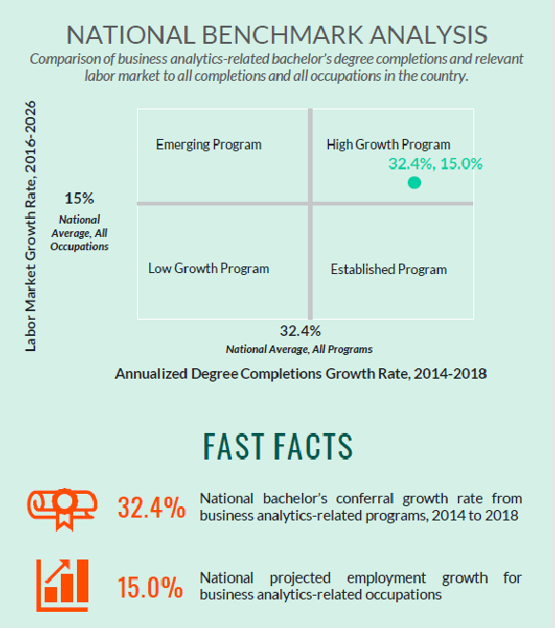

How does the potential program overlap with and/or complement existing CCSU programs, as well as other programs from CSCU institutions? Are there transfer agreements with other CSCU institutes that will be instituted as a result of this approval?

This program is designed to use a set of current courses from the existing course offerings within the programs in the School of Business and from other colleges, schools, and departments on campus. The program does not overlap with existing offerings, and it will be a complement to CCSU and CSCU programs.
The current TAP agreement will be used for this BS, thus there is no need for new transfer agreements.

Is there a natural pipeline for enrollments to this proposed program? If so, please describe.
- CSCU community colleges (CC) are expected to be the major natural pipeline for enrollments to the
B.S. in Business Analytics degree program. Unlike our current Bachelor of Science program, this program will also attract students with associate degrees in areas other than business studies (e.g., the AS in Data Science at Northwestern, Gateway, Tunxis, Capital, and Three Rivers.)
- In addition to the CC, adult learners in the workforce seeking a career in the business analytics field will provide a second major pipeline.
- A strong demand for business analytics jobs will attract high school graduates to the proposed program.

Describe the potential to generate new enrollments for CCSU (not internal transfers from other programs).
The new degree will attract adult learners holding associate degrees who seek a job in the business analytics area or to supplement their existing skillset (upskilling) to advance their current career pathway, and adult learners looking to learn new skills (reskilling) to explore new jobs and career pathways in the business analytics areas.

Year | Expected New Admits | Expected Enrollments
Fall 2022(Pilot) | 20 | 20
Fall 2023 | 23 | 43
Fall 2024 | 23 | 66
Fall 2025 | 32 | 98
Fall 2026 | 32 | 130
Fall 2027 | 36 | 166

How much enrollment do you expect to be drawn from existing CCSU programs (i.e., internal transfers)? Which existing programs would students be most likely to transfer from? Why?

We do not expect that the new program will draw many students from existing CCSU programs.
Existing CCSU programs | Internal transfers (Fall 22/23)
MIS | 8
Other | 12
Total | 20

Provide enrollments for similar programs at competitor institutions, if available. Include Fall enrollments for the past 5 years.
As Business Analytics is an emerging field and the CIP Code for Business Analytics (30.7102) is new as of 2020, it is difficult to find data that directly translate into enrollment estimates.

30.71) Data Analytics.
- 30.7101) Data Analytics, General.
- 30.7102) Business Analytics.
- 30.7103) Data Visualization.
- 30.7104) Financial Analytics.
- 30.7199) Data Analytics, Other.

In Connecticut, the following universities are offering bachelor's degree programs in Business Analytics (some schools offer BS in Data Analytics/Data).
- Quinnipiac University - BS in Business Analytics
- The University of New Haven- BS in Business Analytics
- The University of Hartford- BS in Business Analytics and Managerial Economics
- The University of Connecticut – BS in Business Data Analytics
- University of Bridgeport- BS in Data Analytics
We were not able to find enrolment data for most of them as they are either recent programs or data is not publicly available. Please note that Data Science is under a different CIP.

30.70) Data Science.
- 30.7001) Data Science, General.
- 30.7099) Data Science, Other.

The number of enrollments for similar programs at UConn-Storrs & regional campuses in Fall 2020 is about 352 as shown below:

Similar Programs | Storrs | Hartford | Stamford | Waterbury | Total
Business Data Analytics | NA | 30 | 32 | 14 | 76
Digital Marketing & Analytics | 24 | 23 | 52 | 1 | 100
Business Engineering – Analytics | 176 | NA | NA | NA | 176
Total | 200 | 53 | 84 | 15 | 352

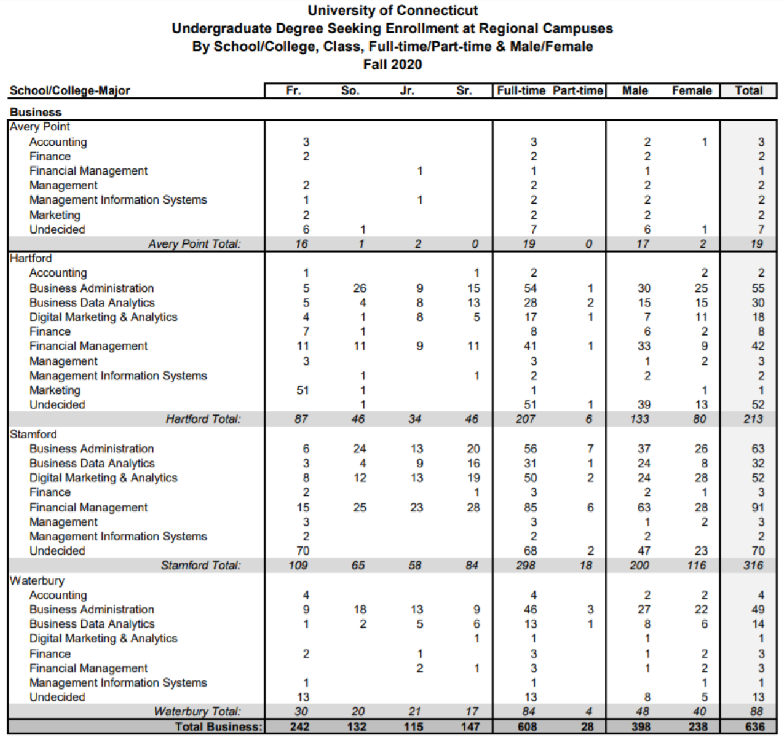
Source: https://oire.uconn.edu/wp-content/uploads/sites/35/2021/01/Regionals20major.pdf

Source: https://oire.uconn.edu/wp-content/uploads/sites/35/2020/12/StorrsTrendTable_Fall20.pdf
University of Connecticut Storrs Campus
Undergraduate Business Program Enrollment Data (Fall 2011 – Fall 2020)
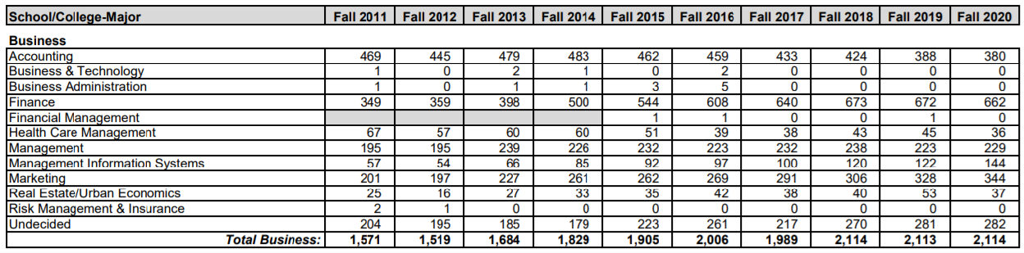

Source: https://oire.uconn.edu/wp- content/uploads/sites/35/2021/01/Majors_Duals_Doubles_Minors_Storrs_FA20.pdf University of Connecticut Storrs Campus
Undergraduate Business Program Enrollment Data (Fall 2020)
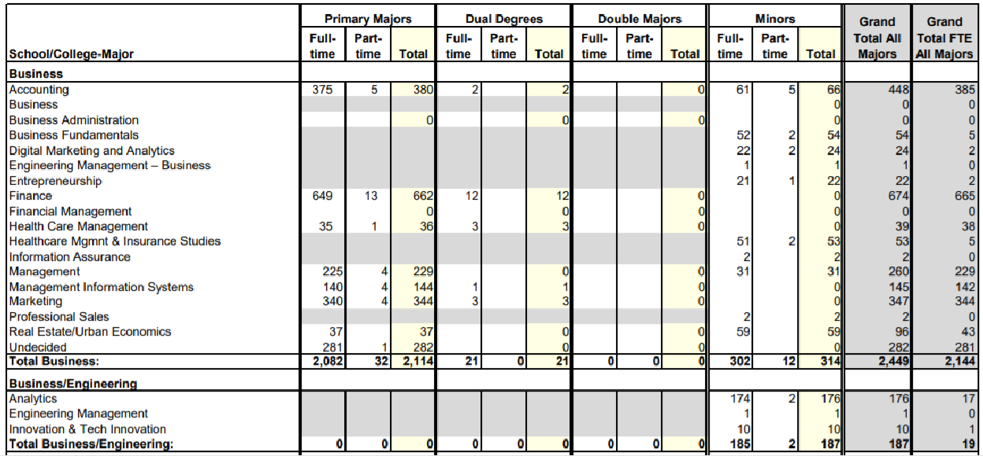

Source: https://oire.uconn.edu/wp-
content/uploads/sites/35/2021/01/Majors_Duals_Doubles_Minors_Hartford_FA20.pdf
University of Connecticut Hartford Campus Undergraduate Business Program Enrollment Data (Fall 2020)
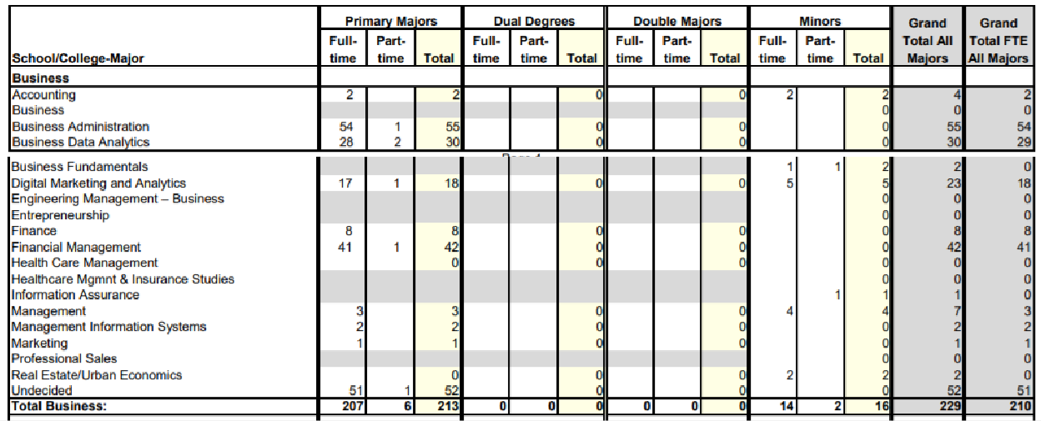

It is estimated that the business analytics program at the University of Hartford has about 100 enrollments.
University of Hartford Barney School of Business
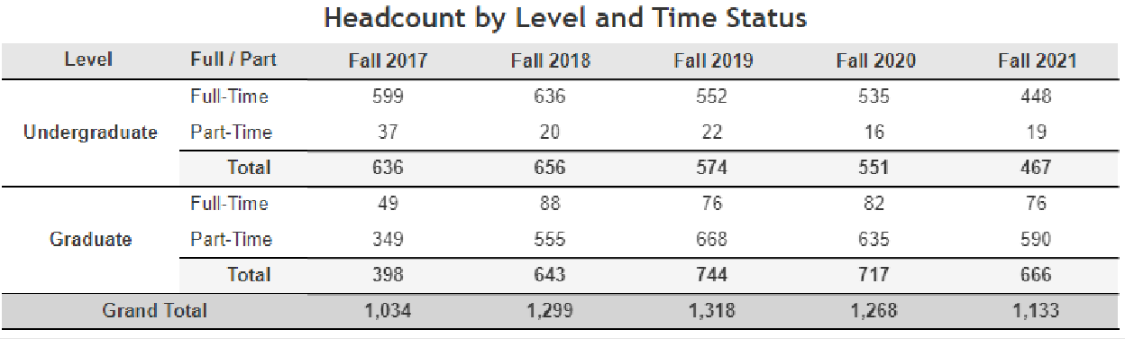
Source: https://www.hartford.edu/about/offices-divisions/institutional-effectiveness/fact- book/enrollment.aspx

Provide conferrals for similar programs at competitor institutions. Include the most recent conferrals for the past 5 years.

As Business Analytics is an emerging field and the CIP Code for Business Analytics (30.7102) is new as of 2020, it is difficult to find data that directly translate into conferrals estimates. The number of conferrals for similar programs at UConn for the past 5 years is about 182, as shown below:

 | 2015-16 | 2016-17 | 2017-18 | 2018-19 | 2019-20 | Total
Business & Technology | 39 | 27 | 0 | 0 | 0 | 66
Business Data Analytics | NA | NA | 27 | 26 | 14 | 67
Digital Marketing & Analytics | 1 | 8 | 17 | 8 | 15 | 49
Total | 40 | 35 | 44 | 34 | 29 | 182

Source: https://oire.uconn.edu/wp- content/uploads/sites/35/2020/12/Degr10yr_summary_sch_level_2011_2020.pdf
UConn Degrees Conferred, 2010-11 through 2019-20 and Ten-Year Total
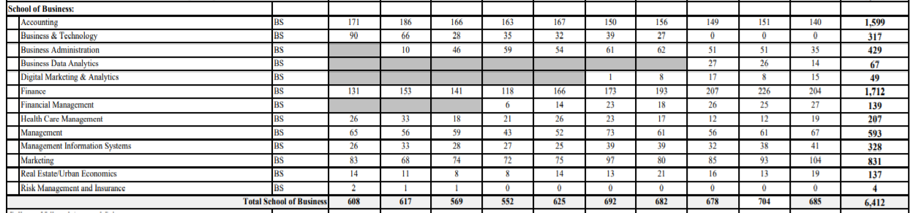

What is the estimated total number of credits for the potential program?
Students must earn a minimum of 120 credits for this degree program.

Describe the credit hour allocation between core classes, program electives, program requirements (outside of the program), general education, and unrestricted free electives.

Students earning a Bachelor of Science in Business Analytics must satisfy:
- 60 credits in general education and School of Business pre-major courses (A minimum GPA 2.5 required)
- 30 credits Common School of Business Core
- CCSU’s residency requirements (30 credits overall)
- 15 -18 Business Analytics Core
- 12-15 credits in Career-focused Analytics tracks
- 120 total credits required with a minimum of 2.5 overall GPA.

List the proposed learning outcomes for the program. Please identify whether outcomes are prescribed by an accrediting body.
The learning outcomes follow those we report to AACSB. On a regular basis we assess the following learning outcomes:
  - Learning Goal 1. Communication Skills (CS):
    - Learning Objective CS1: Students will prepare and deliver an effective business document.
    - Learning Objective CS2: Students will demonstrate comprehension of the business communication process.
  - Learning Goal 2. Team Players (TP):
    - Learning Objective TP1: Students provide meaningful contributions to team outcomes.
    - Learning Objective TP2: Students will describe, identify and explain characteristics of effective teams.
  - Learning Goal 3. Ethics and Social Responsibility (ES):
    - Learning Objective ES1: Students can recommend actions consistent with high ethical standards in response to an ethical dilemma.
    - Learning Objective ES2: Students will identify the impact of business actions and decisions on multiple stakeholders.
  - Learning Goal 4. Thinking Skills:
    - Learning Objective TS1: Students will identify appropriate issues for action when faced with a business situation.
    - Learning Objective TS2: Students will gather, interpret, and integrate data from across disciplines to solve business problems.

What is the estimated number of new courses which are not currently offered at CCSU?
We expect to create 9 new courses for the proposed program:
  - 1 course – Introduction to Business Analytics
  - 1 course – Business Analytics Capstone (Certifications/Lab on current tools, software)
  - 1 course in the Management Analytics area
  - 2 courses in the Sport Management/ Analytics area
  - 3 courses in Healthcare /Analytics areas
  - 1 course in the Financial Analytics area

Would students from other existing programs have the opportunity or interest to take new courses within the potential program? If so, explain.
Yes. The courses offered by this program are open to all students from other colleges/schools within CCSU and CSCU, provided they meet the prerequisite requirements.

Would class size for new courses be limited by factors other than "sound educational principles" (e.g., size of specialized classroom, accreditation requirements, safety issues)? If so, explain.
No, the class size will be at par with the other business courses. Currently, 200-level classes have a size of 35-40 students, 300-level classes have a size of 30-35 students, and 400-level classes have a size of 30 students.

Do we have the expertise to develop and maintain the program? If additional faculty are needed, explain the need, and provide a potential timeline for hire.
In the first year, we will need one faculty line. The faculty in this line will teach multiple sections of BUS
- Introduction to Business Analytics and BUS – Business Analytics Capstone (Certifications/Lab on current tools, software). In the second year, another line is needed to maintain the expansion of the program. The new faculty may contribute to teaching a business analytics course(s) in the MBA/MSA programs at CCSU.

Are there any other aspects of the program that would cause it to be more expensive (e.g., clinical reassigned time supervision for coordination)?
Maintaining a highly quality Business Analytics program requires an annual investment in data analytics software and an annual investment in Business databases. We expect that there will be a special fee for this program that can partially cover the extra cost of maintaining this program.

Describe special facilities needs for the potential program. Are there sufficient classrooms (including computer classrooms) and faculty offices to support the program?
The new program will use the newly built Business Analytics and Research Lab. The nature of the new program is hands-on; thus, computer classrooms are needed for most of the new program core classes. In addition, a collaboration room equipped with 4 to 6 PCs, databases and data analytics software will be needed. Currently, we are working on building the Banking and Finance Collaboration Room, this room may be used as a collaboration room for students in the new program.

Describe any special technological needs for the potential program.
Initially, there are no special technological needs for the B.S. in Business Analytics program. As the program grows, we may upgrade the data analytics software or buy new software and business databases.

Describe any special laboratory equipment needed to implement and maintain the potential program.
None. There is no need for any special laboratory equipment to implement and maintain the program.

Is additional funding required to address the needs described in your responses to #s 25-27? If so, explain.

Some capital funding may be needed to maintain the equipment (PCs, Monitors, Printers…) in the Business Analytics and Research Lab and the collaboration rooms.

Please complete the Excel worksheet that estimates operational expenses.

Please refer to the Excel file named “BS in Business Analytics Fiscal Project.xlsx.”

