Fixed vs. Growth Mindset
Obejctive: To learn the differences between growth and fixed mindset to better understand the impact mindset has on academic performance

First, indicate whether you mostly agree or disagree with each of the following statements.
Agree Disagree Your intelligence is something very basic about you that you cannot change much.
Agree Disagree You can learn new things, but you cannot really change how intelligent you are.
Agree Disagree No matter how much intelligence you have, you can always change it quite a bit.
Agree Disagree You can always substantially change how intelligent you are.

Do you have a Growth Mindset or a Fixed Mindset?
The following diagram shows the different thinking patterns and behaviors associated with each mindset. Use this diagram to reflect on your responses to the questions above.
How have your ways of thinking impacted your own academic performance?
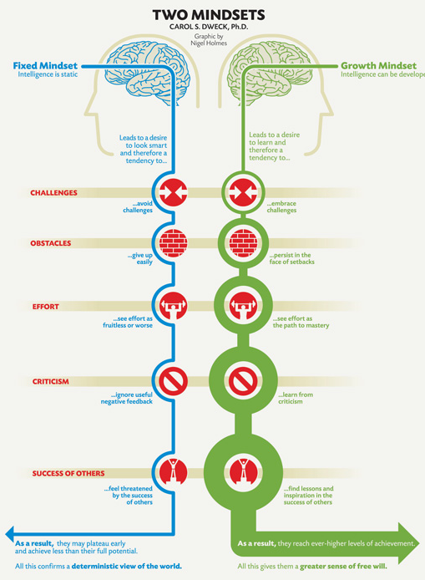

© Carol S. Dweck, Ph.D.

