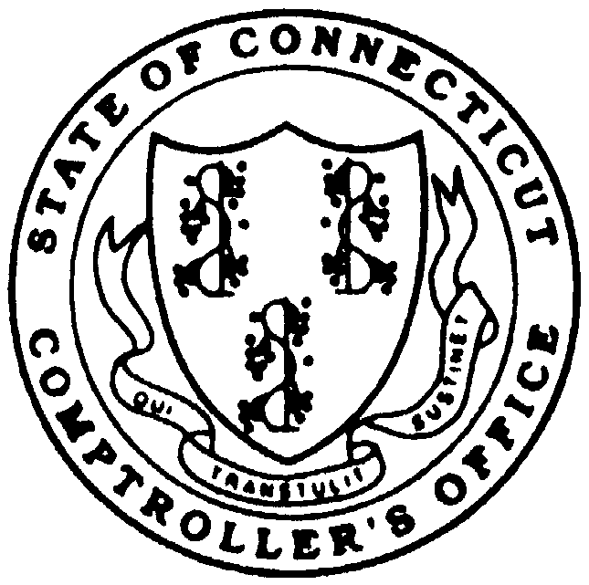

MARRIED

BIWEEKLY
SEMI-MONTHLY
MONTHLY
FIVE PAY

MID YEAR ELECTION/CHANGE ELECTION AMOUNT
NEW HIRE
ADOPTION
MARRIAGE
DEATH
BIRTH
SPOUSE EMPLOYMENT CHANGE
DIVORCE
OTHER
DEPENDENT CARE ASSISTANCE PROGRAM
ENROLLMENT FORM
CO-1310 Revised 10/11
AGENCY NAME:
PLAN YEAR: 20_____
MALE__
FEMALE__
SOCIAL SECURITY NUMBER (MUST BE PROVIDED)
EMPLOYEE LAST NAME:
FIRST NAME
MI
STREET ADDRESS
CITY
STATE
ZIP
HOME PHONE NUMBER
HOME EMAIL ADDRESS
DATE OF BIRTH
MARITAL STATUS
DATE OF HIRE
EMPLOYEE ID#
EMPLOYEE RECORD #
SINGLE__
PAYROLL CYCLE
DATE OF FIRST PAYROLL WITHHOLD
MONTH
DAY
YEAR
The following employees are not eligible to join the Dependent Care Assistance Program:
- Per Diem, sessional, durational, temporary or seasonal workers, adjunct faculty members, graduate
assistants, and employees who are working, or are expected to work, less than 0.5 full time equivalent.
- Employees on unpaid leave for any reason.
- Former employees and rehired retirees.
****ENROLLMENT SUBJECT TO ELIGIBILITY VERIFICATION****
OPEN ENROLLMENT ELECTION AMOUNT
$
ANNUAL AMOUNT
$
REVISED ANNUAL AMOUNT
For Mid Year Enrollment Status Change Election, please check applicable event:
I hereby authorize the State of Connecticut to reduce my gross salary before federal, state and Social Security taxes are withheld by the total annual election amount elected above and affirm my understanding that:
*My election is irrevocable and can not be changed during the plan year, unless I experience a qualifying
change in family status, as defined by the Internal Revenue Code Section 105. Any election changes must be
made within 31 days of the qualifying event.
*Changes will be processed on the check date following receipt of the Enrollment/Change Form pursuant to the
Payroll Cut-off Date Schedule.
*Money in the DCAP account may only be used to reimburse expenses for eligible expenses actually incurred
during the plan year.

I certify that the above information is correct and true and any dependents for whom I have selected the dependent care benefit reside with me in a parent-child relationship and/or are legally dependent on me for their support. I certify that I will not deduct on my tax returns any expenses reimbursed by my DCAP and that I will collect and maintain documentation for claim substantiation.
I understand that any amounts remaining in my DCAP account that have not been used for eligible expenses incurred during the plan year (January 1 - December 31) must be claimed by March 31 of the following year or they will be forfeited in accordance with plan provisions and Internal Revenue Code requirements.
Employee Signature
Date
KEEP A COPY FOR YOUR RECORDS
MAIL OR FAX COMPLETED FORM TO: Progressive Benefit Solutions, LLC (PBS), 23 Maiden Lane, North Haven, CT 06473
FAX: (203) 234-1139 Phone: 1-866-906-8023

