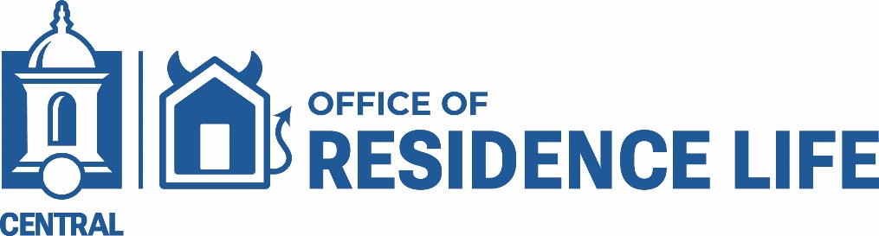

Important Overnight Orientation Information for Central Connecticut State University Freshmen Students.

Attention Class of 2030! As you embark on your overnight orientation, we're thrilled to welcome you to Central - the vibrant home of the Blue Devils!

From meeting like-minded peers to getting familiar with the campus, your two-day overnight experience has it all! You'll get an inside look at the residence halls and discover the unique traditions and culture of our amazing community.
So, get ready to have an awesome orientation experience and start building memories that will last a lifetime! Welcome to Central, new Blue Devils!

Check-in for your overnight stay on-campus:

Reminder: You and other students will be staying in Mid-Campus Residence Hall for your overnight visit and will be assigned a roommate. This is a great opportunity to meet other new Central students and begin making connections. All students must check in and check out with a Residence Life staff member when arriving at or departing from campus housing. This process helps ensure a smooth transition, allows us to accurately track occupancy, and enables staff to assist with any last-minute needs.
Note: If you need accommodations for a documented disability or chronic health condition, please contact the Office of Accessibility Services to discuss your needs. They can be reached at AccessibilityServices@ccsu.edu or 860-832-1952.
What to bring:
- Twin-bed sheets (extra-long), blanket or sleeping bag, pillow, and towels.
- Toiletries (toothbrush, toothpaste, shampoo, soap, shower shoes, etc.).
- Casual, layered clothing (weather appropriate), and comfortable shoes.
- Cell Phone Charger
- Any essential personal use items
- An open mind, and ready to meet people and have some fun!

Check out on day two: Is between 3:15 pm and 4:00 p.m.
Students, before you leave your Residence Hall, please return your room card to the ResLife staff. All parents and families, please park in the Student Center lot (B) to pick up your student.

Housing Information for the Fall Semester:

- All students: Unfamiliar with the residence hall options? Check out the Residence Halls online.
- Unsure about the costs? Talk to Financial Aid about your options and review the On-Campus Housing costs.
- For those of you who have not yet applied to live on campus, it’s not too late. Please click here follow the steps to enroll, pay the housing deposit and apply for on-campus housing.
Fall Residential Students:

- For those of you who have completed the on-campus housing application process, please make sure to regularly check CentralPipeline for your Central email, and MyHousing, as well as the Residence Life webpage, for updates on housing placement, along with other important housing information.
- **Please visit the Residence Life table at the Campus Services Resource Fair in the Student Center between 9:00 AM and 10:00 AM to pick up your housing packet.

Reminders: Please submit all completed Health forms to Student Wellness Services by July 15. Please submit your health forms by uploading them to the Medicat Portal or scan the QR code below. You will have an opportunity to ask Student Wellness Services staff questions on your Orientation Day. For more information, please review these forms.
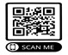

- Remember, you are now officially a student @ Central, and will need to abide by the rules and policies of the Central community! Before you arrive for our Overnight Orientation, we recommend that you review the Central Student Handbook.
While staying on campus, please remember:

- No drugs or alcohol.
- No smoking in the residence halls, including e-cigarettes/vaporizers.
- No tampering with fire equipment. No covering smoke detector heads.
- No restricted items on campus. Please view our listing of Acceptable and Prohibited Items but not limited to.
Central Contact Information: For additional information related to Orientation, please contact New Student Programs at 860-832-1234. For additional questions related to housing, please contact Residence Life at (860) 832-1660.
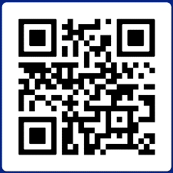
Our main goal is to maintain a safe, happy, and productive community for all students. Also, stay connected and don’t forget to follow us! #LIVEWITHUS!

