University Planning and Budget Committee Meeting of February 3, 2026
1:45 pm – 3:00 pm Davidson Hall 107 (Teams option)
Minutes
J Farhat, S Kazar, E Dlugolenski, J Jarret, L Bucher, K Kostelis, L Jacobson, R Ghodsi, J Aguillar, F Pearson, S Horrax, S Styrczula, Y Kirby, M Bartone, J Whittemore, L Harkness, M Scoggins, L Jacobson
- Approval of minutes from January 20, 2026 – Postponed to 2/17 meeting
- Announcements
  - General – Budget Process Reminder
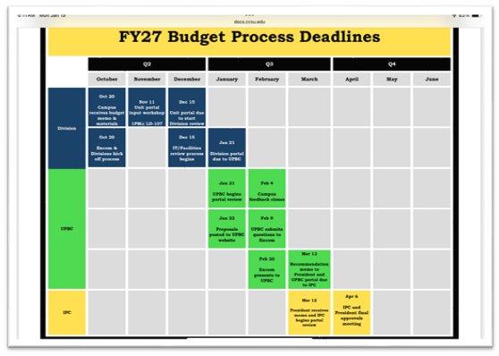
  - IPC – meeting cancelled
  - FPC – James will attend future meetings
- Brief Reports / Division updates
  - Provost
    - CCSU was selected through AASCU (American Association of State Colleges and Universities) as a cohort to explore academic scheduling for student success (received a $20,000 grant)
    - Results will be shared with chairs regarding course scheduling with course mapping and overlaps
    - Applicable to undergraduates and graduates alike
    - Improving scheduling times to encourage student success
  - OIRA
    - Request – Enrollment report, UPBC members will be added to the distribution list
    - Census 5pm 2/11 and final enrollment report will follow
    - 1/26, NECHE president issued letter to the University with impacts of Big Beautiful Bill – July 1, 2026, final rule deadline
    - Impacted offices:
      - Website
      - Financial Aid
      - OIRA – reports, including total cost of each program, success rates, potential professions, IRS data for income – comparing income levels amongst high school, bachelor and graduate degree recipients (concern that lower earning programs might lose access to federal loans and the institution as a whole might be unable to offer financial aid)
      - Information must be published every October 1st
  - CBCO
    - Due to technical setbacks, the deadline for feedback is being pushed back to 2/11/26
    - Next financial update will be available after the census
- Executive Session – 2:41 pm
- Other
- Adjournment

