University Planning and Budget Committee Meeting of January 20, 2026
1:45 pm – 3:00 pm Davidson Hall 107 (Teams option)
Agenda
1. Approval of minutes from December 2, 2025.
2. Announcements
a. General: Jarrett– Budget Process Reminder (see attached schedule): This are going to get busy quickly, the schedule is attached an on the Fiscal Affairs and UPBC website.
b. IPC: Jarrett– Last one was scheduled and then cancelled. The plan was to bring up the IPC pathway that is on the IPC website. Need to find out if there is interest in revising, as it hasn’t been adhered too.
c. FPC: S. Petras - Next meeting is Thursday and the notes will be posted
3. Brief Reports / Division updates
a. Provost: Academic Affairs budgets have been submitted to the portal. Would like to put in more notes but there wasn’t a specific place for that. We put in everything, as we have in the past. There was a note that requests had to be at least $1,000.00 per item or more. A dept asked for $300.00, and it is believed that there may have been other avenues to fund. Another example is asking for 12 $100.00 items, which brings it above the threshold. The thought is that the item should be supported elsewhere, and talk to the CCSU Foundation. Some things are calculators for students, a perfect match for the Foundation. In future, perhaps highlighting or suggesting that items need to be more than $1,000.00. This may have not been official but it has been a practice.
F. Pearson: instead of doing blanket % increase for OE, some Deans wanted each department to be specific before asking for the increase.
K. Kostelis: some of the blanket requests were confusing, some redundancy or overlap. I know you want to see everything even if we don’t support it, but not everything made sense for this process.
J. Farhat: possibility to have partial requests that can be grouped together, because it would be too much to be reviewed.
L. Bucher: lower dollar amounts – many departments leave funds behind each year. This is a place to look. Purchase internally with budget money that isn’t being used. Look elsewhere for smaller amounts or high priority.
Reza: 3D printing lab, outdated. The total is more than $1000 and going with cheaper materials that are still quality printers. Should we be happy that departments are trying to save money, instead of asking for a more expensive equipment so they make it through this process.
K. Kostelis: trying to be realistic and creative with the funds, trying to be thoughtful. Also looking to have this conversation so there can be some consistency across the Deans.
Reza: good convo to have with department chairs.
Farhat: every May and June when we had funds we needed to burn. The budgets used to not be the most up to date, so it wasn’t always easy to know how much money to spend at the end of the fiscal year.
K. Kostelis: there are 07 lab fees that are being attached to help with lab equipment.
J. Jarrett: it’s good because it means people are talking about budgets, but it is important to encourage looking at other funds you could use, but for a grand initiative from a department, they would need to do a good job of communicating with the Provost. We don’t want to spend our time on a few dollars here and there. Deans likely have a discretionary budget.
K. Kostelis: We all need to keep talking about it, blanket increases are difficult. Some may need more than 10%, when cuts had to be made, we went line by line. People need to go back into the weeds and not just a blanket statement, a real justification and what their plan is. More rationale would be easier to support.
L. Bucher: monthly budget reports and transparency in the power BI app, we have a lot of tools so everybody should be able to see what is left in their budget. A blanket increase without a detailed justification makes it hard.
F. Pearson: it sounds like increase in costs isn’t necessary a justification for a blanket increase.
Reza: in engineering sometimes there is uncertainty such as the cost of metal or how many students will pass their prerequisites. Enrollment in the senior projects impacts how much funding is needed, so sometimes they won’t spend all the funds but other times they need more.
b. OIRA Y.Kirby – Do you share the enrollment reports? Brief update on enrollment, up 7.1% compared to last year. Had been up almost 11%. Another snapshot this Weds after 5, census date is February 11. Dual and concurrent enrollment will pick up. Add drop will add to the roller coaster. NSSE will go out to freshmen and seniors. The strategic plan meeting is January 28 2-3:30pm in Founders.
Farhat: motion make a public folder for reports on the UPBC MS Teams, such as enrollment, so we can review prior (Petras) motion passes
c. CBCO L. Bucher – submitted mid-year spending plan on Jan 9 to system office. They will come back with questions. Some conversation to change board meetings dates but they are off from the census data when better information is provided. Last week met with system regarding legislative session Feb 3-6, agenda with a few more asks – prioritize equipment funding. Some funds from FY 22 was not allocated, but would help with equipment and deferred maintenance. Including institutions prior to going to legislature, which is an improvement. Change narrative, CSCU is becoming more accountable, some credibility and institutional knowledge. PACT program, need to plan for FY27.
Budget process - Division heads are finalizing budgets, got some feedback on the tool. A few “stumbling blocks” that have already been fixed. That is due tomorrow, and Lisa’s team will switch everything over to UPBC. Jarrett will get it out to everyone.
F. Pearson – question about free community college specifics, PACT program.
K. Kostelis – no specifics, the presidents are reviewing.
L. Bucher – they need to look beyond 2027 for these students to graduate.
J. Jarrett – regarding budget proposals, we will get access tomorrow. Questions are due Feb 9. Feb 20th ExComm have opportunity to present to UPBC if necessary. March 12 decisions sent.
L. Bucher – reserved a room for discussion on Feb 20, 8am-12pm, possibly Barnard Community Rooms. An email is already drafted so they can weigh in and ask questions. That closes February 4.
4. Executive Session
5. Other
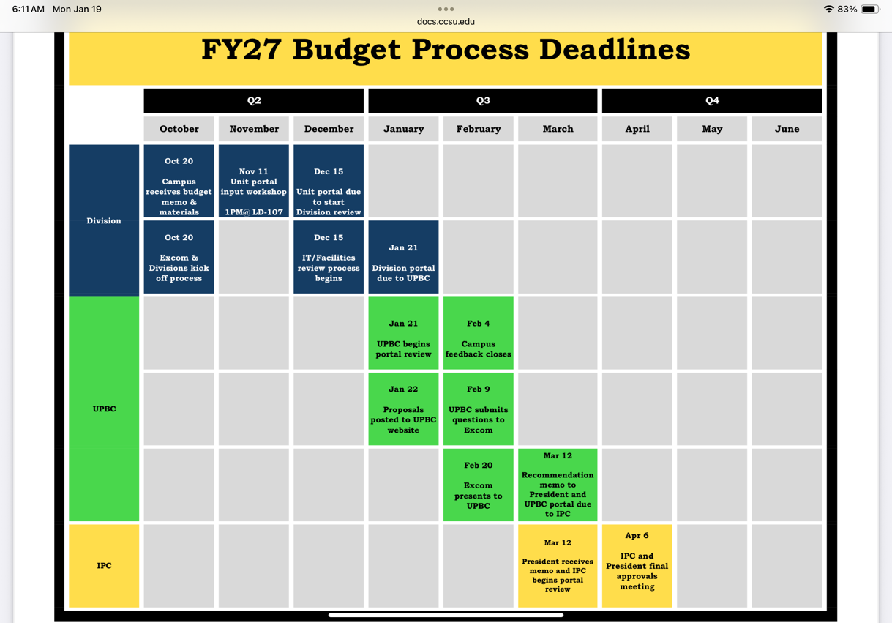
6. Adjournment

