University Planning and Budget Committee Meeting of January 20, 2026
1:45 pm – 3:00 pm Davidson Hall 107 (Teams option)
Agenda
1. Approval of minutes from December 2, 2025.
2. Announcements
a. General – Budget Process Reminder (see attached schedule)
b. IPC
c. FPC
3. Brief Reports / Division updates
a. Provost
b. OIRA
c. CBCO
4. Executive Session
5. Other
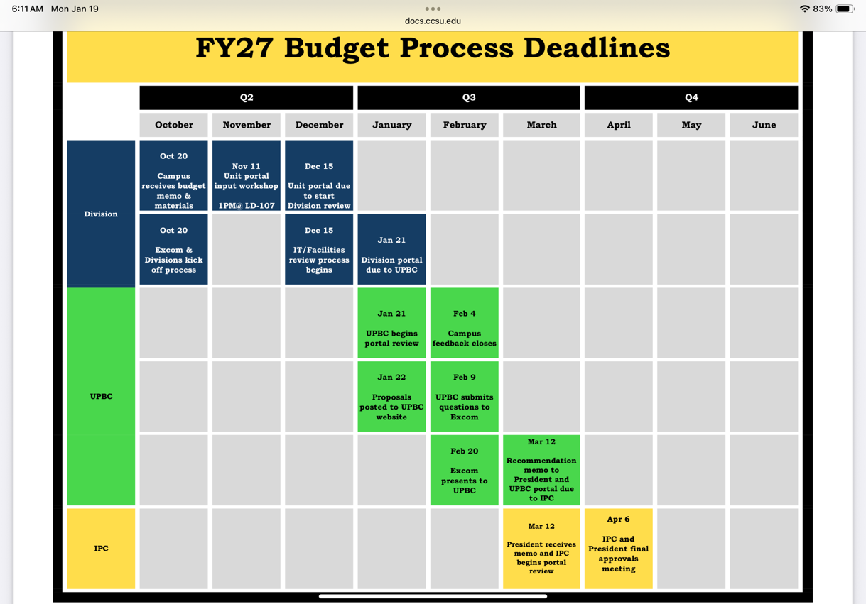
6. Adjournment

