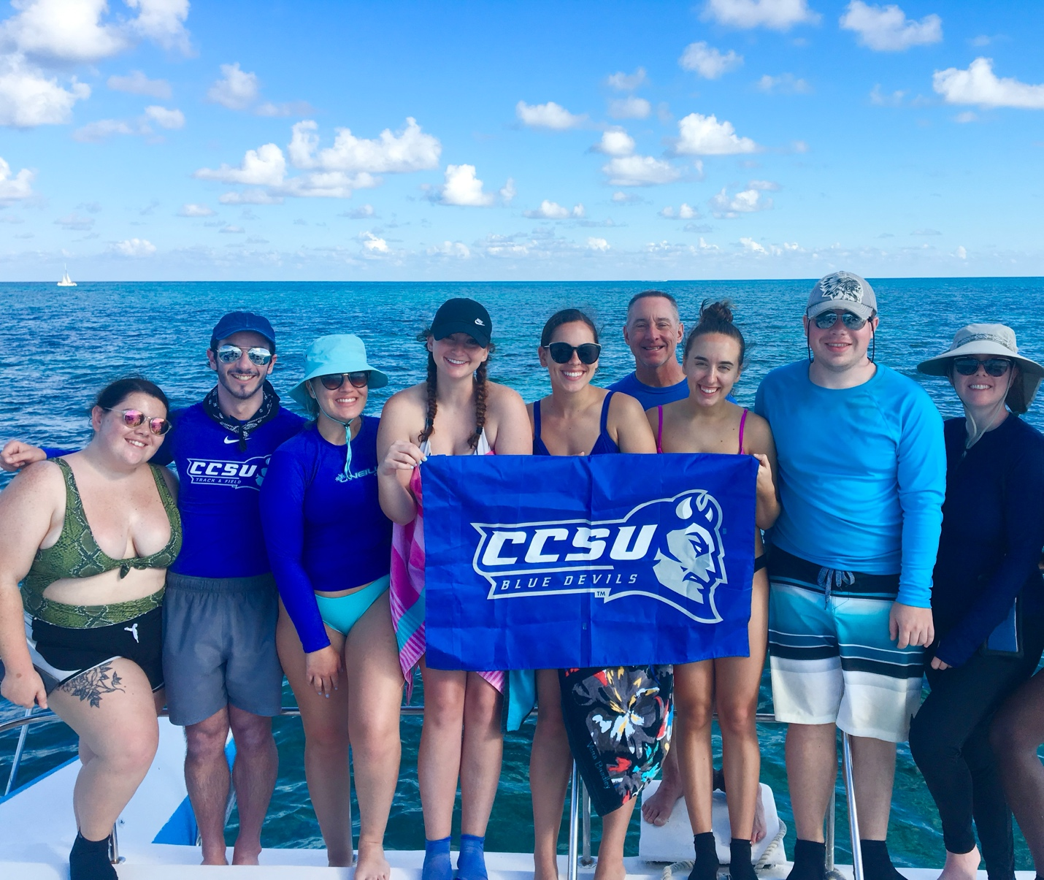
Winter term 2027 – Marine Ecosystems of Belize
Dr. Jarrett and Dr. Kraczkowski plan to offer an international course in early January 2027 to Belize, Central America. Participants will experience coral reef, mangrove, and seagrass habitats along the Belize Barrier reef system and explore Mayan history and culture on the mainland. If you are interested in taking the course or would like to learn more, please follow this link: https://forms.office.com/pages/responsepage.aspx?id=cMUpI4C1I0KAO0J9gA6Btngle2S30EBKg3gnKkGBSWhUMEQ2REQ3RDBISlJBQ1U3VFpYT1pLVlEzRS4u&route=shorturl

