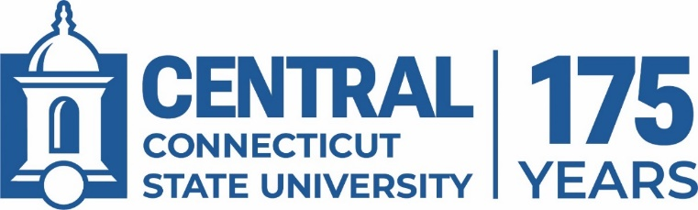

Polytechnic Investment Case Steering Committee Meeting

Tuesday, April 7, 2026 – 9:00 AM – Davidson 107

- Feedback on Webpage

- Questions/Concerns from Task Force Chairs

- Progress Reports on Work of Task Forces

- As May Arise

