CCSU Youth Programs (Ages 8-17)
Registration Instructions

Rec Trac: is the program used to complete all youth Program Registrations for students between the ages of 8-17.
Eligibility Requirements: You DO NOT need to be a CCSU faculty/staff/student to participate in our Youth Programs. If you are CCSU faculty/staff/student, you are eligible for a 15% discount.

Step 1: Go to our CCSU Youth Programs Website by using the QR Code on our flyer or by going to:
Youth Programs | Central or http://www.ccsu.edu/youth-programs

Step 2: Check out the 2026 Summer Program Flyer on this page to look over the dates, times and program offerings.
You may click “click to view programs” to view the offerings as well, but DO NOT put any programs into your cart from here - It will not let you register and pay until you have filled out all of you and your student’s information first!

Step 3: Register for you Rec Trac Account:
- Hit the back arrow to bring you back to Youth Programs | Central or http://www.ccsu.edu/youth-programs

- Via Cell Phone
Click on the three vertical lines on the top left corner and a drop-down menu will appear
Click “My Account SIGN IN / REGISTER”
Create Username & Password to log in
OR
- Via Computer: Click the blue box that reads “Begin your adventure by registering for Central Youth Programs!”
- YOU MUST “Create an Account” with a username and password & ADD your child as a family member BEFORE putting any programs into your cart!
- You may click “click to view programs” to view the offerings but DO NOT put any programs into your cart from here - It will not let you register and pay until you have filled out all of you and your student’s information first!

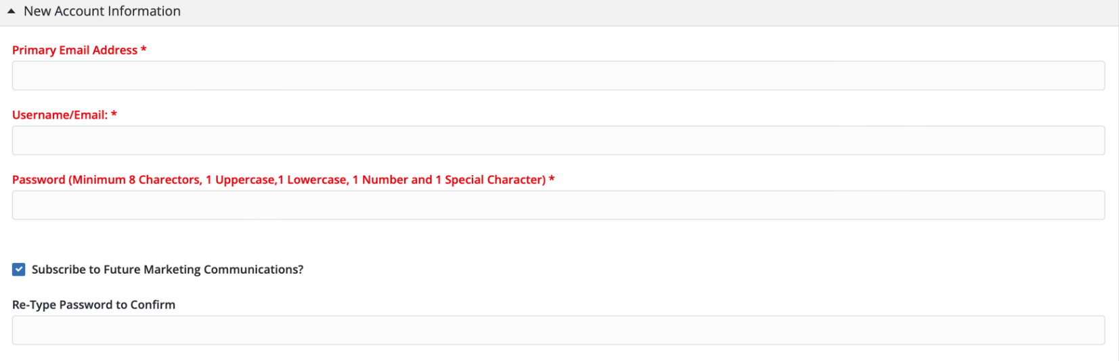

Step 4: Login into your account to create your household.

You are the Primary Guardian. Complete all Primary Guardian Information.
**For youth programs 8-18yo, you do NOT need a CCSU Blue-Card ID

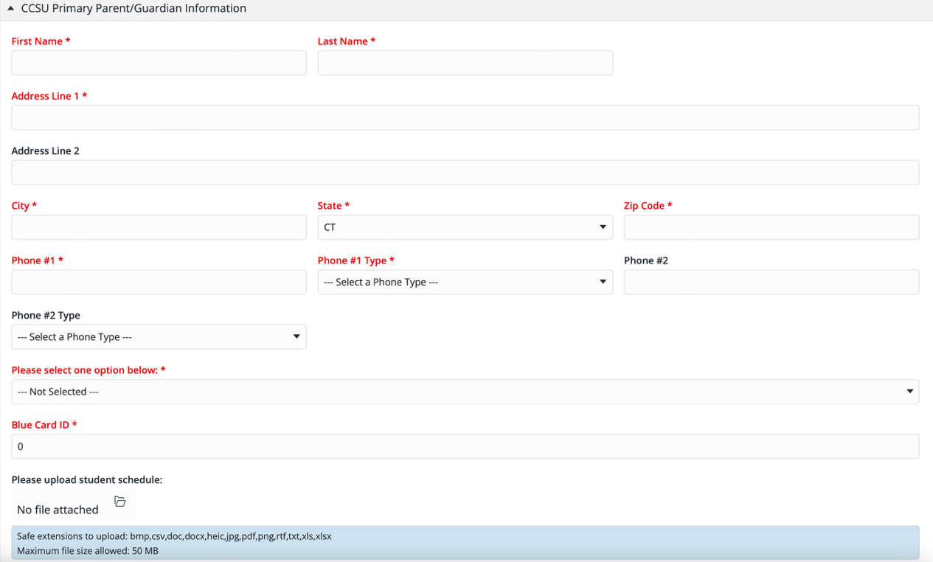

Step 5: You MUST add your child as “A NEW MEMBER” of the family and enter their information OR it won’t let you register!!! Complete all Student Information in this section.

** If you have more than one child you are registering for, you will have to add a ‘new member’ for each child **

ADD A NEW MEMBER/CHILD
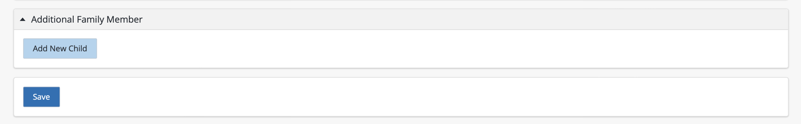

Step 6: Fill out or attach a copy of the “Enrollment Form” (Required before checkout)

Enrollment Form: 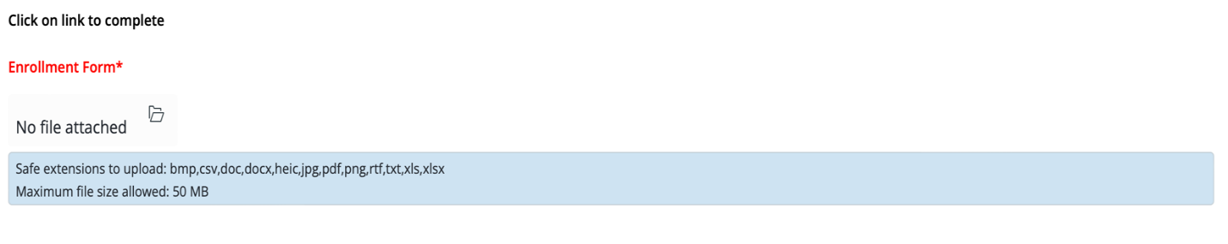

Enrollment Form Information

Student Information (pg. 1):
- Enter your child’s name & address
- Enter two parent/guardians phone numbers
- Enter two parent/guardians email addresses
- Enter child’s D.O.B. & gender
- Enter program(s) start date

Emergency Contact / Pick Up Information (pg. 1):
- Adults who may be contacted in an emergency when the primary
parent/guardian cannot be reached and to whom the child may be released.
- Please make sure to add two emergency contacts.
- Per Connecticut State Law: Emergency personnel will only release a child to someone on this list in an emergency.

Medical Information (pg. 2):
- Please fill this section out in case there is a medical emergency.
- Please list any conditions/allergies/concerns.
- Must still hand in the Health Assessment Form (this section doesn’t cancel that out)

Photo Release Policy (pg. 3):
- Please check yes or no
- Please print & sign your name
- Please date

Authorization to Release (pg. 3):
- Adults who are authorized to pick up the child from CCSU.
- CCSU will only release your child to adults on this list; they must show a valid ID at the time of pick up.
- Please print & sign your name
- Please date the bottom of page
- It is your responsibility to tell the staff at drop - off if there will be an alternate pick up and the name of the adult picking up.

Step 7: Fill out or attach a copy of the “Assumption of Risk and Release Wavier (Required before checkout)
- This form is for our insurance needs and must be filled out.
- For the Event/Location: Please add the title of the program and use the address for CCSU: 1615 Stanley St, New Britain, CT 06050
- Please print, sign your name
- Please add the date next to your signature

Step 8: Attach a copy of current “Health Assessment Record”
- This form needs to be submitted by May 15, 2026
- The pediatrician’s office will have this form and can print a copy for you.
- This form MUST be current and within a year of your child’s annual physical, during the dates of the program.
- Part 1: Must be completed, signed and dated by the parent/guardian.
- Part 2: Must be completed, signed, and dated by the physician (date of exam must be within the year and updated every year)
- Part 2: Must have Immunization Records Attached
- Part 3: Dental section is NOT required.

You can email this to browningj@ccsu.edu or attach a copy of the Health Assessment Record

Directions on how to attach a copy by:

If the entire Health Assessment Record is in one file: (PART 1, PART 2, IMMUNIZATION RECORD), you can upload that file under Health Assessment Record PART 1. Click on the folder icon and attach the HAR file. 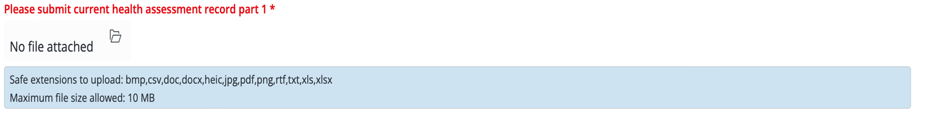
If the HAR is in multiple files, you can upload each file separately
Click on the folder icon for HAR PART 1 and attach HAR PART 1.
HAR Part 1 – completed, signed, dated by parent/guardian
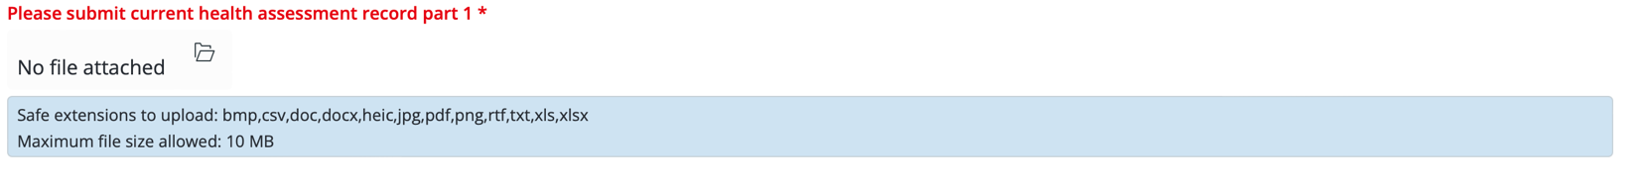
Click on the folder icon for HAR PART 2 and attach HAR PART 2.
HAR Part 2 – completed, signed, dated by physician (date of exam must be within the year and updated every year) 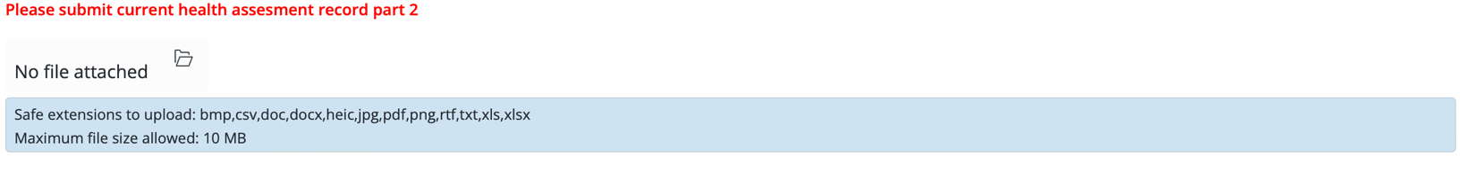
Click on the folder icon and attach the Immunization Record.
HAR Immunization – updated immunizations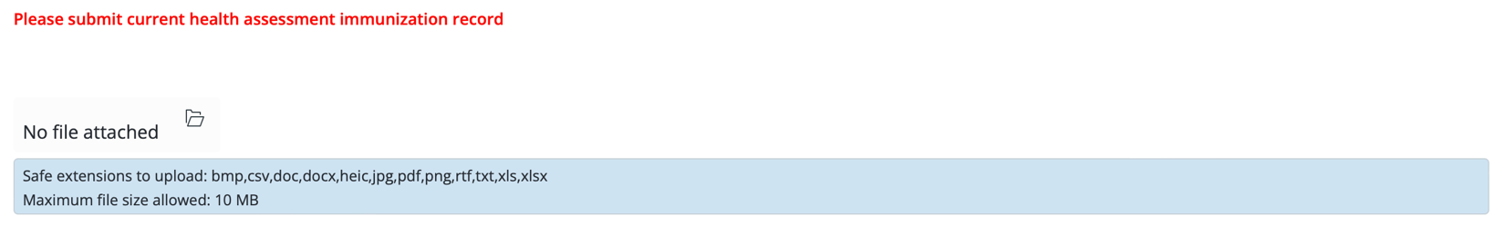

OTHER DOCUMENTS: There is a place to upload additional documents if required by the physician (ex. Additional medical forms/action plans/emergency medical administration forms, flu shot documentation)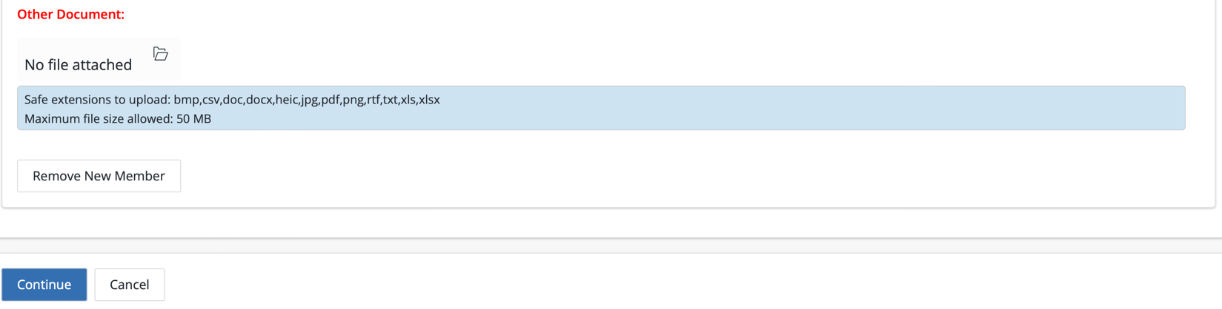

INCOMPLETE/EXPIRED ‘HEALTH ASSESSMENT RECORDS’ WILL NOT BE ACCEPTED & WILL DELAY PROGRAM REGISTRATION,

*Incomplete/Expired Health Assessment Records are not accepted after Mat 15th. If we don’t have this form by May 15, we cannot allow your child to partake in the program(s).

*If your physician requires emergency medication while here on campus, additional paperwork will be
sent to you to complete.

*Connecticut law requires that children ages 24-59 months receive at least one dose of the fly vaccine each year between August 1st – December 31st to attend licensed childcare programs.

Step 9: Select Programs you want to purchase and add them to the cart.

Step 10: Proceed to the checkout to enter billing information and pay for program(s).

UPDATED 3-11-26

