

Guide for Hiring Student Workers

Revised 3/19/26

Guide for Hiring Student Workers
STUDENT WORKERS
Procedures and Criteria for Appointing Student Workers:
Important Policies
- Student Workers must be matriculated at Central Connecticut State University and must be currently enrolled in courses or enrolled in the Intensive English Language Program (IELP).
- Student Workers cannot be on any other State payroll other than the student employee payroll of the University.
- Student Workers may only work for 1 state agency and may only have one job as a Student Worker. Student Workers may only work for 1 department.
- Students may work in the summer only if they were enrolled in the prior Spring semester and plan to continue enrollment in the subsequent Fall semester, or plan to complete their degree requirements during one of the summer sessions.
- Students may work no more than 40 hours per pay period during the Spring and Fall semesters when classes are in session. During periods when there are no classes Student Workers may work 40 hours per week.
- All hours worked should be submitted through Core-CT’s Time & Attendance system.

Supervisors are responsible for monitoring the hours of their Student Workers.
- Student Workers must have a valid Social Security Number (SSN) issued by the United States Social Security Administration in order to work before finding a position.
- The rules of the Federal College Work Study Program, or any other Federal Work Program, prevail if there is a conflict with the Board Resolution for Student Workers.
- Student Workers are paid from individual department operating budgets, at an hourly rate of pay in accordance with Appendix A.
- Student Workers are state employees and receive state paychecks.
- As state employees, Student Workers are required to abide by State and University policies.
- Upon completing 680 hours worked with no break in service, a Student Worker will be eligible to use sick time. A Student Worker will accrue one (1) hour paid sick leave for every 40 hours worked and can use a maximum of 40 hours per calendar year.
- A justification is required for changes to a Student Worker’s pay rate; complete the “Student Worker Pay Increase Justification” form found in Appendix B.
- If a student’s pay rate changes, or there are any other changes to the student’s payroll status, the Student Worker may be required to submit new or revised forms with Human Resources.
- A Student Worker’s assignment ends at the end of the semester if the Student Worker is on work study and the department does not contact Human Resources to continue the employment from the department budget.
- Student Workers are terminated in Core-CT by Human Resources if the Student Worker has not worked for a period of more than three (3) months.
Advertising for a Student Worker Position:
- Student Worker positions are listed on Handshake, an online database that connects students and alumni to thousands of employers. Central Connecticut State University is listed as an employer. The Career Development Office can post the position on Handshake once you provide a short description of the position and anticipated schedule of hours.
- Not all Student Worker positions need to be posted on Handshake. Hiring Process
- The hiring office interviews the student and extends the recommendation to hire.
- The hiring office will complete a Student Help Certification Form found in Appendix C and submit to the Career Development office.
1

Guide for Hiring Student Workers

- The Career Development Office will review the Student Help Certification Form, ensure the information is accurate and complete, and forward to Human Resources for processing.
- Human Resources will contact the student via e-mail to complete in-person onboarding and to complete background screening (as applicable).

No Student Worker may begin working until they have completed the onboarding process with Human Resources and receive a Core-CT login credentials from Human Resources.

Re-hiring Student Workers
- The supervisor should check the employment status of their Student Workers with Human Resources.
- A new Student Help Form must be submitted to Human Resources to rehire a Student Worker.
- Some Student Workers may be required to complete a new I-9 Form if the forms of identification previously submitted to Human Resources expired.
- If there is a break in service for a period of more than one year, the Student Worker will be required to complete new onboarding paperwork with Human Resources to be re-hired.
- Rehired Student Workers may not begin to work until the student receives a Core-CT login email from Human Resources.

2

Guide for Hiring Student Workers

APPENDIX A
Student Worker Pay Rates and Job Classifications

CSCU STUDENT WORKER PAY RATE SCHEDULE (MINIMUM WAGE COMPLIANCE)
The Board of Regents has approved revisions to the Student Worker Pay Rate Schedule eﬀective with the pay periods that
include the eﬀective dates in 2024 as listed below.

All student workers compensated at a level below the minimum hourly wage or below the minimum rate for the student worker classiﬁcation to which assigned when a change takes eﬀect should receive an appropriate adjustment in pay to ensure compliance with the statutory minimum wage and revision in the pay rate schedule listed below beginning January 1, 2024.
Student worker pay rates shall be reviewed by the System Oﬃce at least once each ﬁscal year with annual adjustments to the minimum rate being tied to the percentage change in the U.S. Department of Labor’s employment cost index for the 12- month period ending on June 30th of the preceding year. The CSCU Chancellor shall approve rate adjustments as necessary and advise the Board of Regents.

Class I:
Position requiring no work experience or some experience and/ or training sufficient to work at semi-skilled jobs not requiring supervisory responsibility.

Effective Date | Hourly Range
Effective Date | Min. | Max.
Effective 1/1/2026 | $16.94 | $21.00

Class II:
Position requiring demonstrated skill and/ or technical knowledge with capability of assuming extra responsibilities such as supervision of others.

Effective Date | Hourly Range
Effective Date | Min. | Max.
Effective 1/1/2026 | $17.46 | $21.50

Class III:
Advanced position requiring skills and knowledge acquired through prior employment or training in the appropriate area. This class usually requires supervisory responsibilities or the ability to work independently on projects requiring specialized skills.

Effective Date | Hourly Range
Effective Date | Min. | Max.
Effective 1/1/2026 | $18.49 | $22.00

3

Guide for Hiring Student Workers

Students who participate in off campus employment programs such as work study and community services may be compensated utilizing any of the pay rates noted above.
- Effective Dates:
If the pay increase form is submitted with original appointment documents the increase will be effective upon the student's new appointment.
If the pay increase form is not submitted in the manner described above, the increase will be effective the next available pay period for processing.
- No retroactive adjustments are made for a previously paid payroll.
- Return form to Human Resources, Davidson Hall, Room 201. An effective and prompt review of requests for adjustments is dependent upon accurate and complete justiﬁcation forms. Please be sure to provide all requested information to facilitate prompt action on your request.
- Any increase in wage rates will affect your student help budget. We encourage you to assess the impact on your budget to ensure that funds are not over-expended.

4

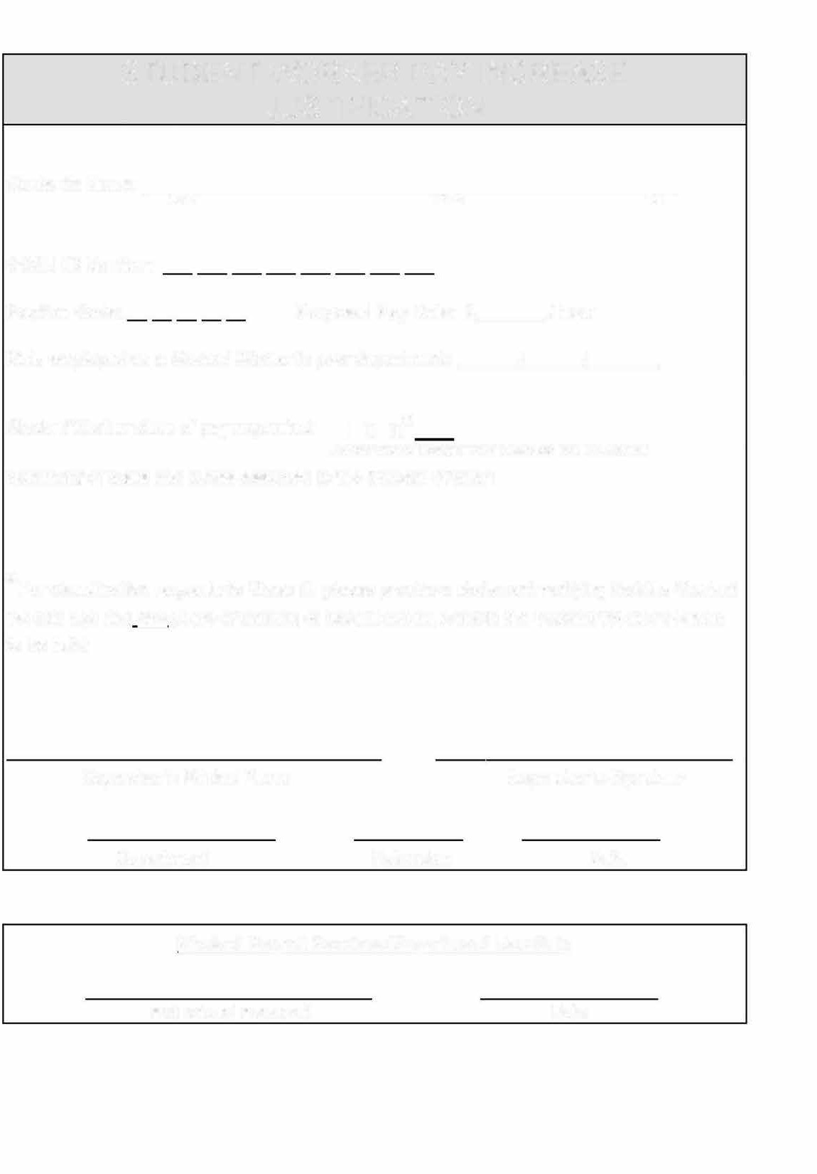
STUDENT WORKER PAY INCREASE JUSTIFICATION
APPENDIX B

Student's Name: -
CCSU ID Number:

Position Code: Proposed Pay Rate: $ /hour Date employed as a Student Worker in your department: / /

Student Worker class of pay requested: I 11 111*
(Circle One or Indicate Your Selection on Line Above)
Summary of tasks and duties assigned to the Student Worker:

* For classification requests to Class 111, please provide a statement verifying that the Student Worker has had two years of training or experience relevant to the Student Worker position to be held:

Supervisor's Printed Name Supervisor's Signature

Department Extension Date

Human Resources Department Use Only

Authorized Approval Date

APPENDIX C

Central Connecticut State University

Student Help Program Certification
Student's Name:
Last | First | MI
CCSU ID #:

Student's Certification

In accepting this position, I agree to abide by all State Statutes, Board of Trustees'/Regents' Resolutions and University Policies regarding student employment, some of which are outlined below:
- I am a matriculated student at one of the Connecticut State Universities and I am currently enrolled in Fall/Spring courses or enrolled in the Intensive English Language Program (IELP) at one of the universities.
- I understand that I must remain matriculated and enrolled in Fall/Spring courses/IELP in order to continue student employment.
- I understand my employment is temporary, at will, and can end at any time.
- I understand that I may not work for more than one supervisor in any given pay period or any other state agency.
- I will work no more than 40 hours per pay period when classes are in session and no more than 40 hours per week during vacation periods and the summer session.
- I understand that certain Student Worker assignments may require consent to a background check investigation. If applicable, I will not begin working until my background check has been successfully completed and I receive an email with my CORE-CT user ID and password.
- I have read, understand, agree, and will comply with and abide by the State Code of Ethics, Violence in the Workplace Prevention Policy, Records Retention and Disposition Policy, and the Board of Regents for Higher Education Acceptable and Responsible Use of Information Technology and Resources policy. If you wish to receive a copy of these policies, check here:

Student's Signature Date

Supervisor's Certification

In hiring this student worker, I agree under penalty of law, to abide by all Federal Regulations, State Statutes, Board of Trustees'/Regents' Resolutions, and University Policies regarding student employment, some of which are outlined as follows: I will not allow the student to work more than 40 hours per pay period when classes are in session and no more than 40 hours per week during vacation periods and the summer session. I will not allow the student to begin working until their employment paperwork is completed, processed, and the student receives an email with their CORE-CT user ID and password.
Per BOR/CSCU policy, certain Student Worker positions are subject to a pre-employment background investigation. If you check "Yes" to any of the questions below, the Student Worker may not begin working until the background check has been successfully completed and you are copied on an email that includes the Student Worker's CORE-CT user ID and password.
- Will this student be a Resident Assistant? Yes No
- Will this student be assigned to the Public Safety Department? Yes No
- Will this student handle DCL3 data (DCL3 is protected confidential data, which comprises identity and financial data? Yes No
- Will this student have fiduciary responsibility, handle cash or credit transactions, or have a primary responsibility related to finance or budget? Yes No
- Will this student be employed in a safety or security-sensitive position not noted above (requires approval by the Chief HR Officer)?
Yes No If yes:
Description of Safety or Security-Sensitive Position
All lines below must be completed:

- Effective date: (This date must be the 1st day of a pay period)

- Position: Department:

- Banner Index: Telephone Extension:

Supervisor's Name (Print) Supervisor's Signature Date
Grants Administration (GRANT-FUNDED ONLY) Date

Please email completed form to HRStudentWorker.list@ccsu.edu.

Location of Employment

  - Where will the work be performed?  On-Campus  Off-Campus
If Off-Campus, please complete questions #2 and #3
  - If the employment is off campus, is there an agreement in place with the off campus employer? If so please provide a copy of the agreement to Human Resources.

  - If employment is off campus, how will the supervisor at Central verify the hours worked? Please provide a written statement of how student workers will be supervised while working off campus.

Nature of Work
Please provide a brief description of the type of work the student will perform.

No student employment should begin until all hiring paperwork is completed with Human Resources and the student receives a Core- CT login email

New Employee Personal Data
All New Employees Must Complete This

- Name:
Last First MI

- Permanent Address:
Street

City State Zip

- Telephone #s (Home): (Cell):

- Gender: (Voluntary) Female Male 5. Date of Birth:

- Are you authorized to work in the United States? Yes No

- Have you previously been employed by CCSU or another state agency?

7a. If yes, what agency and when were you last employed?

- Email Address:

- Race/Ethnicity State coding (select one): (Voluntary)
American Indian/Alaskan Native
Native Hawaiian/Other Pacific Islander
Yes No

Hispanic/Latino Asian
Black/African American White

9a. Federal coding: (Voluntary)
Hispanic or Latino Not Hispanic or Latino

Also, select one or more races to indicate what you consider yourself to be: (Voluntary)
American Indian/Alaskan Native Native Hawaiian/Other Pacific Islander Asian White Black/African American

- Emergency Contacts

Name:
Last Name First Name Relationship

Address:
Street (Apt. No. if applicable)

City State Zip Code (Country, if not US)

Phone: (Home): (Cell): (Work):

General Information
The official payroll title for students engaged in the Student Help Program is Student Laborer. Employment is temporary, at will, and can end at any time. This position is in the "Unclassified" category of state service. Wages earned as a Student Laborer are not covered by State Retirement or Unemployment Compensation Law. Social Security contributions are not deducted while the student is attending classes. Wages are subject to Federal and State withholding tax. Hours worked are reported through the CORE-CT time entry system. Payrolls are processed bi-weekly. Expect a minimum four-week delay before receipt of your first paycheck. Subsequent paychecks will be issued every two weeks.
Newly hired students MAY NOT begin working until all hiring paperwork is complete and the student receives an email with their CORE-CT user ID and password.
***Please submit this completed form, I9 (Employment Eligibility Verification), Federal W-4, and CT W-4 via email to HRStudentWorker.list@ccsu.edu***
An in-person meeting is required to present I9 Identifications.
For Human Resources Use Only

I-9
W-4 CT W-4
Background check completed:
Employee# SL CO-999 Banner Signature/date

