CT 1776: A Revolutionary Event
The Connecticut Conference of America 250  Central Connecticut State University  Alumni Hall, Student Center  Friday and Saturday, March 20-21, 2026  https://www.ccsu.edu/event/ct-1776-revolutionary-event | 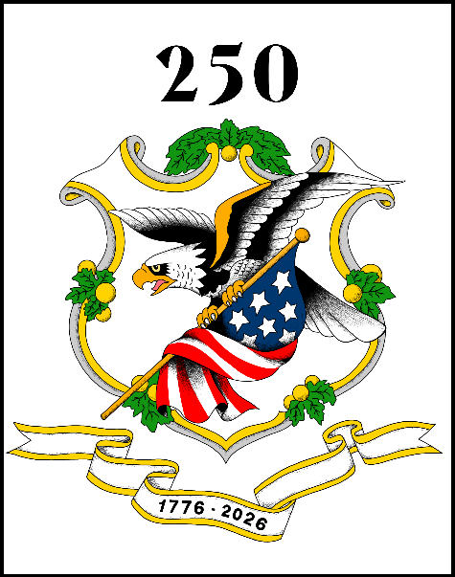

Conference Timeline – Day 1
Friday, March 20, 2026

7:45-8:30 a.m. – Registration

8:30 a.m. – Welcome and Introduction

8:45 a.m.
ACT 1 – January-July 1776 – The Dawn of Liberty
- The Music of Revolution – Richard Franklin Donohue
- Common Sense – Luke Boyd
- Instructing CT’s Continental Congressional Delegation – Matt Warshauer
- The Declaration: A Reading – Howard Wright
9:50 a.m. – Break – 10 minutes
10:00 a.m.
ACT 2 – July-December 1776 – The Scourge of War
- The Music of Revolution – Richard Franklin Donohue
- The Continental Line – Dave Naumec
- Black Soldiers – John Mills
- Indigenous Soldiers – Michael Kicking Bear Johnson
11:05 a.m. – Break – 10 minutes
11:15 a.m.
- Joseph Martin Plumb – Matt Vallier
- Women Respond – Rebecca Bayreuther Donohue
- The CT Clergy – Nora Howard
12:15 p.m. – Break for lunch – 1 hour

1:15 p.m.
ACT 2 Continued.
- Nathan Hale – Anne Marie Charland
- Noah Webster – Jeff Mainville
- CT Deserters – Dana Meyer
- Tories and New Gate Prison – Morgan Bengel
2:35 p.m. – Break – 10 minutes

2:45 p.m. -
ACT 3 – 1777 and on – The Long Battle for Independence
- The Music of Revolution – Richard Franklin Donohue
- The Reality of War – Dave Naumec
- The Burning of Danbury/Ridgefield – Keith Marshall Jones
- The Raid on Middlesex Parish (Darien), 1781 – Tom Balcerski
- Benedict Arnold – Matt Reardon
3:55 p.m. – Break – 10 minutes

4:05 p.m. – Grand Finale: John Trumbull’s War – Walt Woodward

5:00 p.m. – Conference Ends

Prepare for Day 2!! With a deeper dive into subjects raised on Day 1 as well as a variety of additional presentations. The Day 2 outline is forthcoming.

