CCSU - Computer Electronics & Graphic Technology Fall 2025 - Faculty Schedules

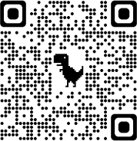

Book an appointment

