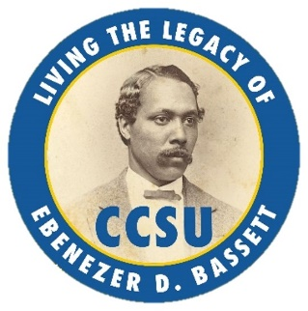
EBENEZER D. BASSETT SCHOLARSHIP

First name: | Surname:
Cell phone number:

Email address: (print)

Nominee’s major
_____________________________

Class standing:
Freshman Sophomore Junior Senior Graduate

References
Contact Information:
Name _________________________________ Title______________________________________

Cell phone number: ______________________ Email: _____________________________________________

Organization _____________________________________ Affiliation __________________________________

Name _________________________________ Title______________________________________

Cell phone number: ______________________ Email: _____________________________________________

Organization _____________________________________ Affiliation __________________________________

Date

In a single PDF, email your completed application to the Ebenezer D. Bassett Award Nomination Committee Chairperson. (See website for contact information.)

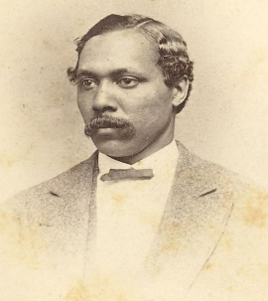

Ebenezer D. Bassett Legacy Virtues

Student Achievement Awards | Descriptions
Scholastic | The Scholastic category recognizes students who have excelled educationally. These students have demonstrated a commitment to learning and educational success in and outside of the classroom. This honor recognizes outstanding academic achievement and exists to highlight sound scholarship (e.g., contributing to their field of study, internship experiences, research, presentation, and (or) other scholarly endeavors).
Leadership | The Leadership category recognizes students who have demonstrated leadership through exemplary service to the Central Connecticut State University community. This category highlights students who have demonstrated their capacity to lead, advise, provide guidance, and serve as a role model to others. Students are recognized for their civility and exceptional character (e.g., conduct, honesty, integrity, and his capacity to work as a team player and collaborator.
Compatriot | The Compatriot category recognizes students who have demonstrated extraordinary service of distinction. The category highlights the service of students who have committed themselves to making a difference through their involvement in civic, cultural, or charitable activities. The award is presented to individuals who have, through excellence, innovation, creativity, inventiveness, social responsibility, or patriotism, distinguished themselves as true ambassadors of hope and opportunity. These individuals have committed themselves to making a difference.
Humanitarian | The Humanitarian category recognizes students who have demonstrated their commitment to helping those in need by selflessly giving their time, resources, and expertise to benefit the lives of others. They are also committed to inspire others to do the same. The award celebrates students who have contributed significantly to the advancement of peace, civil rights, inclusion, diversity, equity/equality, and (or) social justice. Special emphasis is placed on those involved in activities that improve/eliminate health, wellness, and educational disparities impacting the lives of male populations.
Victor & Triumph | The Victor & Triumph category recognizes students who have overcome and triumphed over adversity (e.g., cultural, financial, disabilities, etc.) and other barriers to succeed. The award celebrates the courage, fortitude, persistence, and the capacity of each student to achieve despite his circumstances. The award honors the “overcomer spirit.”

