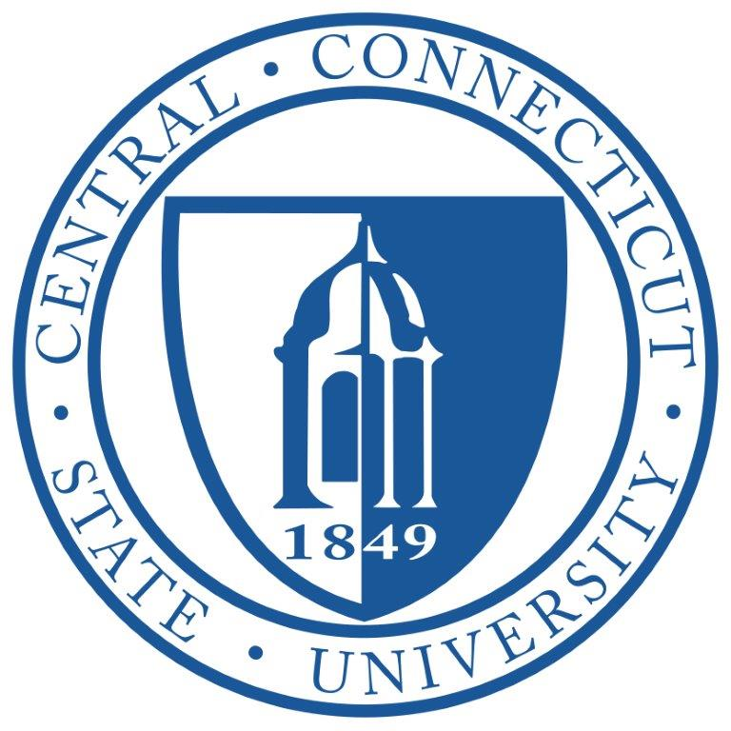 Facilities Planning Committee

October 26, 2023

Via Teams

Attendees: Sal Cintorino, Chief Operations Officer
Dr. Kim Kostelis, Provost
Dr. Frederic Latour, Faculty Senate President
Jim Grupp, Director of Facilities Management
Stacey Votto, University Counsel
Dr. Kellie Byrd Danso, Vice President of Student Affairs
Dr. Craig Wright, Vice President for Equity and Inclusion
Lisa Bucher, Chief Budget and Compliance Officer
Chris Wethje, Chief Human Resources Officer
J. Dahn, Provost Office

Copernicus Community Clinic
- Finishing touches in progress, events being scheduled including training and public outreach

Central Welcome Center (former Charter Oak)
- Work currently in progress to create formal campus entrance for Admissions and IA
- Relocation of these areas will create space in Davidson

Library Annex
- Work currently in progress on stack areas

Media Center Refresh
- Design plans for refresh to align with current technology

Davidson Hall
- Bids due 11/15 for Provost renovation
- Look at other spaces in Davidson Hall for new hires, etc

Copernicus Hall
- Lab improvements to occur in 3 phases
- Room 324-over winter break
- Look at computer lab utilization/3-5 year reprogramming plan

Memorial Hall
- Complete mechanical renovation around operations, anticipate Summer 25 for building to be offline, increase use of Hilltop

Forensics Program
- K. Kostelis discussed the stackable credentials of this program to law enforcement and also growth potential. Program needs to be kept management. Looking at potential spaces on campus and developing cost analysis.

Misc
- AIH noise issues
- Completion of warranty work
- Potential relocation of MARCOM from Maria Sanford

Respectfully Submitted

Rene Karas

