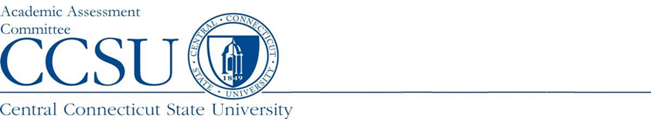

Program report Summary

Department: | Report Type: FULL REPORT
Program Name and Level: | Academic Year Data: 2021-22
Report Preparer: | Date Completed:
Date of Last Program Review: | Semester of Next Program Review:

Program Assessment Question | Response
- URL: Provide the URL where the Learning Outcomes (LO) can be viewed.
- Assessment Instruments: Please list the source(s) of the data/evidence, other than GPA, that is/are used to assess the stated outcomes? (e.g., capstone course, portfolio review and scoring rubric, licensure examination, etc.)
- Interpretation: Who interprets the evidence? (e.g., faculty, Admin. assistant, etc.).
4) Results: Using this year’s Findings, list:
a. The conclusion(s) drawn
b. The changes that were or will be made as a result of those conclusion(s)
5) Strengths: List ways in which your assessment process is working well.
6) Improvements: List ways in which your assessment process needs to improve based on student data (A brief summary of changes to assessment plan can be reported here).
7) General Education Assessment: Please list the department faculty who have participated in our General Education Assessment Initiative. (For graduate degree programs, please type N/A.) | Faculty member(s):

