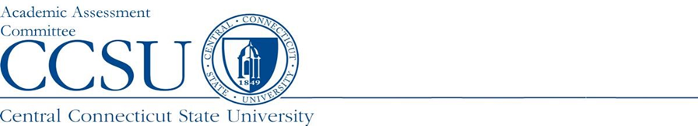

Program report Summary

Department: | Report Type: SUMMARY
Program Name: | Program Award Level:
Report Preparer: | Academic Year Data: 2021-22
Program Structure (Choose One): Accredited Non-Accredited Combination | Date Report Completed:
Accreditation Agency (If Applicable): | Date Next Self Study Due to Agency:

Program Assessment Question | Response
- URL: Provide the URL where the learning outcomes (LO) can be viewed.
- Assessment Instruments: Please list the source(s) of the data/evidence, other than GPA, that is/are used to assess the stated outcomes? (e.g., capstone course, portfolio review and scoring rubric, licensure examination, etc.)
3) Interpretation: Who interprets the evidence? (e.g., faculty, Admin. assistant, etc.).
4) Results: Since the last submitted report, list:
a. The conclusion(s) drawn, noting strengths and weaknesses.
b. The changes that were or will be made as a result of those conclusion(s).
- Strengths: What about your assessment process is working well?
- Improvements: List ways in which your assessment process needs to be improved based on student data. (A brief summary of changes to assessment plan can be reported here)
- General Education Assessment: Please list the department faculty who have participated in our General Education Assessment Initiative. (For graduate degree programs, please type N/A.) | Faculty member(s):

End of Report

