The Central Connecticut Writing Project (CCWP) works with writers of all ages. While we are all staying at home, we have opportunities to develop and extend our creative writing. Here are some ideas….

- Writing into the Day WID
A hallmark of our Central Connecticut Writing Project (CCWP) is that we start every session with a WID, Writing Into Day. Each morning, we post a prompt, and everybody writes for a set amount of time. For mature writers, it’s about 15-20 minutes; younger writers can start at 5 – 10 minutes. Once we write, we talk about what we have written. A dozen prompts to get you started are:
- Let me tell you about my pet….
- Trace your hand and tell me all the things it has touched.
- A knight is lost in an enchanted forest and just ate a poisonous berry.
- Listen to the sounds around you. Pick one and tell a story about it.
- Look up in the sky, tell the story of the most interesting cloud you see.
- You and your three best friends are stuck driving in a car with your mom for the next week.
- You found a remote control, you don’t know what happens if you press the button, but you do it anyways.
- The school day has ended but you and your best friend are locked inside. It looks like a sleepover. Tell me about your night.
- The tree in your backyard starts talking to you. What does it say? What do you say?
- You can only drink hot things or cold things for the rest of your life. Which do you pick and why?
- You’re stuck on a deserted island. What three items do you hope to find in your bag?
- If you could write a message in a bottle, what would it say?

Sometimes you can’t think about anything to say about a particular prompt. Don’t
worry. You can write about a different topic, just keep the pen moving.

- Writing I
The Writing I helps a writer quickly come up with lots of possible ideas to write about. On a piece of paper or a page in your journal draw a big letter “I” as shown below. Brainstorm from your life on all the really cool big events and unforgettable small moments. The Writing I will become an ever-ready source to turn to when you are looking for ideas.

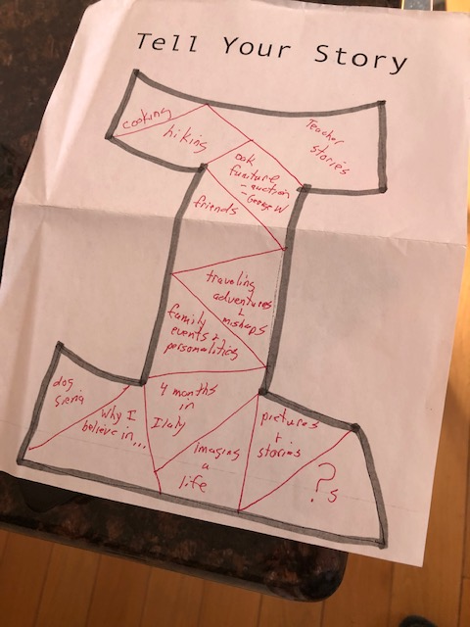

- Coloring Your World
- Invent three colors that have never been invented before. Use your wildest imagination. (Examples: mud yellow; throw-up beige; invisible white).
- Write a paragraph describing LaZoona using your invented colors. Perhaps describe the color of her jacket: “LaZoona always wore her throw-up beige jacket to school, because she thought it made her look intelligent.”

- Silly Sentences Story Starters

Number 1 | Number 2 | Number 3
1 Piano | 1 Falling | 1 Dangerous
2 Hammer | 2 Sing | 2 Delicious
3 Truck | 3 Swallow | 3 Exhausted
4 Duck | 4 Gallop | 4 Sharp
5 Star | 5 Sleep | 5 Fascinating
6 Pie | 6 Cook | 6 Valuable
7 Water bottle | 7 Relax | 7 Round
8 Bike | 8 Laughing | 8 Scarlett
9 Cell Phone | 9 Worry | 9 Blurry
10 Lamp | 10 Swim | 10 Forty

Begin by randomly selecting 3 numbers from 1 to 10 and writing them on little slips of paper (examples 2-3-5, 10-1-4). Fold and put in a bowl. Each person chooses one. Based on the sequence of your three numbers, write an original sentence that can be used as a story starter using the words from the above table. You do not have to use the words in the order indicated by the three numbers.

Example: 2-3-5
From column 1 the 2nd word is hammer. From column 2 the 3rd word is swallow. From column 3 the 5th word is fascinating.
Sentence: Yesterday, we went to a fascinating talent show where the magician swallowed a hammer! He promised to reveal the secret of how he did it if we could find three things.

After using the words from the above table, pick your own words

  - Take five index cards and on each one write an adjective. Try to make them fun, unusual, weird. (Examples: floppy, stinky, ginormous, etc.)
  - Take five index cards and on each one write a noun. Try to make them fun, unusual, weird. (Examples: Horseshoe, Zoo; Eyebrow)
  - Now match them up randomly, one adjective and one noun, and write a paragraph about that topic. (Example: stinky eyebrow.)

Example: My best friend, LaZoona, is a great person, except for her stinky eyebrow. Let me explain…

- Zoology 2050

  - Invent an animal that doesn’t exist. Give it a name (example: A Drac). Describe the animal in great detail (example: A Drac is a small animal the size of a poodle. It has long, luxurious purple fur. It has three small eyes lined up across its forehead and a large mouth with three upper and three lower teeth.)
  - Write a paragraph about the day LaZoona finds a Drac and decides to take it home as her pet.

- Counting…
- Choose any number from one to ten and give that number three personality traits (example: 9 is often the last one to arrive at a party; 9 is afraid of snow; 9 likes to sing.)
- Write a paragraph in which LaZoona meets your number in McDonald’s and has a conversation with it. Make sure the number is consistent with its personality traits. You are using personification here. Be silly!

- Cooking
Begin a family cookbook! We all have our favorite meals or dishes. Sometimes it comes from a long family history, a favorite restaurant, or dinner at a friend’s house.
- On an index card, give your recipe a title (example: Aunt Rita’s frosting).
- Write why it is a favorite recipe.
- List the ingredients.
- Write instructions.
- Draw a picture.

- Salsa Words
In your journal start a section, called Salsa Words, to collect the words that are spicy, colorful and fun to read or to say out loud.
From a favorite story, pick out some salsa words to start your collection.
Reread your own writing and see where you can exchange a dull word with a salsa word.

- Opening
  - Walk through these doors.
  - What happens?
  - Where are your characters?
  - Is this the beginning, the solution, the end of your story, or any combination of these?

10) Interview a friend or family member via phone, FaceTime, email….
- Have a list of 10 questions ready. Write down the replies.
- From those replies choose just 15 – 20 words to form a found poem.
- Find a picture with no people in it to go along with your poem.
- Share it with the person you interviewed.

