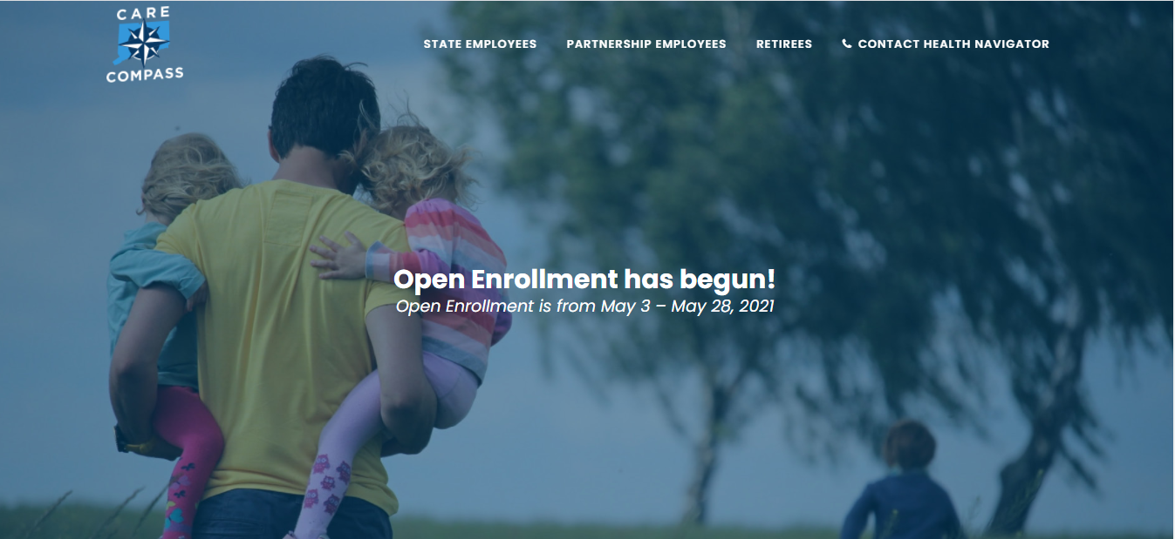
2021-22 Health/Dental Insurance Open Enrollment
The 2021-22 health/dental insurance open enrollment is currently underway and runs through May 28, 2021. During open enrollment, employees may change medical and/or dental plans, add or drop coverage for your eligible family members, or enroll yourself if you previously waived coverage. These changes are not allowed at other times outside of open enrollment unless an employee experiences a qualifying event, such as marriage, divorce, civil union, birth, adoption, legal guardianship or loss of other health insurance coverage by an eligible dependent. Any changes you make are effective July 1, 2021 through June 30, 2022 unless you have a qualifying status change.
This year the Office of the State Comptroller has scheduled six virtual question and answer sessions. These sessions have replaced the traditional open enrollment fairs that took place prior to COVID-19. Health Navigator, Anthem, Cigna, CVS and HEP representatives will be available to answer employee questions. The dates, times and links to each of these events can be found on the open enrollment dedicated landing page on Care Compass accessible by clicking on the following link: https://carecompass.ct.gov/openenrollment/ .
CVS, Anthem and Cigna presentations are also available to view on-demand by clicking on the following link: https://carecompass.ct.gov/ , then clicking or hovering over the open enrollment icon on the top right and then clicking on the link for the specific item in the drop down menu.

- New Dental Plan Option – Total Care DHMO Plan – A plan that provides dental services from a defined network of dentists. There is no annual deductible or calendar-year maximum. When you need care, you pay coinsurance based on the service your receive. You must select a primary care dentist to coordinate your care. Referrals are required for all specialist services.
- Quality- Focused Medical Plan Option – The State BlueCare Prime Plus POS plan. This medical plan option offers access to high-performing doctors and specialists in Connecticut – at lower premiums.
- Care Compass – A centralized benefits hub that provides access to all health benefit materials – accessible at https://carecompass.ct.gov/ .
- Health Navigator – A service to assist all health plan members obtain answers to all their benefit questions. Members can speak with a Health Navigator by phone (866.611.8005), visit the web at https://carecompass.ct.gov/state/ or online messenger chat.
- Networks of Distinction – This program identifies high-quality, cost-effective doctors and care locations that offer comprehensive care for many common medical tests and procedures, and health conditions. Members can earn incentives for utilizing Networks of Distinction for certain medical procedures or conditions.
- During open enrollment, you may enroll in the Health Enhancement Program (HEP) if you have not already done so. Note: HEP monitoring for 2021 has been reinstated. All enrolled members are encouraged to review outstanding preventive requirements and make necessary appointments. Questions should be directed to HEP Customer Service at 877.687.1448.

The Employee 2021-2022 Health Care Options Planner is attached and also available at the following link: https://carecompass.ct.gov/wp-content/uploads/2021/05/ActivePlanner_2021.pdf .

Please also be aware that covered employees are required to immediately report a divorce or legal separation to the Human Resources Department and must ensure that their information is correct during the open enrollment process. Employees must notify Human Resources if any of their covered dependents are no longer eligible for coverage. Failure to do so may require the payment of federal and state tax on the fair market value of benefits provided to an individual who is not an eligible dependent.

PLEASE NOTE: A marriage certificate is required to add a spouse on to health benefits and birth certificates (long version with employee’s name also on the certificate) are required to add eligible dependent children.

Please contact Human Resources at x21756 or email at HumanResources-1@mail.ccsu.edu with questions you may have or to request a Benefit Enrollment Form – Open Enrollment as this form will be sent to you via email. Completed forms/documentation may be dropped off to Human Resources located in Davidson Hall, Room 201.

