2021

**CCSU Foundation, Inc.**

**Policies and Procedures Manual**

**CCSU Foundation, Inc.**

**Policies and Procedures Manual**

**Adopted by the Board of Directors**

**on**

**November 19, 2021**

Direct Inquiries to:  
  
CCSU Foundation, Inc.

PO Box 612

New Britain, CT 06050-0612

Phone: (860) 832-0712

Fax: (860) 832-2588

E-mail: foundation@ccsu.edu

**CCSU Foundation, Inc.  
Policy and Procedures Manual**

**Table of Contents**

1. **Overview** ………………………………………………………………………. 1  
   1. Purpose ………………………………………………………………. 1
   2. Mission ………………………………………………………………. 1
   3. Role and Scope ………………………………………………………. 1
2. **Governance** ………………………………………………………………………. 2  
   1. Board of Directors ………………………………………………………. 2
3. **Charitable Giving** ………………………………………………………………. 2  
   1. Definition of a Charitable Gift ………………………………………………. 2
   2. Evaluation of Offered Gifts ………………………………………………. 2
   3. Donor Involvement in the Administration of Their Gift ………………. 3
4. **Types of Gifts Accepted by the CCSU Foundation, Inc.** ………………………. 3  
   1. Gifts of Cash, Marketable Securities, and Mutual Funds……………………. 3
      1. Cash/Electronic Transfer ………………………………………. 3
      2. Marketable Securities ………………………………………………. 3
      3. Mutual Funds ………………………………………………………. 3
   2. Gifts of Real Estate and Tangible Personal Property ………………………. 3
      1. Real Estate ………………………………………………………. 4
      2. Tangible Personal Property ………………………………………. 4
         1. Artwork ………………………………………………. 4
         2. Books, Manuscripts, and Other Library Materials ………. 4
         3. Equipment ………………………………………………. 5
         4. Other Tangible Personal Property ………………………. 5
   3. Life Insurance ………………………………………………………………. 5
   4. Intellectual Property ………………………………………………………. 5
   5. Gifts-In-Kind ………………………………………………………………. 6
   6. Planned Gifts ………………………………………………………………. 6
5. **Fiscal Management Policies** ………………………………………………………. 6  
   1. Foundation Investment Policy ………………………………………………. 6
      1. Introduction ………………………………………………………. 6
      2. Responsibilities ………………………………………………. 7
      3. Conflicts of Interest ………………………………………………. 7
      4. Investment Objectives ………………………………………………. 7
      5. Asset Allocation ………………………………………………. 8
      6. Adherence to Policy Targets and Unbalancing ………………………. 8
      7. Guidelines for Equity and Fixed Income Managers ………………. 9
      8. Guidelines for Hedge Funds ………………………………………. 9
      9. Derivatives ……………………………………………………….. 9
      10. Leverage ………………………………………………………. 10
      11. Guidelines for Private Equity ………………………………………. 11
      12. Volatility ………………………………………………………. 11
      13. Execution of Security Trades ………………………………………. 11
      14. Adoption of Investment Policy Statement ………………………. 11
   2. Distribution of Earnings Policy ………………………………………. 11
   3. Budget and Spending Policy ………………………………………………. 12
   4. Custodial Fee Policy ………………………………………………………. 12
   5. Gift-In-Kind Valuation Policy ………………………………………………. 12
      1. Goods ………………………………………………………………. 12
      2. Services ………………………………………………………. 13
   6. High Value Expenditure Policy ………………………………………. 13
   7. Policy on Restricted Purchases ………………………………………………. 13
   8. Policy on Appreciation Gifts for Constituents ………………………………. 13
   9. Policy on Procuring Financial Services ………………………………………. 13
   10. General Policy on the Disbursement of Funds ………………………………. 14
       1. Payments to Students ………………………………………………. 14
          1. Awards ………………………………………………. 14
          2. Prizes ……………………………………………… 14
          3. Scholarships ……………………………………… 14

5.10.1.3.1 Policy on Scholarship Stacking ………………………. 15

* + 1. Payments to Non-Students ………………………………………. 15
    2. Salary and Wage Payments ………………………………………. 16
    3. Stipends and Honoraria ………………………………………. 16
    4. Expense Reimbursement Paid to a University Employee   
       or Other Individual ………………………………………………. 16

1. **Administrative Policies** ……………………………………………………… 18  
   1. Board of Directors’ Conflict of Interest Policy ………………………………. 18
      1. Policy Statement ………………………………………………. 18
      2. Disclosure Statement ………………………………………………. 18
   2. Policy on Executing Contracts, Documents, and Certificates in the   
      Name of the CCSU Foundation, Inc. ………………………………………. 18
   3. Check Signature Policy ………………………………………………………. 19
   4. Policy on Authorized Credit Card Users ………………………………. 19
   5. Policy on Policy Review ………………………………………………. 19
   6. Gift Acceptance Policy ………………………………………………………. 19
   7. Gift Refusal Policy ………………………………………………………. 20
   8. Gift Receipt Policy ………………………………………………………. 20
   9. Donor Recognition Policy ………………………………………………. 20
   10. Donor Privacy & Security Standards Policy ………………………………. 21
   11. Records Retention Policy ………………………………………………. 22
   12. Ethics Policy ………………………………………………………………. 23
   13. Whistleblower Policy ………………………………………………………. 23
   14. Policy on Non-Discrimination ………………………………………………. 23
2. **Fund Administration Policies** ……………………………………………… 24  
   1. Fund Agreements ………………………………………………………. 24
   2. Fund Endowment Requirements ……………………………………… 24
   3. Naming Opportunities ……………………………………………………… 25
   4. Donor Fund Reports ……………………………………………………… 25
   5. Fund Manager Reports ……………………………………………………… 25
3. **Policies and Processes for Accepting and Administering Gifts** ……………… 25  
   1. Receipts ……………………………………………………………… 25
   2. Acknowledgements ……………………………………………………… 25
   3. Depositing Revenue ……………………………………………………… 25
   4. Gift Entry and Recording Policy and Procedures for Cash Gifts ……… 26
   5. Gift Entry and Recording Policy and Procedures for Non-Cash Gifts ……… 26
   6. Gift Entry and Recording Policy and Procedure for Marketable Securities … 27
   7. Sponsorship and Event Revenue ……………………………………… 27
4. **Disbursement Procedures for Payments Made to Students, Vendors,   
   and Other Non-Student Entities** ……………………………………………… 28  
   1. Disbursement Orders ……………………………………………………… 28
   2. Disbursement Schedule ……………………………………………… 28
   3. Award, Prize, and Scholarship Disbursements Made to Students ……… 28
   4. Athletics Program Disbursements ……………………………………… 29

**Exhibits**

1. CCSU Foundation, Inc. Disbursement Order ……………………………………… 30
2. CCSU Foundation, Inc. Personal Services Agreement ……………………………… 31
3. CCSU Foundation, Inc. Purchase Order ……………………………………… 32
4. CCSU Foundation, Inc. Reimbursement of Expense Report ……………………… 33
5. CCSU Foundation, Inc. Transmittal Sheet ……………………………………… 34
6. IRS Form W-9 ……………………………………………………………………… 35
7. CASE Statement of Ethics ……………………………………………………… 36

***Note***: Downloadable forms are available on the Foundation’s website: www.ccsu.edu/foundation.

**1.0 Overview**

**1.1 Purpose**  
The following policies and procedures set forth in this document shall be used by the CCSU Foundation, Inc. to fulfill its mission.  Policy exceptions may be granted, when appropriate, by the CCSU Foundation Board of Directors. Any exception in excess of $40,000 shall be communicated to the Board in accordance with section 5.6.

* 1. **Mission**

As an eleemosynary organization, the CCSU Foundation, Inc. was conceived with the principal intent of providing a vehicle through which Central Connecticut State University could obtain private contributions to support educational programs and research. The overarching goal of the Foundation is to develop the University’s capacity and effectiveness in attracting gift support, and to serve as the principal source of leadership, guidance, and direct assistance in achieving fund-raising goals and objectives. The Foundation is the single and sole philanthropic repository of gifts to the University, and donors view the Foundation and the University as one and the same.

* 1. **Role and Scope**

The CCSU Foundation, Inc. was created in 1971, at the request of the University, as a vehicle to obtain private contributions to support educational programs and research at Central Connecticut State University. Incorporated under the laws of the State of Connecticut, the non-profit, eleemosynary organization is governed by an independent Board of Directors which includes members of the faculty, the student body, the alumni, and the general public. The President of Central Connecticut State University is an ex-officio member of the Board of Directors.

The Foundation solicits private contributions to benefit Central Connecticut State University. Funds are allocated in five major program areas: institutional enrichment, scholarships, academic enrichment, research, and unrestricted. The Board of Directors disburses unrestricted funds to University programs and activities deemed by the Board, in consultation with the President of the University, to be the worthiest. Restricted donations are disbursed according to the terms of the donation.

The relationship between the University and the CCSU Foundation, Inc. is subject to Sections 4-37e through 4-37j of the Connecticut General Statutes, which establishes principles for operation of private foundations which exist to benefit public colleges and universities. This relationship is further defined in an agreement between the Board of Regents of the Connecticut State University and College System and the CCSU Foundation, Inc.

The CCSU Foundation, Inc. is not an entity of the State of Connecticut and as such is not subject to Connecticut's Freedom of Information Act, to routine inspection by the Auditors of State Accounts, or to direct regulation by the State. The Foundation employs independent certified public accountants who conduct an annual audit. Copies of the annual audit are available for public inspection in the University Library.

The Foundation is exempt from tax under section 501(c)(3) of the Internal Revenue Code. Its non-profit organization identification number may be obtained by contacting the Foundation office. Gifts to the Foundation are deductible in accordance with income tax law.

1. **Governance**

**2.1 Board of Directors**

The business and affairs of the CCSU Foundation, Inc. are managed under the authority its Board of Directors. The Board of Directors of the Foundation has the power to do all things necessary or convenient to carry out its affairs as may be necessary, useful, suitable or proper for the furtherance or accomplishment of its nonprofit and exempt purposes as specified in its Articles of Incorporation. As such, the content of this manual is subject to additions, changes or deletions by the Board of Directors, with or without notice, as the needs of the Foundation, the University, and/or applicable law may require.

**3.0. Charitable Giving**

* 1. **Definition of a Charitable Gift**   
     The Internal Revenue Service defines a donor as someone who makes a contribution directly to a "qualified organization" or legal representative of that qualified organization for the use of a legally enforceable trust for that organization or in a similar legal arrangement (fund agreement). In order to meet the legal definition, the gift must not be designated for use by a specific person.

For purposes of this Manual, a gift is defined as a voluntary, irrevocable, gratuitous transfer to and acceptance by the Foundation of cash or cash equivalent, securities, or property of value, or execution of an instrument that legally vests an interest of value in the Foundation.

Gifts can come from individuals, corporations, partnerships, private liability companies, private, community or corporate foundations, donor-advised funds, public charities, estates, and trusts.

The donor may designate a gift for unrestricted use by the Foundation. A donor may also make a designated gift to a particular school, department, or unit or a restricted use gift by designating a specific use or purpose for the gift. In order to meet the legal definition, the gift must NOT be designated for use by a specific person.

The donor may limit the expenditure of a gift by adding the gift to an existing endowed fund or establishing a new endowed fund.

* 1. **Evaluation of Offered Gifts**

The Foundation in collaboration with the University will assess the financial desirability of gifts from potential donors and determine whether or not to accept a gift as offered. The Foundation may refuse gifts that are offered for purposes that are inconsistent with the educational mission of the University, that are so narrowly restricted that effective use or administration – either immediately or over time – will be problematic, or gifts with restrictions that, in the judgment of the Foundation or the University, unlawfully discriminate on the basis of ancestry, race, creed, color, citizenship, national origin, sexual orientation, marital status, gender or gender identity and expression, age, physical or intellectual disability or any other status protected by federal or state laws.

The following do not constitute gifts and will not be receipted or acknowledged as such:

* Any “grant” that involves contractual obligations of the University to perform services or deliver products to the grantor. These are often “contracts” administered by the Office of Grants and Funded Research. (A transaction that involves a grant or contract may also include a separate gift which shall be treated accordingly.)
* Federal, state, and municipal government grants and grants from foreign governments.
* A transfer for the benefit of a specific individual (e.g., money to pay the tuition of a specific individual.)
* Investment income on previous gifts to Foundation (e.g., dividends, royalties, rents.)
* Interest income earned on gift funds.
* Transfer payments from other Foundation funds, University departmental funds or other University accounts.
* Contract revenues.
* Appraisal fees paid by donors in relation to their gifts.
* Professional services.
* Payment for goods and services. (Note: The only exception to this rule involves payments that are part gift and part non-gift, such as tickets to a university event in which a value of goods/services is received and the remainder of the payment has donative value.)
* A contribution to an entity that is not legally part of the CCSU Foundation, Inc. or Central Connecticut State University.
* The right to use real property, such as a vacation home, time-share, or rent-free office space.
* The right to use intellectual property, such as software offered license free.

**3.3 Donor Involvement in the Administration of Their Gift**

Direct donor involvement in the administration of a gift is prohibited, although some advisory or consultative involvement may be acceptable. The convening of oversight committees is generally discouraged. If advisory boards are required as a condition of a gift, the University and not the donor must appoint the majority of members.

1. **Types of Gifts Accepted by the CCSU Foundation, Inc.**

The Foundation may accept gifts of the following types:

* 1. **Gifts of Cash, Marketable Securities, and Mutual Funds**

4.1.1 The Foundation will accept cash gifts in the form of currency, checks, money order, wire transfers or electronic funds transfers (EFT.) Currency is the least preferred means of conferring a cash donation. Upon request, the Foundation will provide wire transfer/electronic transfer instructions to a donor, their financial advisor, or bank.

4.1.2 Marketable securities are transferred directly to the Foundation’s investment firm. Upon request, the Foundation will provide full details so that the transfer can take effect.

4.1.3 The Foundation receives donations in the form of mutual funds through its mutual fund account. Upon request, the Foundation will provide full details so that the transfer can take effect.

* 1. **Gifts of Real Estate and Tangible Personal Property**

The Foundation will accept gifts of real estate or personal property provided they can be used in the fulfillment of Central Connecticut State University’s mission as determined by the President of the University. A complete transfer of ownership must occur before the Foundation can receipt and recognize any gift of real or personal property. All gifts of real or personal property which are disposed of within two years from the date of receipt will be duly reported to the IRS as required.

If the donor expects the Foundation to use the property in a particular way, or if the donor intends for the Foundation to sell the asset and use the proceeds in a particular way, which may include the establishment of an endowed fund, the donor and Foundation must enter into a written agreement (Memorandum of Understanding) setting forth the terms of the agreement.

* + 1. **Real Estate**

Before the Foundation can accept a real estate gift, University and Foundation personnel must inspect the property and determine that there are no environmental hazards that could expose the University or the Foundation to future liability or remediation expenses. The donor will be responsible for obtaining and paying for an appraisal of fair market value and an environmental audit of the property. Prior to accepting the gift, the University and/or the Foundation will review the appraisal and audit and may also look at a number of other issues, including the existence of special zoning or use restrictions, mortgages or liens against the property, expenses related to holding the property if it is not immediately sold, and other circumstances that could affect the future sale of the property.

* + 1. **Tangible Personal Property  
         
       4.2.2.1 Artwork**

Donors wishing to make gifts of artwork will be asked to provide the title, artist, and a photograph of the work. The Foundation will consult the Chair of CCSU’s Department of Art, the Curator of CCSU’s Art Gallery, or the Head of CCSU’s Inventory and Property Control prior to accepting gifts of art. If the Foundation determines that it will accept the artwork, the donor will be asked to provide an independent appraisal that can be used determining the value of the gift. Any gift of artwork valued at more than $5,000 requires an independent professional appraisal, which shall be paid for by the donor. Any value used in record keeping is for the Foundation’s internal use only. The Foundation will acknowledge the gift but not put a dollar amount in a letter or on a receipt. The Foundation will also give the donor a signed IRS Form 8283. This acknowledges that we received the gift of art. The appraiser also signs the form. Donors will be referred to IRS Publication 561, Determining the Value of Donated Property (available on the IRS website) or seek advice from an attorney or tax advisors for the tax implications of gift.

In most circumstance, artwork donated to the Foundation will be immediately transferred to the University. The University reserves the right to sell donated artwork at its sole discretion.

**4.2.2.2 Books, Manuscripts and Other Library Materials**

CCSU Director of Library Services will be consulted prior to accepting gifts of books, manuscripts and other library materials.

**4.2.2.3 Equipment**

All gifts of equipment must be approved by the appropriate academic department head, academic dean and by CCSU Facilities Management department prior to acceptance by the Foundation.

If the equipment is new, the value will be determined by list price of the item, less any educational discount.

If the item is used, information on comparable equipment cost will used to determine the value. This information can be obtained from used equipment dealers. If no commercial pricing information is available, the Foundation will seek the expertise of faculty to assist in ascertaining the market value by making comparisons to similar items for which pricing is known.

Equipment provided for a fixed amount of time (e.g., 2 years, or 5 years) is not considered a charitable contribution and not countable as a gift. The Foundation may recognize the constituent based on the amount that it would cost the Foundation or the University to lease the equipment for that amount of time.

**4.2.2.4 Other Tangible Personal Property**

The Vice President of Institutional Advancement and Strategic partnerships or designee will be consulted before the Foundation will accept other gifts of tangible personal property (e.g., cars, boat, airplanes, antiques and collectibles, jewelry, etc.). Typically, the Foundation will not accept gifts of cars or trucks for resale.

The CCSU Foundation, Inc. may refuse a gift of real or personal property if it believes that accepting such a gift would be incompatible with the mission of the Foundation, conflict with its core values, or create a financial, administrative, or other burden. When making a decision to refuse a gift, the Foundation shall consult with the Vice President of Institutional Advancement and Strategic Partners or designee, who may also consult with the President of the University.

For most gifts of real/tangible property, the donor must provide the Foundation with an independent appraisal which provides reliable information that can be used determining the value of the gift property. Values used in record keeping are for the Foundation’s internal use only. Donors must consult IRS Publication 561, Determining the Value of Donated Property and seek advice from their attorneys or tax advisors for the tax implications of donated property.

* 1. **Life Insurance**   
     At the discretion of the Foundation, it may accept the donation of a life insurance policy as a gift provided that CCSU Foundation, Inc. is named as the owner and/or beneficiary of the policy. If the Foundation is named as the “owner” of the policy, then either (1) it must be a gift of “paid-up” whole life insurance (i.e., no further premium payments are due) or (2) the donor agrees to make an annual cash donation in the amount of the annual policy premium.
  2. **Intellectual Property**At the discretion of the Foundation, it may accept a gift of intellectual property, though such gifts are generally discouraged.

**4.5 Gifts In-Kind**

The CCSU Foundation, Inc. accepts gifts-in-kind that support its mission, are consistent with its policies and are properly accounted for and acknowledged. A gift-in-kind is an item such as equipment, software or a product that a donor voluntarily transfers to the Foundation without charge or consideration. Only the Vice President of Institutional Advancement and Strategic Partners or designee and the Foundation Board have the authority to accept gifts-in-kind. In most instances, however, it is desirable for the gift-in-kind to be donated directly to the University.

Donors must complete a gift-in-kind form that includes the name of the donor, a description of the item(s), the retail value of the item(s) and permission to publicly recognize the donation. Once accepted, the donated item(s) become the property of the CCSU Foundation, which retains the right to dispose of a gift-in-kind as it sees fit, unless another arrangement has been made with the donor and codified in a Memorandum of Understanding.

Gifts of real estate and personal property (e.g., equipment, automobiles, or anything subject to personal ownership) are subject to different valuation rules.

**4.6 Planned Gifts**

Planned gifts, often also referred to as deferred gifts or bequests, are a means for a Donor to provide for a charitable gift to a non-profit organization in their estate planning. Planned gifts may be in the form of cash, marketable securities, real estate and other tangible assets, a life insurance policy or retirement plan naming the Foundation as a beneficiary, etc. Planned gifts often allow a Donor to make a larger gift than they could make from their income while living.

When making a planned gift, a Donor may direct the use of the gift by codifying their intentions in a legal instrument such as a Last Will and Testament or a Memorandum of Understanding executed with the CCSU Foundation in their lifetime. The Foundation will honor Donor’s intentions when the donation is accompanied by written documentation directing its use. The Foundation may direct unrestricted gifts to an endowed or operating fund, taking into consideration whatever may be known about the Donor as well as the needs of the University at the time the gift is received.

**5.0 Fiscal Management Policies**

**5.1 Foundation Investment Policy**

**5.1.1 Introduction**This document establishes the Investment Policy for the CCSU Foundation, Inc. (the “Fund”) invested assets. The Board of Directors for CCSU Foundation, Inc. (“Board”) is responsible for managing the investment process of the Fund in a prudent manner with regard to preserving principal while providing reasonable returns.

The Board has arrived at this Investment Policy through careful study of the returns and risks associated with various investment strategies in relation to the current and projected needs of the Fund. This Policy has been chosen as the most appropriate policy for achieving the financial objectives of the Fund.

The Board has adopted a long-term investment horizon such that the chances and duration of investment losses are carefully weighed against the long-term potential for appreciation of assets. The Finance and Audit Committee, along with staff and advisors, are expected to propose revisions in the guidelines at any time the existing guidelines would impede meeting the Fund’s investment objectives.

* + 1. **Responsibilities**

The oversight responsibilities of the Finance and Audit Committee include regular reports to the Board, periodic review of investment performance, development of investment policies, monitoring and evaluating the performance of the Investment Manager and recommending action to the Board for failure to perform as expected; oversight of implementation and monitoring of the spending policy with responsibility to recommend changes to the Board. With respect to the investment process, specific responsibilities to be performed with the advice and assistance of appropriate professional advisors include:

* Ensuring that current spending requirements are supported while also preserving the purchasing power
* Achieving an optimum level of return within commensurate levels of risk.
* Developing a sound and consistent investment policy including asset allocation, asset class diversification and investment manager diversification.
* Monitoring and evaluating results to ensure that policy guidelines are being adhered to and that policy objectives are being met; and
* Reporting on the status and performance of the Fund on a regular basis.

**5.1.3 Conflicts of Interest**  
The Finance and Audit Committee should avoid any management groups where conflicts of interest exist. A conflict of interest would exist where any person who is associated with the Fund such as a Trustee, Finance and Audit Committee Member, or Employee would benefit directly or indirectly from an investment made by the Fund

**5.1.4 Investment Objectives**  
The overall financial objective of the Fund is to preserve and grow its real value to support student scholarships, academic programs, and other needs of Central Connecticut State University (“University”.) The Fund should provide a level of support for the University’s activities consistent with the Fund’s purchasing power being maintained over time by generating a total real return that exceeds the spending rate plus inflation.

* The specific investment goals enumerated below will be achieved through a multi-asset-class, multi-manager portfolio:
* Earn a total return, net of fees, of 5% in excess of the Higher Education Price Index (HEPI).
* Outperform:
* A weighted, market index: 60% S&P 500 and 40% Barclays Aggregate Bond Index and/or.
* A custom index comprised of benchmark indices for each asset class represented in the policy portfolio; and
* Over the long-term (rolling ten-year periods) but monitor it over rolling three- to five-year periods or a full market cycle, whichever is longer.

**5.1.5 Asset Allocation**The purpose of establishing a long-term strategic policy for the Fund is to construct a target set of investments, based on long-term return, risk and correlation assumptions that properly balance the need for liquidity, preservation of purchasing power, and risk tolerance. The Committee, with appropriate input and assistance from staff and professional advisors, shall periodically examine the policy portfolio targets and consider adjustments to the asset allocation as may be appropriate. Changes to the policy portfolio targets will be reviewed and approved by the Board.

In addition to being diversified across asset classes, the Fund will seek to be diversified within each asset class. This will provide reasonable assurance that the investment performance of any single security, issuer or class of securities, or investment manager will not have a disproportionate impact on the total Fund performance.

The current policy portfolio for the Fund is as follows:

**Asset Classes as a Percent of Total Assets:**

**Asset Class Target Allowable Range**

Equities 55% 50% - 75%

Fixed Income* 21% 20% - 50%

Multi-Asset/Inflation Protection 5% 0% - 10%

Alternatives 19% 0% - 20%

* Fixed income includes a money market account with a target allocation of <1% and an allowable range of 0% - 1%.

**5.1.6 Adherence to Policy Targets and Rebalancing**The long-term strategic policy established represents a long-term perspective. As such, rapid unanticipated market shifts or changes in economic conditions may cause the asset mix to fall outside of the policy range. Generally, these divergences should be of a short-term nature. Rebalancing of account assets (including mutual funds and alternative assets) will occur on a quarterly basis. Rebalancing of alternative fund investments (such as collective investment trusts or hedge funds) will occur as soon as reasonably practicable, taking into consideration the investment buy/sell provisions of each alternative asset class. Rebalancing asset allocations to strategic targets is essential for maintaining the risk profile adopted by the Finance and Audit Committee. The Fund's actual asset allocation will be monitored regularly relative to established strategic targets. The Finance and Audit Committee recognizes adjustments may be constrained by practical limits with respect to liquidity and transaction costs but will make efforts to rebalance as appropriate.

**5.1.7 Guidelines for Equity and Fixed Income Managers**

The objective for the Equity and Fixed Income Investment Manager(s) is to outperform a clearly defined benchmark. Decisions as to individual security selection, security size and quality, number of industries or holdings, current income levels, turnover, and the use of options or financial futures are left to broad manager discretion, subject to the usual standards of fiduciary prudence.

The Equity and Fixed Income Manager(s) implements this Investment Policy through investments in mutual funds and other pooled asset portfolios. It is the responsibility of the Investment Manager(s) to provide a prospectus for each investment.

Some funds may utilize shorting strategies as outlined in the prospectus. Further, certain mutual funds may participate in securities lending as determined by the prospectus. Such investments are acceptable investments provided they conform to the diversification restrictions set forth by the Investment Company Act of 1940, as amended (the “1940 Act”) below.

Additionally, the funds may invest in derivative instruments within a portion of their portfolios. Portfolios may purchase derivatives, generally using only a fraction of the assets that would be needed to purchase equity or fixed income securities directly. As a result, the derivatives could be backed by a wide range of asset classes including but not limited to: U.S, and foreign equities, U.S. and foreign fixed income securities of different types and maturities, mortgage-backed or other asset-backed securities, securities rated below investment grade, non-U.S. equities, limited partnerships, currencies, commodities, and repurchase or reverse repurchase agreements. The investment goal of such a strategy would be to add diversifying investments with an historical record of risk-adjusted excess return relative to investment’s the benchmark index while minimizing the portfolio’s exposure to investments with historic volatility that is equal to or above market average.

**5.1.8 Guidelines for Hedge Funds**The hedge fund portion of the portfolio may consist of various index-listed as well as over-the-counter securities including but not limited to: common or preferred stock issued by U.S. and non-U.S. corporations, debt securities issued by U.S. and non-U.S. corporations, governments, or government-sponsored agencies, asset-backed securities, convertible bonds, warrants and exchange-traded funds. The hedge fund portion of the portfolio may also consist of various index-listed or over-the-counter derivative instruments including but not limited to forward contracts, futures contracts, options, swaps and swap options. Derivatives may be valued based on the price of underlying debt or equity securities or the level of particular economic variables such as interest rates, inflation rates, currency exchange rates, or commodity prices. In addition to purchasing securities outright hedge funds may employ specialized investment techniques, such as short-selling and using leverage.

**5.1.9 Derivatives**For the purposes of this Policy, a derivative is an instrument that derives its value, usefulness and marketability from an underlying instrument (the "Primary Security") which represents direct ownership of an asset or a direct obligation of an issuer. Derivatives may provide a cost effective, efficient and time sensitive method for implementing investment objectives, adjusting allocations and affecting other aspects of this investment policy.

Derivative instruments are permissible in the Plan’s portfolios to the extent that they comply with all of the policy guidelines and are consistent with the Plan’s risk and return objectives. In addition, any investment in derivatives must meet the following conditions:

* Derivatives may be used if the vehicle is deemed by the manager to be more   
  attractive than a similar direct investment in the underlying cash market, or if the vehicle is being used to manage risk of the portfolio.
* Derivatives may be used in the management of the portfolio when their possible effects can be quantified; shown to enhance the risk-return profile of the portfolio; and reported in a meaningful and understandable manner.
* Listed derivatives, including futures, swaps and options, will be liquid instruments traded on major exchanges. Alternatively, their over-the-counter equivalents will be executed with major dealers.
* Within a reasonable range of market scenarios, a portfolio’s derivatives positions will not increase risk levels beyond that permitted by that portfolio’s guidelines when no derivatives positions are used.

As a fundamental operating principle, any restrictions on the underlying assets apply to a respective derivative. This includes percentage allocations and credit quality. The purpose of the use of derivatives is to enhance investment in the underlying assets, not to circumvent portfolio restrictions.

The general policy guidelines set forth above are designed to control risk related to the use of derivatives, as well as ensure that all parties understand the risks that may be assumed. The primary risks related to the use of derivative products that are to be limited include: i) the risk that the derivative does not behave as expected in response to a given set of conditions; ii) the risk that conditions do not develop as expected while the derivative strategies are in effect; iii) the risk that a counterparty to a derivative position is unable to honor a commitment; and iv) the risk of substantial price volatility and leverage in the derivative position.

**5.1.10 Leverage**Leverage exists if i) the maximum possible loss exceeds the then current value of the investment; or ii) the systematic volatility of an investment is expected to exceed that of a Primary Security that itself complies with applicable Plan guidelines. (Systematic volatility is a measure of the extent to which an investment moves in lockstep with an applicable broad market index of Primary Securities.)

A total asset class is leveraged if i) the maximum possible loss exceeds the then current value of the asset class portfolio; or ii) the systematic volatility of the asset class portfolio is expected to exceed that of a portfolio of Primary Securities that itself complies with applicable Plan guidelines and whose characteristics are consistent with the asset class characteristics assumed in the Plan’s asset-liability study.

Leverage is permitted within the individual accounts of an asset class as identified below, however, an asset class may not be leveraged, (e.g., the total U.S. equity portfolio).

**5.1.11 Guidelines for Private Equity**Private equity investments will consist of primary limited partnership interests in corporate finance and venture capital funds. In addition, secondary partnership and co-investment deals are acceptable. Corporate finance investments may include leveraged buy-out, industry consolidation, growth or fundamental business change, acquisitions, refinancing and recapitalization, mezzanine investments and distressed and turnaround strategies. Venture capital investments include start-up companies and companies developing new business solutions and technologies. New technologies may include semi-conductors, telecommunications, software, biotechnology, computers and medical devices. Investments may be made to domestic and international partnerships.

**5.1.12 Volatility**Consistent with the desire for adequate diversification, the investment policy is based on the assumption that the volatility of the combined equity investment will be similar to that of the market opportunity available to institutional investors with similar return objectives. The volatility of fixed income portfolios may be greater than the market during periods when the portfolio duration exceeds that of the market.

**5.1.13 Execution of Security Trades**  
The Fund expects the purchase and sale of its securities to be made in a manner designed to receive the combination of best price and execution. The Board recognizes that mutual fund shares are purchased and sold at the net asset value next determined after receipt of the order, and that accordingly, best price and execution may not be applicable to such transactions.

**5.1.14 Adoption of Investment Policy Statement**

***ADOPTION OF INVESTMENT POLICY STATEMENT***

*The Board of Directors of the CCSU Foundation, Inc. has reviewed, approved and adopted this Investment Policy Statement, dated February 28, 2014 , prepared with the assistance of SEI Investments Management Corporation.*

*/s/ Robert A. Kerzner February 28, 2014*

*Signature Date*

**5.2 Distribution of Earnings Policy**

Each endowed fund receives its pro rata share of the Foundation’s total return (interest, realized gains/losses and unrealized gains/losses) based on the fund’s value on the first day of the quarter.

Each operating fund receives its pro rata share of the Foundation’s realized gains/losses and unrealized gains/losses based on the fund’s value on the first day of the quarter.

**5.3 Budget and Spending Policy**

For purposes of developing an annual budget, the CCSU Foundation policy on spending shall be applied as follows:

From Endowed Funds: 5% of the five-year quarterly market value, inclusive of fees.

From Operating Funds: up to the limit of the balance of the respective fund.

**5.4 Custodial Fee Policy**

A custodial fee will be charged to all funds held by the CCSU Foundation computed as follows:

* three-fourths of one percent (0.75%) of the five-year average of the quarterly market value of the fund or $25.00, whichever is greater,
* for funds which have not been in existence for five years, the quarterly market value of the fund shall be considered to be zero during quarters prior to the creation of the fund,
* the non-performing portion of the fund’s net assets (i.e., pledges receivable) are not to be included in the fund’s quarterly market value in calculating custodial fees,
* no custodial fee will be charged once a fund is closed,
* no custodial fee is charged against an operating fund in excess of the balance in the fund prior to charging the fee,
* no custodial fee is charged for the fiscal year in which the fund is created,
* the time period for calculating the five-year average will be the same as the time period used for calculating annual spending.

**5.5 Gift-in-Kind Valuation Policy**

The CCSU Foundation’s gift recording procedures and policies require placing a value on all gifts-in-kind for internal record keeping and donor recognition purposes. The Foundation does not provide valuation information to donors and acknowledgement letters do not refer to the value of their gifts. Donors planning to take tax deductions for gifts-in-kind are responsible for obtaining appraisals of the gifts. For information on determining the fair market value of donated property, donors should be referred to IRS Publication 561 or consult with a professional tax advisor.

The value of a gift-in-kind will be determined in the following ways:

***5.5.1 Goods***

If the goods are new, the value will be determined by list price of the goods, less any available discount. If the goods are used, information on comparable cost will used to determine the value. If no commercial pricing information is available, the Foundation will seek outside expertise to assist in ascertaining the market value by making comparisons to similar items for which pricing is known.

***5.5.2 Services***

The value of a person’s time or service is not considered a charitable contribution and is not countable as a gift-in-kind, regardless of whether the individual assists as a volunteer or as a professional providing a specialized service (e.g., accounting, legal, consulting, training, installation.) The Foundation encourages the providers of these services to bill for their services, accept payment, and subsequently make a gift back to the Foundation in the same amount.

**5.6 High Value Expenditure Policy**

The signatures of any two of the officers specified in Paragraph 6.3 are required on checks for $2,500 or more. Expenditures over $10,000 require the review and approval of the Vice President of Institutional Advancement and Strategic Partnerships or designee. Approvals must be obtained prior to issuance of a Foundation Purchase Order. All expenses in excess of $40,000 shall be reported to the Board on a quarterly basis.

**5.7 Policy on Restricted Purchases**   
The use of CCSU Foundation funds is restricted to funding activities that further institutional goals. The following are examples of expenditures that are considered inconsistent with this goal, and will not be approved:

* Farewell gifts or gifts of appreciation to University employees;
* Lavish or extraordinary ‘thank you’ or appreciation gifts to donors;
* Entertainment (e.g., meals or other events) of University personnel with no current or prospective donors present;
* Flowers, edible arrangements, or other perishable gifts for current or former University employees.;
* Contributions to other organizations, which are not associated with the performance of a service/services associated with a University-sponsored program or event.

**5.8 Policy on Appreciation Gifts for Constituents**

Gifts to donors are generally inappropriate. The Foundation follows the Internal Revenue Code in regard to *quid pro quo* items for donors to the University. However, the Foundation recognizes that it is appropriate to purchase modest gifts for constituents in appreciation for extraordinary charitable donations or volunteer service to the University. Such gift items must be justified as beneficial to both the University and the individual and generally require the **advance approval** of the President, Provost, Vice President, Chief Officer, Dean or immediate supervisor. Any gifts of merchandise for such purposes shall be modest and reasonable. Gifts that create the appearance of being extravagant or lavish, as well as gifts of alcoholic beverages are not permitted. The preferred vendor for purchasing appreciation gifts is the CCSU Bookstore. Foundation funds shall not be used for employee retirement recognition gifts.

**5.9 Policy on Procuring Financial Services**

The Foundation shall conduct periodic review of all outsourced financial services (e.g., banking, credit card processing, certified public accountant (CPA), investment management services, etc.) at least every ten years, or sooner if the Finance Committee deems appropriate, whether due to performance or other considerations. The Finance Committee will issue a Request for Proposals (RFP) for the service being re-bid and responses shall be reviewed by the Finance Committee or a subcommittee thereof, which shall make a recommendation to the full Board of Directors at its next regularly scheduled meeting or, if necessary, a special meeting called for the sole purpose of disposing of the recommendation.

**5.10 General Policy on the Disbursement of Funds**

The Foundation has a responsibility to donors to ensure that funds are utilized in accordance with the terms and conditions of their gifts. This standard, commonly referred to as “donative intent,” is the primary limitation on the expenditure of Foundation funds. There are additional restrictions that apply universally to the expenditure of Foundation funds. Some of these represent controls intended to enhance the financial oversight function of the Foundation, while others emanate from the various legal and administrative constraints within which the Foundation operates.

Generally speaking, Foundation funds may be distributed to two populations: students and non-students, as follows:

* + 1. **Payments to Students**   
       Payments made to students may be in any of the following forms in conformance with the intent of the donor; some forms have greater tax implications than others:  
       1. **Awards**  
          An award is financial support based on achievement, performance, or other criteria. The grantor does not specifically state that the money should be used for educational expenses. Example: Departments and schools honor students at award ceremonies held at the end of an academic year. Certificates are typically given to students at that time. The Foundation will disburse awards directly to students and awards are not contingent upon enrolling in a future semester.
       2. **Prizes**

A prize is a recognition based on competition or other criteria. Example: a competition is held and prizes for 1st, 2nd, and 3rd places are awarded to students.  
  
All prize or award payments made to employees must be paid through the payroll process, per the IRS tax code, where all applicable income and employment taxes are withheld.  These types of payments are required to be reported on the employee’s W-2 form.

* + - 1. **Scholarships**Scholarships comprise the vast majority of the CCSU Foundation’s disbursements. Scholarships are financial support based on academic achievement or other criteria that may include financial need. The donor of the scholarship sets the criteria for recipient selection. The grantor specifically intends money be spent to defray the costs of study, training, or research. Proceeds of the scholarship offset the cost of the student's education for an upcoming or current academic year, depending on when the student receives the funds. Example: Departments, Schools, or the Financial Aid Office select recipients based on the criteria of the scholarship agreement (major, grade level, grade point average, financial need, or a combination other restrictive criteria.) The Foundation transfers scholarship funds to the University, which credits the students account in accordance with University policy.

**5.10.1.3.1 Policy on Scholarship Stacking**In order to maximize the number of students who benefit from CCSU Foundation, Inc. scholarships and distribute scholarships in a fair and equitable manner, and to prevent the stacking of Foundation scholarships with other University scholarships and tuition waivers aimed at covering the same dollar of tuition, the Foundation will not award a tuition-based scholarship to a student receiving a full-tuition scholarship or tuition waiver, when such stacking will result in a cash payout to the student. 

* + 1. **Payments to Non-Students**

In spending Foundation operating funds, the Foundation and University require Fund Administrators to exercise good judgment, display just prudence, and maintain a high sense of ethics in making expenditure decisions. Disbursement requests will be monitored for reasonableness. The Foundation will submit to the President, Provost, Vice President of Institutional Advancement and Strategic Partners or designee or any other relevant senior-level manager any request for a disbursement believed to be unreasonable or inappropriate in some other way.

Goods and services are procured through a Foundation Purchase Order and resulting invoices are paid upon submission of a completed and signed Foundation Disbursement Order. A minimum of three written competitive bids is required for the purchase of goods or services totaling $5,000.00 or more. A Foundation Purchase Order (Appendix I) must be executed prior to making a purchase.

All Purchase Orders and Disbursement Orders with a value of $10,000.00 or more must be approved by the Vice President of Institutional Advancement and Strategic Partners or designee or designee

Foundation funds may not be expended for any activity or purpose that:

* jeopardizes the Foundation’s status as a Charitable Organization as defined by the Internal Revenue Code Section 501(c)(3);
* benefits the campaign of any candidate for public office;
* pays for lobbying or any purpose intended to influence public legislation;
* is paid for, or inures to, the personal benefit of an individual;
* may involve or create liability exposure for Central Connecticut State University or the CCSU Foundation;
* is not considered a customary or reasonable expense incurred while conducting University business; or
* fails to meet standards of equity and ordinary prudence in the management of the property of another.

Examples of expenditures that may not be paid from Foundation funds include:

* fines, traffic tickets, parking tickets, impound and/or towing fees;
* office supplies that are not business related, customary or reasonable;
* furniture or equipment that is not business related, customary or reasonable;
* first class airfare (coach airfare should be purchased whenever possible);
* personal items such as medication, toiletries, accessories or clothing;
* non-work related magazines or books;
* political campaign contributions;
* meal reimbursements when only CCSU employees are in attendance without a clearly stated, written justification of the University related business purpose for the meal expense;
* loans;
* employee relocation expenses unless approved by the CCSU President or senior management official;
* gifts for fellow employees; and
* retirement or holiday parties.

Additionally, the cost of admission to a fund-raising event being run under the auspices of one restricted fund may not be paid from a different restricted fund; fund to fund payments are not allowed.

The Foundation is required to submit a report to the President of the Board of Regents and the Auditors of Public Accounts annually containing the complete list of disbursements paid to University employees. Upon submission of this report, it becomes open to public inspection.

**5.10.3 Salary and Wage Payments**

The Foundation shall not make any direct salary and/or wage payments to University employees. If Foundation funds are to be used to underwrite personnel expenditures, the University will serve as the employer-of-record and the Foundation will execute, on a quarterly basis, a transfer of funds to the University to reimburse the University for salaries and associated fringe benefits for the preceding quarter.

**5.10.4 Stipends and Honoraria**

Under limited circumstances, Foundation funds may be used to pay stipends and honoraria. Payment of stipends or honoraria must be approved in advance using the Foundation’s Personal Services Agreement form (Appendix I). Stipends and honoraria are considered taxable events and will be reported on IRS Form 1099. PSA’s will not be approved unless accompanied by an IRS Form W-9 (Appendix I) completed and signed by the payee.

**5.10.5** **Expense Reimbursement Paid to a University Employee or Other Individual**

At times it is appropriate for a University employee or other individual to incur costs which may be approved for reimbursement using Foundation funds. Ideally, these situations are identified prior to their occurrence and prior authorization is given by a Fund Administrator (an individual authorized to commit Foundation funds.)

* + - 1. When requesting reimbursement for expenses incurred, a Disbursement Order must be accompanied by a Reimbursement of Expense form (Appendix I). The form must be completed by the individual seeking reimbursement. A blank form signed by the payee is not acceptable. If a receipt has been lost, a signed memo must accompany the request certifying that “The receipt cannot be found, no personal items are being reimbursed, and the reimbursement has not been submitted for payment to any other source.” The Foundation may also require other proof of purchase, such as a cancelled check, bank or credit card statement. Travel-related items, such as tips, which do not appear on receipts should be listed on the form if reimbursement is claimed.
      2. Requests for reimbursement of meals and other forms of entertainment must identify the name and the relationship of the constituent being hosted as well as the business purpose served by providing the meal or entertainment.
      3. Generally, the Foundation will reimburse a University employee for local travel using his/her personal automobile. Mileage will be reimbursed at the per mile rate used by the University. Extended travel and travel involving airfare should be processed through the University’s Travel Office using the University's official Travel Authorization process. Upon the request of the Fund Administrator, the Foundation can make a gift to CCSU to reimburse the University for the cost of an individual's extended travel. Guest speakers and other non-employees may be directly reimbursed for airfare provided the proper receipts and/or other documentation are submitted.
      4. The Foundation will not pay the cost of student travel directly under any circumstances. Upon the request of the Fund Administrator, the Foundation may make a gift to CCSU in support of student travel that is paid under approved University Travel Office guidelines.
      5. The Foundation will not pay recruitment and/or relocation expenses to an individual directly unless approved by the President, Provost or appropriate Vice President or chief officer.
      6. Fund Administrators shall use the Reimbursement of Expenses form ONLY when the disbursement is reimbursing an individual for expenses incurred. It is not necessary to use this form if the disbursement is paying an invoice from an outside vendor.
      7. Reimbursement requests should be submitted to the Foundation within thirty days of the transaction. Requests submitted more than 30 days after the transaction require written justification as to the reason for the delay and may not be reimbursed.

Questions regarding any anticipated expenditure can be directed to the Foundation Office.

**6.0 Administrative Policies**

**6.1 Board of Directors’ Conflict of Interest Policy**

When a Director of the CCSU Foundation is involved in a decision-making role and the resulting decision could adversely affect his or her judgment with respect to the business of the Foundation or otherwise diminish the interest of the Foundation, a conflict of interest arises. It is the goal of the CCSU Foundation that all Board decisions are made absent a conflict of interest and that even the appearance of a conflict of interest will be avoided. In order to accomplish this objective, the Board of Directors adopts the following Conflict of Interest policy:

***6.1.1 Policy Statement***Any member of the Board of Directors or any committee of the Board, or any employee of the CCSU Foundation, who would derive any profit or gain directly or indirectly by reason of action or inaction of the Board or any committee, shall disclose such interest to the Board and refrain from participating in any decision on such matters. Such a person shall also disclose any known significant reason(s) why the transaction(s) might not be in the best interest of the Foundation. The Director’s abstention from the vote and the reason for it will be recorded in the minutes of any meeting of the Board or sub-committee of the Board at which such matters are discussed. Each Director and committee member shall be required to submit a disclosure statement at the Annual Meeting of the Foundation. The form and substances of such statement shall be as follows:

***6.1.2 Disclosure Statement***

I have read and I am fully familiar with the CCSU Foundation’s Conflict of Interest policy. I am not presently involved in any transaction, investment or other matter in which I would profit or gain directly or indirectly as a result of my membership on the Foundation’s Board of Directors or any sub-committee of the Board of Directors or by my employment with the Foundation. I agree to disclose any such interest which may arise in accordance with the requirements of the Conflict-of-Interest policy. I further agree that I will refrain from participating in the Foundation’s consideration of any proposed business or financial relationship with an entity in which I or a member of my immediate family may be interested, except to respond to questions or to provide further information.

**6.2 Policy on Executing Contracts, Documents, and Certificates in the Name  
 of the CCSU Foundation, Inc.**

The Chairman, Vice Chairman, Secretary, Treasurer, Assistant Treasurer and the Vice President of Institutional Advancement and Strategic Partners or designee, or any one of them acting individually, are hereby authorized to do and perform such acts, including execution of contracts, documents and certificates, as said officers shall deem necessary or advisable to carry out the purposes of the CCSU Foundation, Inc. The execution of contract, documents and certificates will occur only after approved resolutions have been adopted by the Foundation Board of Directors.

Authorized signers shall be elected or appointed by the Board of Directors annually. The Board of Directors may revoke signing authority at any time. Any person who is no longer entitled to sign contracts, documents and certificates will be notified by the Foundation in writing by the Chairman or designee.

**6.3 Check Signature Policy**

The Chairman, Secretary, Treasurer, Assistant Treasurer of the CCSU Foundation, Inc. and the Vice President of Institutional Advancement and Strategic Partners or designee are authorized to sign checks issued to or on behalf of the CCSU Foundation, Inc... The signature of one of the above-named officers is required on all issued checks for amounts up to $2,500. The signatures of any two of the above-named officers are required on checks issued for $2,500 or more. Additional Directors may be authorized by resolution of the Board of Directors to sign checks as necessary.

Authorized check signers shall be elected or appointed by the Board of Directors annually.

The Board of Directors may revoke check-signing authority at any time. Any person who is no longer entitled to sign checks will be notified by the Foundation in writing. The Treasurer or designee will oversee the proper notification of the Foundation’s bank(s) whenever authorized signature changes are made.

The signing of blank checks is strictly prohibited.

**6.4 Policy on Authorized Credit Card Use**

The President of the University and the Vice President of Institutional Advancement and Strategic Partners or designee shall be authorized cardholders on a corporate credit card associated with the CCSU Foundation, Inc. Cardholders may use issued cards for official CCSU Foundation business only. Use of the card for personal purposes is strictly prohibited. Improper use of a corporate credit card may result in the revocation of cardholder privileges and the Foundation will pursue all criminal and administrative remedies available.

All affinity/rewards program benefits (e.g., miles, points, rewards, etc.) shall accrue to the primary cardholder and any/all benefits that may accrue to the affinity program associated with the card shall be converted to instruments (e.g., gift cards) which may be awarded to students, auctioned at Foundation-sponsored events, or used to reduce actual cash expenditures of the Foundation.

**6.5 Policy on Policy Review**  
The Foundation shall annually review its policy statements and the Board of Directors shall act on policy changes at its Annual Meeting in October. The Foundation may implement interim guidelines to address urgent issues. Such guidelines must be reviewed and acted upon at the next regularly scheduled meeting of the Board. Guidelines not adopted as policy will be voided.

**6.6 Gift Acceptance Policy**The CCSU Foundation, Inc. seeks outright gifts and future gift commitments that are consistent with its mission. Donations generally will be accepted from individuals, partnerships, corporations, organizations, or other entities without limitations—unless acceptance of gifts from a specific source is inconsistent with the organization’s beliefs, values and mission or expressly prohibited by law. The CCSU Foundation will not accept gifts from companies whose products may be harmful to our clients or from donors whose requests for public recognition are incompatible with our philosophy of appreciation. In processing, all gifts will be coded in the donor database for the constituency source from which the gifts were given (e.g., individual, corporation, foundation, organization, etc.). When appropriate, relationship credit to another donor may also be given.

Multiyear pledges for major gifts are encouraged. Ideally, the donor will fulfill the commitment within three years, however, the Foundation may, at its discretion, extend the timeline to five years from the date of the pledge. Donors should complete and sign a Memorandum of Understanding (gift agreement) detailing the purpose of the gift, payment schedule, and how they wish their names to appear in donor-recognition materials.

Donors are encouraged to support areas reflecting their interests. The CCSU Foundation’s priorities include gifts for unrestricted, restricted and endowment purposes.

A selection of named or commemorative gift opportunities may be made available to each donor. Such opportunities represent a tangible means of demonstrating an individual donor’s investment in the CCSU Foundation.  
  
When gifts with restrictions are accepted, restrictions will be honored. These restrictions will be detailed in the donor’s gift or pledge commitment letter.  
  
Donor information that should be private and confidential will not be made public.

**6.7 Gift Refusal Policy**The CCSU Foundation, Inc. may refuse a gift if it believes that accepting such a gift would be incompatible with the mission of the Foundation, conflict with its core values, or may create a financial, administrative, or other burden. When making a decision to refuse a gift, the Foundation shall consult with the Vice President of Institutional Advancement and Strategic Partners or designee, who may also consult with the President of the University.

**6.8 Gift Receipt Policy  
  
The CCSU Foundation is the only entity authorized to issue Official Gift Receipts for contributions to the CCSU Foundation as required by the Internal Revenue Service**. The appropriate receipt is generated at the time the gift or pledge payment is recorded. The Foundation’s receipt shall be an accurate reflection of how and when a contribution was processed and shall be prepared in a format considered acceptable for tax preparation purposes. The Foundation’s receipt will reflect any benefits received by the donor, if applicable.

**6.9 Donor Recognition Policy**

The CCSU Foundation may recognize donors by inducting them into the following donor societies, which recognize achievement of a certain giving level: Founders Society; Henry Barnard Society; Benefactors Society; President’s Club; Clock Tower Society; 1849 Society Platinum; 1849 Society Gold; 1849 Society Silver; 1849 Society; Century Club Gold; Century Club Silver; Century Club; Patron; Donor; Corporate Sponsor. A listing of the societies and their members shall be made available on the Foundation’s website and may be included in select University publications.

**6.10 Donor Privacy & Security Standards Policy**

The CCSU Foundation, Inc. will only share personal information with the companies that it engages to provide the services it needs to fulfill its mission of service to Central Connecticut State University. The Foundation requires that these companies protect financial and other personally identifiable information and use it only to provide the contracted services. All financial and other personally identifiable information collected by the CCSU Foundation or its contracted agents will be managed and maintained in accordance with standards issued by the PCI Security Standards Council.

**[REMAINDER OF PAGE LEFT BLANK INTENTIONALLY.]**

**6.11 Records Retention Policy**This policy establishes guidelines for maintaining and documenting the storage and destruction of electronic and hard-copy files as required by law and for a period of time deemed to be sufficient given the content and purpose of the record.

|  |  |  |
| --- | --- | --- |
| **Type of Record** | **Retention Period** | **Disposition** |
| Articles of Incorporation | Permanent | Original plus electronic backup copy |
| By-Laws | Permanent | Original plus electronic backup copy |
| Constituent files | Permanent | Electronic file with backup copy |
| Copyright and Trademark Registration | Permanent | Original plus electronic backup copy |
| Deeds | Permanent | Original plus electronic backup copy |
| Endowment Fund Agreements | Permanent | Original plus electronic backup copy |
| Financial Statements and Annual Audit Report | Permanent | Original plus electronic backup copy |
| Form 990 Tax Returns | Permanent | Original plus electronic backup copy |
| IRS Tax Exempt Determination Letter | Permanent | Original plus electronic backup copy |
| Minutes | Permanent | Original plus electronic backup copy |
| Donation records (copies of checks, gift cards, ACH donation, and pledges) | Three (3) years | Electronic file with backup copy |
| Financial records (deposits, invoices, disbursements, general and subsidiary ledgers, bank reconciliations, etc.) | Seven (7) years | Destruction |
| Investment records (reports relating to investment performance, investment manager operations, market valuations, etc.) | Seven (7) years | Destruction |
| Insurance policies | Life of policy plus 3 years | Destruction |
| Insurance claim documents | Settlement plus three (3) years | Destruction |
| Personnel records | Active plus seven (7) years | Destruction |
| Payroll records (processed and paid disbursements, W-2 & 1099 forms) | Seven (7) years | Destruction |

**6.12 Ethics Policy**

The CCSU Foundation, Inc. endorses and subscribes to the CASE Statement of Ethics for institutional advancement professionals as developed under the leadership of the Council for Advancement and Support of Education (see Exhibit G).

**6.13 Whistleblower Policy**

It is the policy of the CCSU Foundation, Inc., in conjunction with the Auditors of Public Accounts: (1) to investigate any matter involving corruption, unethical practices, violation of state laws or regulation, mismanagement, gross waste of funds, abuse of authority, or danger to the public safety (collectively, “violations”) occurring in or with respect to this Foundation; (2) to prohibit any officer or employee of the Foundation from taking or threatening to take any personnel action against a Foundation employee who transmits information concerning any such matter; (3) that a Foundation employee who is found to have knowingly and maliciously made false charges concerning any such matter shall be subject to disciplinary action by the Foundation up to and including dismissal; and (4) to provide a copy of this policy to all employees of the Foundation and to periodically notify the employees of the Foundation of the existence of this policy.

The establishment of this policy is mandated by Section 4-37j (Public Act 98-68) of the Connecticut General Statutes. This section authorizes the Auditors of Public Accounts to receive information concerning such violations occurring in foundations established to benefit state agencies.

Anyone having such information may report to the Auditors of Public Accounts by calling (860) 566-1435 or toll free (800) 797-1702 or by mail to:

Auditors of Public Accounts

18 Trinity Street

Hartford, CT 06106-1628

Attention: Whistleblower Unit

Such information should include the following (to the extent known):

• The name and title of the person/persons about whom the complaint is made,

• The name of the foundation involved,

• The name of the university involved,

• As much information about the alleged violation(s) as possible

Such information should state whether the informant actually observed the violation(s) and, if so, whether he/she is willing to sign a sworn statement. If he/she did not personally observe the violation(s), include the names and addresses of witnesses to the violation(s).

It is requested that informants furnish their name, address and phone number but complaints may be made anonymously provided the names of witnesses are provided.

**6.14 Policy on Non-Discrimination**

It is the policy of the CCSU Foundation, Inc. that unlawful discrimination be prohibited. In all of its activities, the Foundation will not discriminate or permit discrimination against any person or group of persons on the grounds of race, color, religious creed, age, marital status, national origin, ancestry, sex, developmental disability, physical disability or other handicap in any manner prohibited by the laws of the United States or of the State of Connecticut.

The Foundation will not tolerate sexual misconduct against students, staff, faculty, visitors or constituents of Central Connecticut State University, whether it comes in the form of intimate partner violence, sexual assault, sexual exploitation or sexual harassment, as defined in the policies of the Board of Regents for the Connecticut State Colleges and Universities or the statues of the State of Connecticut. The Foundation is committed to pursuing all criminal and administrative remedies for complains of sexual misconduct or sexual harassment.

All Foundation directors, employees and volunteers are expected to conduct themselves, both in word and in deed, in a manner that is consistent with this policy.

This policy of non-discrimination will not be limited to employment practices but will extend, as well, to services and programs provided by the Foundation.

1. **Fund Administration**

**7.1 Fund Agreements**

A Memorandum of Understanding (MOU) shall be established when a donor commits to endowing a scholarship, award, or program. This written document must include the name of the fund, the purpose for which the gift is made and, if applicable, a timeframe (generally not to exceed 5 years) for reaching the $25,000 threshold for endowing a fund. The MOU shall also include the general terms and policies of the Foundation, how and when the initial and subsequent contributions may be received, the criteria for how the spendable earnings of the fund are to be used, and how the fund will be administered. The Foundation may also execute a Memorandum of Understanding to formalize a gift of any amount if that gift necessitates the creation of a new endowed or operating fund. The MOU will include successor language to address how the endowed fund may be used should changes occur in the organization of the University and impact the program(s) the donor originally intended to support. Once the language is finalized, the MOU will be signed by the Donor(s) and a duly authorized representative of the Foundation.

The University or the donor may request revision to an existing MOU as needs or changing interests arise.

**7.2 Fund Endowment Requirements**  
As of this publication date, the minimum donation required to fully capitalize an endowed fund is $25,000. Funds fully endowed under previous, lower endowment thresholds are grandfathered and not subject to this minimum.

Once donor intent is memorialized in a Memorandum of Understanding (MOU), the fund is endowed and, consistent with the terms of the MOU, any future payments no expressly identified for other purposes (e.g., donations made to fund scholarships for immediate distribution, donations made to other endowed funds, or tickets purchased for an event to benefit another fund, etc.) will be credited to the endowed account.

Contributions toward the endowment threshold shall show as Fund Balance on the Fund’s Income Statement; accrued interest and realized/unrealized gains/losses shall not be considered when determining whether a fund has met the endowment threshold.

**7.3 Naming Opportunities**   
  
In order to pay tribute to generous donors or those whom donors wish to honor or memorialize, the CCSU Foundation will make available several opportunities to establish named funds or facilities.

Each of these naming opportunities vitally supports the mission of Central Connecticut State University and represents the Foundation’s and the University’s appreciation for all that philanthropy makes possible.

The Foundation will honor donors and/or their designees by ascribing to an endowment fund, an annually supported scholarship, award or program, or physical space, place or object the name of the donor’s choosing when he/she contributes a pre-specified minimum amount toward the purpose, project or cause. The naming of physical spaces, places or objects shall conform to policies defined by the University and/or its governing body.

**7.4 Donor Fund Reports**

The Foundation shall, on an annual basis, provide Donors with a fund report which includes a statement about the overall financial performance of the Foundation within the preceding year, the balance in the Donor’s fund according to the year-end audit, and information about any disbursements made from the fund during the reporting period.

1. **Policies and Processes for Accepting and Administering Gifts**

**8.1 Receipts**  
  
For the purposes of this Manual, the term “receipt” will refer to the formal document issued by the CCSU Foundation that: (1) confirms the gift has been received by the Foundation; and (2) contains the necessary information to serve as documentation for the donor’s claim of a charitable deduction for income tax purposes

**8.2** **Acknowledgement**

The term “acknowledgement” has a broader connotation than “receipt,” for acknowledgements may include a wide variety of means for expressing gratitude and appreciation to a donor. A receipt is considered to be an acknowledgement, but all acknowledgments do not necessarily qualify as receipts.

* 1. **Depositing Revenue**
     1. All gifts or other income designated for the Foundation received by any unit within the University are to be delivered, preferably hand-delivered, directly to the Office of Advancement Services within one working day of receipt. The department or office receiving the revenue is responsible for preparing the CCSU Foundation Transmittal Sheet (Appendix I).
     2. Cash (currency) is strongly discouraged. If the revenue can only be transmitted in the form of cash, it must be hand-delivered to the Office of Advancement Services where it will be counted in the presence of the courier who delivers it. A Transmittal Sheet with the cash total must accompany the cash.
     3. Since it is imperative to differentiate between gifts and other revenue, any correspondence or other written material pertaining to the revenue must be included.
     4. Checks or money orders should be made payable to: CCSU Foundation, Inc. In order for a check not made payable directly to the Foundation to be deposited to a Foundation account, it must be accompanied by supporting documentation from the payer clearly indicating the intent.
     5. Payers wishing to make electronic fund transfers or to transfer f marketable securities should be referred to the Foundation in advance for guidance on how to affect the transfer.
     6. Non-cash gifts such as gifts of art, books, equipment, real estate or intellectual property shall not be accepted without prior approval of the Foundation, which shall also secure the consent of the University President, or designee prior to accepting any such gift.

**8.4 Gift Entry and Recording Policy and Procedures for Cash Gifts**

All campus personnel who handle cash, check and credit card payments, whether donations or event proceeds, will send the payments to Office of Advancement Services for recording within one business day of receipt. All transfers that include cash, regardless of the amount and all non-cash transfers of $250 or more will be done in-person. Since it is imperative to differentiate between gifts and other revenue, any correspondence or other written material pertaining to the revenue must be included. Upon receipt of the transfer, the Office of Advancement Services shall make notations as follows:

* + 1. Update donor information in the database if the information on the check and/or response

form is different. Note the date of change in the record.

* + 1. Record in the system the source of the gift, i.e. direct-mail appeal, special event, personal solicitation, etc.
    2. Prepare, as requested, a report of gifts to be circulated to appropriate staff for information and special acknowledgement attention.

The Office of Advancement Services will forward all payments to the Foundation Office for accounting and depositing. The Foundation shall update accounting software according to the donor’s intended use, i.e. unrestricted, restricted (specific program or project), endowment, etc.

**8.5 Gift Entry and Recording Policy and Procedures for Non-Cash Gifts**

The Foundation will accept a donor’s written promise to make gifts over a period of time. Such a promise is called a “pledge.” Pledges are recorded using the following guidelines:

* + 1. The Foundation will record unconditional pledges greater than $1,000.00 at 85% of their face value if it has appropriate documentation from the donor and can reasonably expect the donor to fulfill the commitment within five years.
    2. The amount recorded is reported as revenue during the year in which the pledge is made.
    3. The remaining 15% of the pledge’s face value is recorded as an allowance for default and is reported as revenue in the year it is actually received.
    4. The Foundation will execute a gift agreement document, also called a Memorandum of Understanding, to formalize and record any pledge of $25,000 or more, or a pledge of any amount that necessitates the creation of a new fund. This written document shall include the amount the donor promises to give, the period in which the donor intends to make gifts in satisfaction of the promise and/or a schedule of payments (generally not to exceed five years), and the purpose for which the gift will be used. Once negotiated with the Donor, the gift agreement shall be signed by the donor and by a duly authorized representative of the Foundation.
    5. The Foundation will not enter a verbal pledge onto the books.
    6. In most cases, a bequest will not be treated as a pledge.
  1. **Gift Entry and Recording Policy and Procedures for Marketable Securities**

Gifts of marketable securities are accepted. Securities, other than those held in the form of a paper stock certificate, must be transferred to the Foundation via The Depository Trust Company (DTC). Securities held in the form of a paper stock certificate may be transferred in that form. It is the policy of the Foundation to sell all gifts of marketable securities immediately and invest the proceeds in accordance with the Foundation investment policy.

For record keeping purposes, the Foundation shall record the gift in an amount equal to the average of the high and low price of the security on the date of the exchange of ownership.

* 1. **Sponsorship and Event Revenue**

The IRS defines a fundraising event as any event having the primary purpose of raising funds and requires that charitable organizations identify and report all fundraising event income. No department, office, or other unit within the University may engage in soliciting sponsorship or event revenue in the name of the CCSU Foundation without the advance approval of the Vice President of Institutional Advancement and Strategic Partners or designee, who will determine whether an event is a fundraising event based on the information submitted.

Revenue received for sponsorships and for certain fund-raising events may contain both a gift and non-gift portion. The non-gift portion is that portion which represents fair market value of any goods, services, or other benefit received by the Donor. Examples may include: (a) an activity sponsored by the University for the purpose of raising funds to support a department or program when, in exchange for the price of admission, the Donor generally receives a benefit or privilege; or (b) an auction, a fund-raising event at which Donors pay for good or services contributed by third parties. Donative value will be assigned to the gift-portion of the revenue; no donative value will be assigned to the non-gift portion of the event that reflects the fair market value of the goods or services received.

In accordance with IRS requirements, invitations, reply cards, tickets, letters and other printed materials produced for any fund-raising event sponsored by the Foundation must clearly reflect fair market value of any benefit to the Donor. This applies to all fund-raising events, including those that are under-written.

**9.0 Disbursement Procedures for Payments made to Students, Vendors, and Other Non-Student Entities**

**9.1 Disbursement Orders**

9.1.1 Requests for disbursement of Foundation funds are to be prepared by the department or office requesting payment and submitted to the Foundation on a Disbursement Order form (Appendix I). Vendor invoices, expenses receipts, and/or other supporting documentation must accompany the Disbursement Order.

9.1.2 All disbursement orders require the approval of the Fund Administrator or other person designated as authorized to approve expenditure of Foundation funds. Signatures must be original and be the full name of the signer. Signature stamps or initials are not an acceptable form of signature.

9.1.3 Supervisory approval is required when the payee is the Fund Administrator or when, in the view of the Foundation officer, the nature of the expenditure may be construed to provide a personal benefit to an employee. This type of expenditure could include, but is not limited to, membership dues or attendance at social events. Approving supervisors can include the University President, Vice Presidents, chief officers, and Deans. The approving supervisor does not have to be an authorized signatory on the disbursing fund.

**9.2 Disbursement Schedule**

9.2.1 The Foundation issues disbursement checks weekly, on Thursdays. Completed disbursement orders must be received by 12:00 noon the day prior in order to be included in the weekly batch of payables.

9.2.2 Requests for rush payments should be avoided whenever possible. Any rush payment request must include a memo from the responsible party with a justification describing why the payment is urgent.

9.2.3 Payments over $2,500 require additional signatures that may prevent immediate payment of any rush request.

**9.3 Award, Prize, and Scholarship Disbursements Made to Students**

9.3.1 The Foundation will disburses scholarships in accordance with the terms agreed to by the Foundation and the Donor at the time the gift was made or a subsequently executed Memorandum of Understanding, whichever is later. There is no available pool of discretionary scholarship funds. A stated previously, awards and prizes are paid directly by the Foundation and scholarship disbursements are paid to the University for credit to the students’ accounts.

9.3.2 Scholarship awards not directly related to an offer of admission must be approved by the University Scholarship Committee prior to disbursement by the Foundation. Students should not be notified of any award(s) until the University Scholarship Committee has acted upon/approved a nomination.

9.3.3 Under no circumstances will the Foundation make loans to students.

**9.4 Athletic Program Disbursements**

The signature of the Director of Athletics is required for all disbursements pertaining to the intercollegiate athletics program. By approving athletic disbursement requests, the Director of Athletics certifies that the expenses being paid comply with all regulations of the National Collegiate Athletic Association, the Northeast Conference, and Central Connecticut State University. All other policies and guidelines pertaining to disbursement of Foundation funds discussed elsewhere in this publication also apply to all Athletics-related expenditures.

Any expenditure of $2,500 or more requires the signatures of any two of the officers specified in Paragraph 6.3. Expenditures over $40,000 require the additional review and approval of the Vice President of Institutional Advancement and Strategic Partners or designee. Approvals must be obtained prior to issuance of a Foundation Purchase Order.

**Exhibits**

Downloadable forms are available on the Foundation’s website: www.ccsu.edu/foundation.



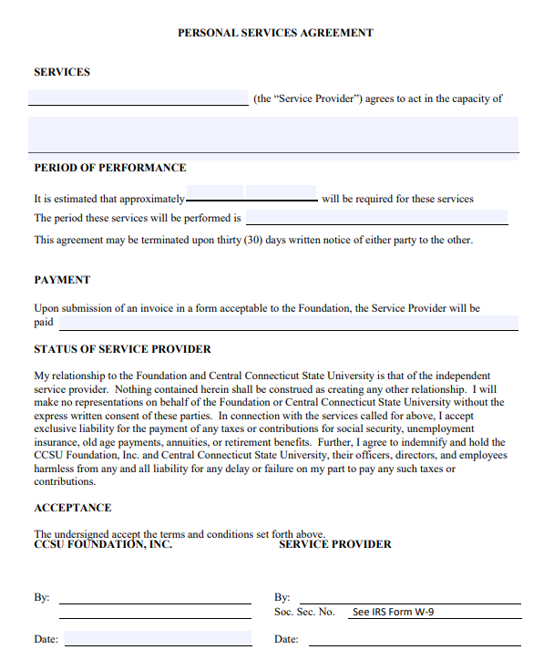

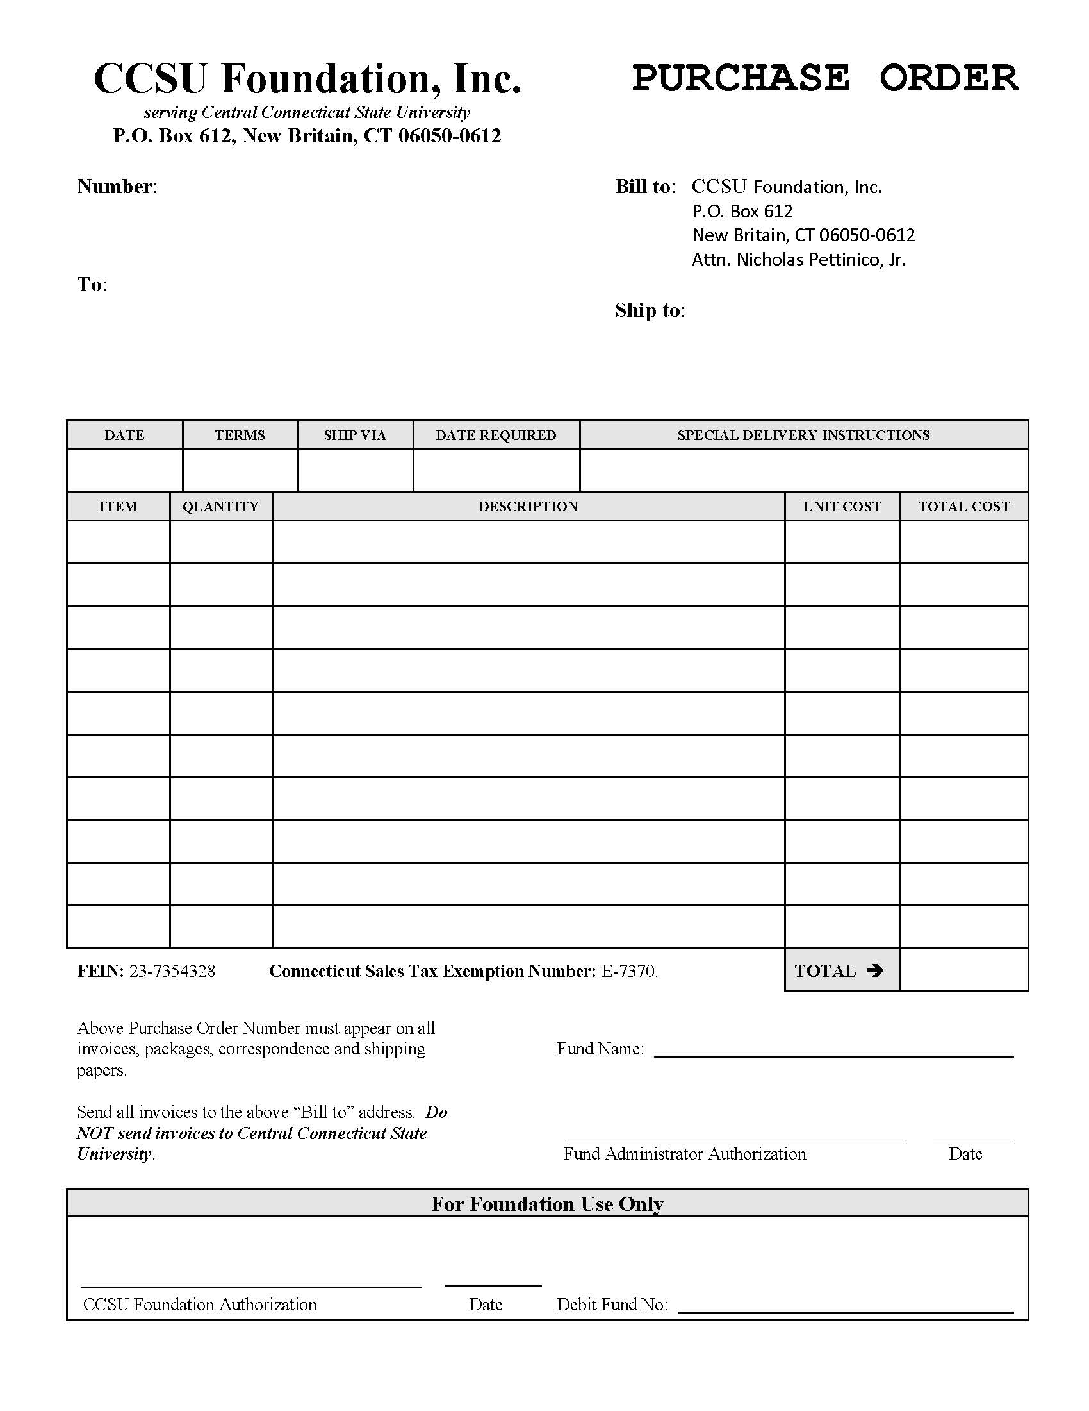

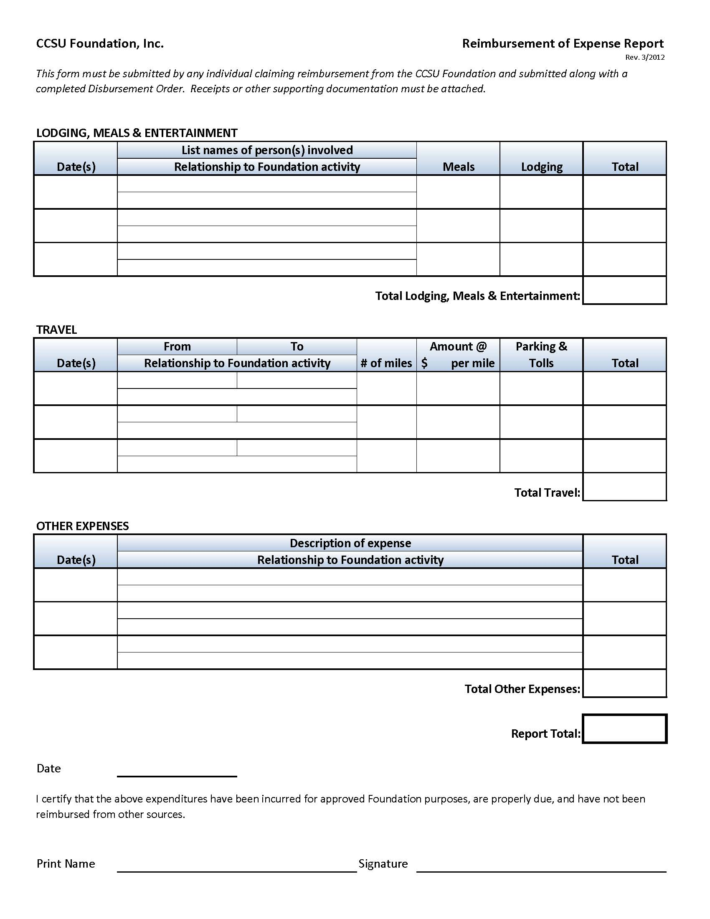

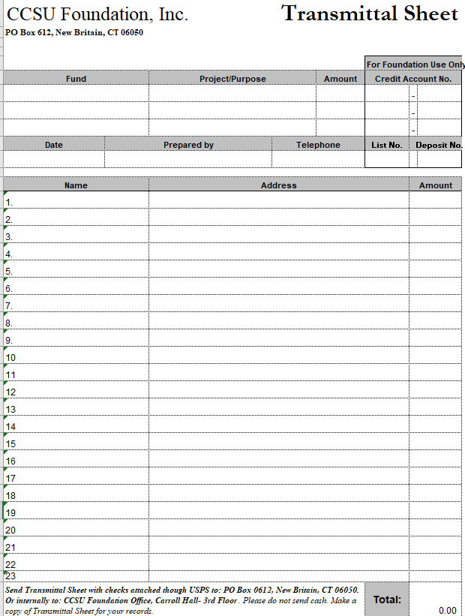



**CASE Statement of Ethics**

Institutional advancement professionals, by virtue of their responsibilities within the academic community, represent their colleges, universities, and schools to the larger society. They have, therefore, a special duty to exemplify the best qualities of their institutions and to observe the highest standards of personal and professional conduct.

In so doing, they promote the merits of their institutions, and of education generally, without disparaging other colleges and schools.

Their words and actions embody respect for truth, fairness, free inquiry, and the opinions of others.

They respect all individuals without regard to race, color, sex, sexual orientation, marital status, creed, ethnic or national identity, handicap, or age.

They uphold the professional reputation of other advancement officers and give credit for ideas, words, or images originated by others.

They safeguard privacy rights and confidential information.

They do not grant or accept favors for personal gain, nor do they solicit or accept favors for their institutions where a higher public interest would be violated.

They avoid actual or apparent conflicts of interest and, if in doubt, seek guidance from appropriate authorities.

They follow the letter and spirit of laws and regulations affecting institutional advancement.

They observe these standards and others that apply to their professions and actively encourage colleagues to join them in supporting the highest standards of conduct.

The CASE Board of Trustees   
adopted this July 11, 1982