Thinkwell-Learnwell: Learning Sufficiency
Objective: To understand the relationship between level of thinking and learning outcomes

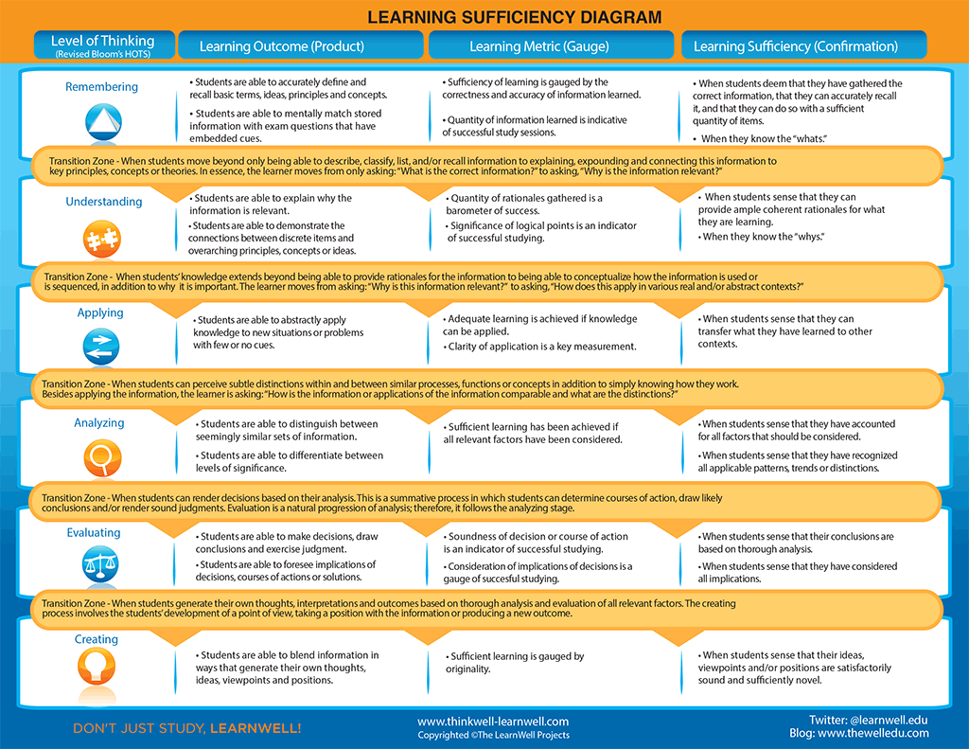
Thinkwell-Learnwell: Bloom’s Higher Order Thinking Skills
Objective: To understand the concept of near transfer of learning and how it relates to college level learning

