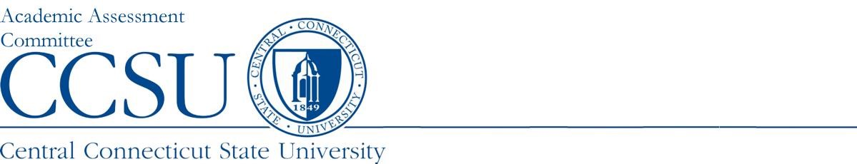

Program Summary

Department: |  | Report Type: Choose an item.
Program Name, Degree Level: |  | Academic Year Data: 2022-23
Report Preparer: |  | Date Report Submitted: Click or tap to enter a date.
Semester/Yr Last PR*: | Semester/Yr Next Full Report*: | Semester/Yr Next PR*:
*Please refer to Assessment Report Calendar for the current schedule

Program Assessment Question | Response
- URL: Provide the URL where the learning outcomes (LO) can be viewed. | URL:
- LO Changes: Identify any changes to the LO and briefly describe why they were changed (e.g., make LO more discrete, align LO with findings). If no changes were made, please report not applicable. | List any changes made to Learning Outcomes:
- Strengths: What about your assessment process is working well? | What are the strengths of the program based on the assessment data?
- Last Year’s Improvements: What changes were made last year as a result of the assessment data? What are the results of those changes? | What changes were made last year?  What are the results of those changes?
- General Education Assessment: Please list the department faculty who have participated in our General Education Assessment Initiative, submitting artifacts to OIRA for faculty scoring. (For graduate degree programs, please type N/A.) | If applicable, list Faculty member(s) participating in the GenEd Assessment Initiative:
For Each Learning Outcome (LO) complete questions below: Many programs have a large number of LOs, please limit the report to no more than five.

Learning Outcome #1: please type learning outcome here

Assessment Instruments: What is the source of the data/evidence, other than GPA, that is used to assess the stated outcomes? (e.g., capstone course, portfolio review and scoring rubric, licensure examination, etc.)
Interpretation: Who interprets the evidence? (e.g., faculty, Admin. assistant, etc.).
Results from changes implemented last year:  - What changes were made last year?  - What are the results of those changes? | What changes were made last year to this year learning outcome?  What are the results of those changes?
For this year’s Findings:  - What did the assessment results show for this year?  - What changes will be implemented this year as a result of those findings? | What did the assessment results show for this year for this learning outcome?  What changes will be implemented this year as a result of the findings?

Learning Outcome #2: please type learning outcome here

Assessment Instruments: What is the source of the data/evidence, other than GPA, that is used to assess the stated outcomes? (e.g., capstone course, portfolio review and scoring rubric, licensure examination, etc.)
Interpretation: Who interprets the evidence? (e.g., faculty, Admin. assistant, etc.).
Results from changes implemented last year:  - What changes were made last year?  - What are the results of those changes? | What changes were made last year to this year learning outcome?  What are the results of those changes?
For this year’s Findings:  - What did the assessment results show for this year?  - What changes will be implemented this year as a result of those findings? | What did the assessment results show for this year for this learning outcome?  What changes will be implemented this year as a result of the findings?

Learning Outcome #3: please type learning outcome here

Assessment Instruments: What is the source of the data/evidence, other than GPA, that is used to assess the stated outcomes? (e.g., capstone course, portfolio review and scoring rubric, licensure examination, etc.)
Interpretation: Who interprets the evidence? (e.g., faculty, Admin. assistant, etc.).
Results from changes implemented last year:  - What changes were made last year?  - What are the results of those changes? | What changes were made last year to this year learning outcome?  What are the results of those changes?
For this year’s Findings:  - What did the assessment results show for this year?  - What changes will be implemented this year as a result of those findings? | What did the assessment results show for this year for this learning outcome?  What changes will be implemented this year as a result of the findings?

Learning Outcome #4: please type learning outcome here

Assessment Instruments: What is the source of the data/evidence, other than GPA, that is used to assess the stated outcomes? (e.g., capstone course, portfolio review and scoring rubric, licensure examination, etc.)
Interpretation: Who interprets the evidence? (e.g., faculty, Admin. assistant, etc.).
Results from changes implemented last year:  - What changes were made last year?  - What are the results of those changes? | What changes were made last year to this year learning outcome?  What are the results of those changes?
For this year’s Findings:  - What did the assessment results show for this year?  - What changes will be implemented this year as a result of those findings? | What did the assessment results show for this year for this learning outcome?  What changes will be implemented this year as a result of the findings?

Learning Outcome #5: please type learning outcome here

Assessment Instruments: What is the source of the data/evidence, other than GPA, that is used to assess the stated outcomes? (e.g., capstone course, portfolio review and scoring rubric, licensure examination, etc.) | List assessment instruments here:
Interpretation: Who interprets the evidence? (e.g., faculty, Admin. assistant, etc.).
Results from changes implemented last year:  - What changes were made last year?  - What are the results of those changes? | What changes were made last year to this year learning outcome?  What are the results of those changes?
For this year’s Findings:  - What did the assessment results show for this year?  - What changes will be implemented this year as a result of those findings? | What did the assessment results show for this year for this learning outcome?  What changes will be implemented this year as a result of the findings?

APPENDIX
Please provide rubric and data tables to support each measured Learning Outcome.

End of Report

