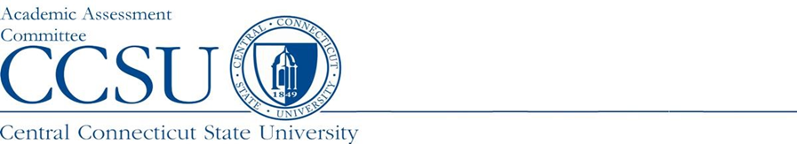

PROGRAM SUMMARY REPORT for NEW PROGRAMS
Department: | Report Type: NEW PROGRAM REPORT for AY21-22
Program Name and Level: | Starting Year of New Program:
Report Preparer: | Date Report Submitted:

Program Assessment Question | Response
- URL: Provide the URL where the Learning Outcomes (LO) can be viewed.

- Assessment Instruments: Please list the source(s) of the data/evidence, other than GPA, that is/are used to assess the stated outcomes? (e.g., capstone course, portfolio review and scoring rubric, licensure examination, etc.)

- Interpretation: Who interprets the evidence? (e.g., faculty, Admin. assistant, etc.).

- Changes: What changes have been or will be made based on previous year results or experiences?

